**PROJECT**

**Chat Application**

**GROUP: 1**

**Nguyễn Lê Tài Đức**

**Lê Bá Thịnh**

**Tô Cao Kim Ngân**

**Trần Minh Nhựt**

Table of Contents

I. SYSTEM CONTEXT DIAGRAM 5

a. System context diagram 5

b. Total context diagram 5

II. USE CASE DIAGRAM 6

a. Guest 7

b. User 7

c. Admin 9

III. ENITY CLASS DIAGRAM 10

IV. SEQUENCE DIAGRAM 11

a. Conversation 11

i. CreateGroupConversation 11

ii. DeleteConversation 12

iii. GetConversation 13

iv. GetMemberListByConversationId 14

v. GroupAddUser 15

vi. GroupBlockUser 16

vii. GroupDisband 17

viii. SendClientMessage 18

ix. UpdateGroupConversation 19

x. UserExitGroup 20

xi. UserJoinGroup 21

b. Identity 22

i. AcceptFriendRequest 22

ii. BlockUser 23

iii. DeleteFriend 24

iv. DeleteFriendRequest 25

v. GetFriendListByUserId 26

vi. GetFriendRequestByUserId 27

vii. GetUserById 28

viii. HelperSequenceDiagram 29

ix. Login 31

x. Register 33

xi. SearchUser 34

xii. SendFriendRequest 35

xiii. UnblockUser 36

xiv. UpdateUser 37

c. Notification 38

i. UpdateNotificationStatus 38

d. Post 39

i. CreateComment 39

ii. CreateInteractionEmoji 40

iii. CreatePost 41

iv. CreatePostInteraction 42

v. CreatePostReport 43

vi. CreateTag 44

vii. DeleteInteractionEmoji 45

viii. DeleteTag 46

ix. DisablePost 47

x. GetListInteractionEmoji 48

xi. GetPostById 49

xii. GetReportPostList 50

xiii. GetTagList 51

xiv. UpdateInteractionEmoji 52

xv. UpdatePost 53

xvi. UpdateTag 54

e. Websocket 55

i. Call 55

ii. SendCallEventMessageToClient 56

**V.** **Architecture Diagram** 56

**VI.** **Subsystem Diagram** 57

**a.** **High Level** 57

**b.** **Identity** 58

**c.** **Conversation** 59

**d.** **Upload** 60

**e.** **Post** 61

**VII.** **Class Diagram** 62

**a.** **Identity** 62

**i.** **Accept Friend Request** 62

**ii.** **Block User** 63

**iii.** **Delete Friend** 64

**iv.** **Delete Friend Request** 65

**v.** **Get Friend List By User Id** 66

**vi.** **Get Friend Request List** 67

**vii.** **Get User By Id** 68

**viii.** **Login** 69

**ix.** **Register** 70

**x.** **Search User** 70

**xi.** **Send Friend Request** 71

**xii.** **Unblock User** 72

**xiii.** **Update User** 73

**b.** **Conversation** 74

**i.** **Create Group Conversation** 74

**ii.** **Delete Conversation** 75

**iii.** **Get All** 76

**iv.** **Get By Id** 76

**v.** **Get Conversation List By User Id** 77

**vi.** **Get Member List By Conversation Id** 78

**vii.** **Group Add User** 79

**viii.** **Group Block User** 79

**ix.** **Group Disband** 80

**x.** **Send Client Message** 81

**xi.** **Update Group Conversation** 82

**xii.** **User Exit Group** 82

**xiii.** **User Join Group** 83

**c.** **Post** 84

**i.** **Create Post** 84

**ii.** **Create Post Interaction** 84

**iii.** **Create Report Post** 85

**iv.** **Get All Post** 86

**v.** **Get All Report Post** 87

**vi.** **Get Post By Id** 88

**vii.** **Get By User Id** 89

**viii.** **Get Post Interaction** 90

**ix.** **Get Report Post By Post Id** 91

**x.** **Uninteraction Post** 92

**xi.** **Update Post** 93

**xii.** **Create Comment** 94

**xiii.** **Get Comment By Post Id** 95

**xiv.** **Update Comment** 96

**xv.** **Create Interaction** 97

**xvi.** **Delete Interaction** 98

**xvii.** **Get All Interaction** 98

**xviii.** **Update Interaction** 99

**xix.** **Create Tag** 100

**xx.** **Delete Tag** 101

**xxi.** **Get All Tag** 101

**xxii.** **Update Tag** 102

**VIII.** **Database diagram** 103

**a.** **FileDB** 103

**b.** **IdentityDB** 104

**c.** **MessageDB** 105

**d.** **PostDB** 106

# SYSTEM CONTEXT DIAGRAM

## System context diagram

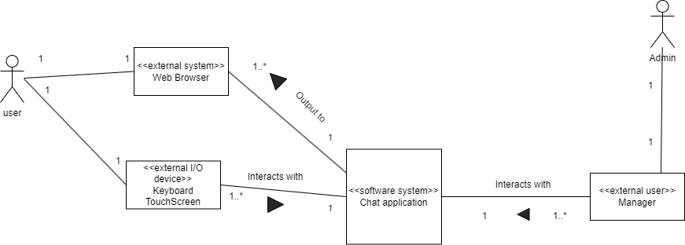

## Total context diagram

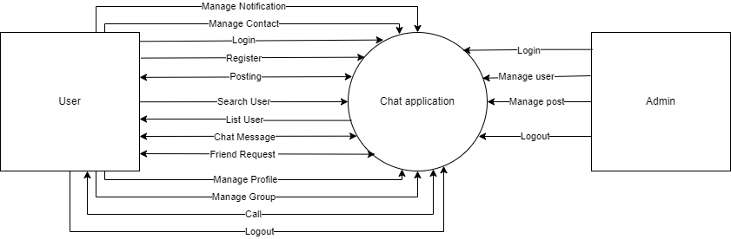

1. USE CASE DIAGRAM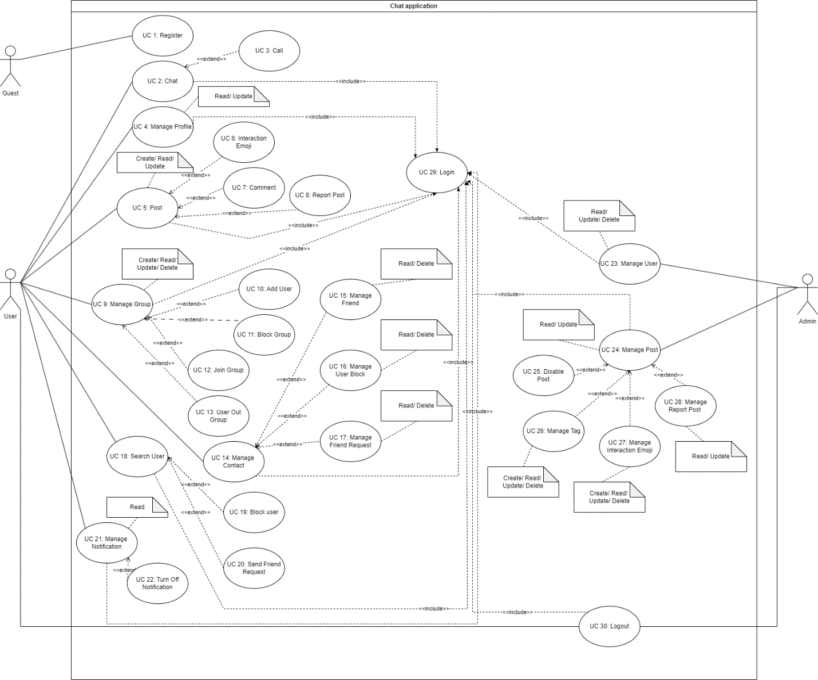

## Guest

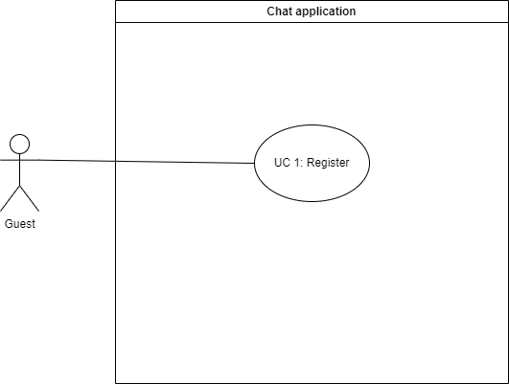

## User

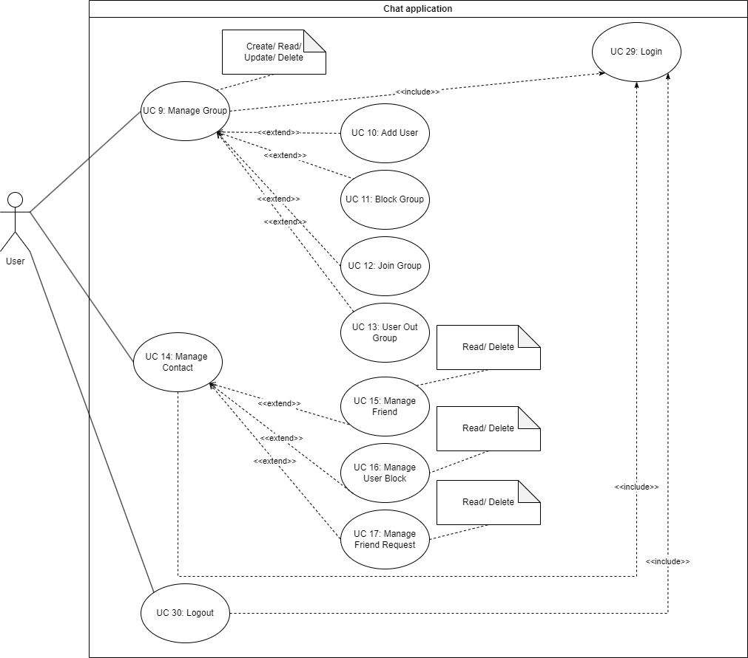

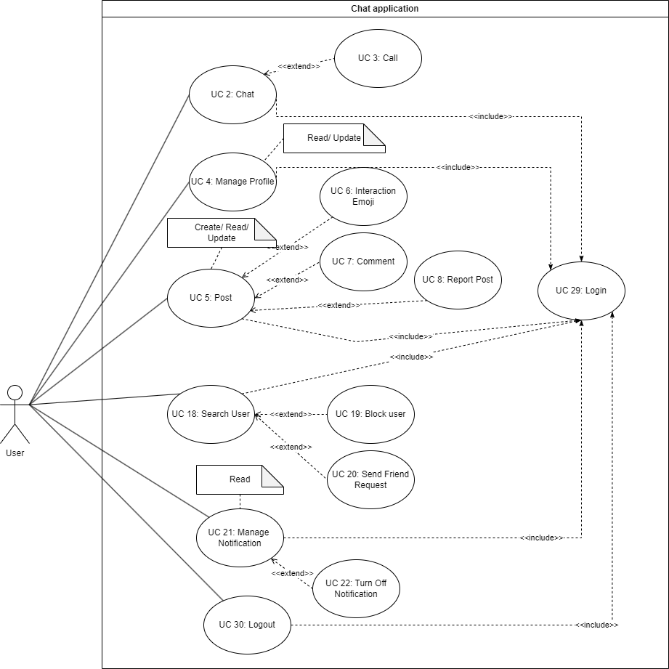

## Admin

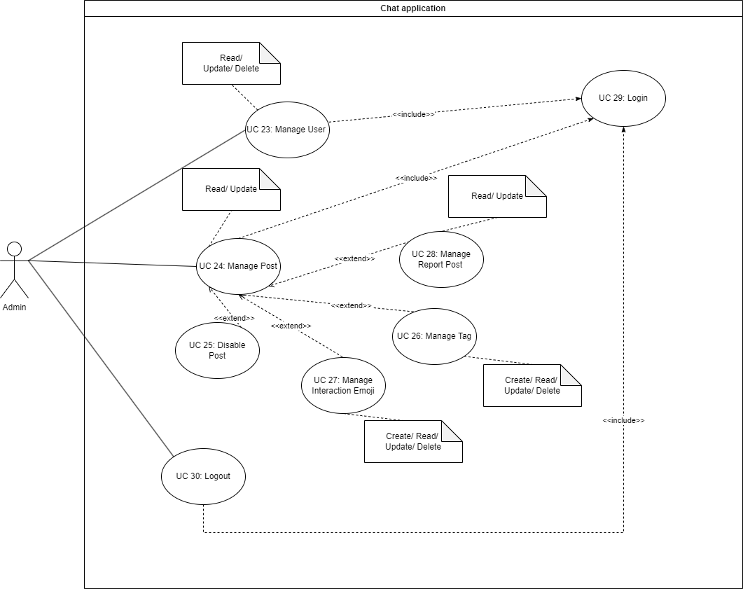

# ENITY CLASS DIAGRAM

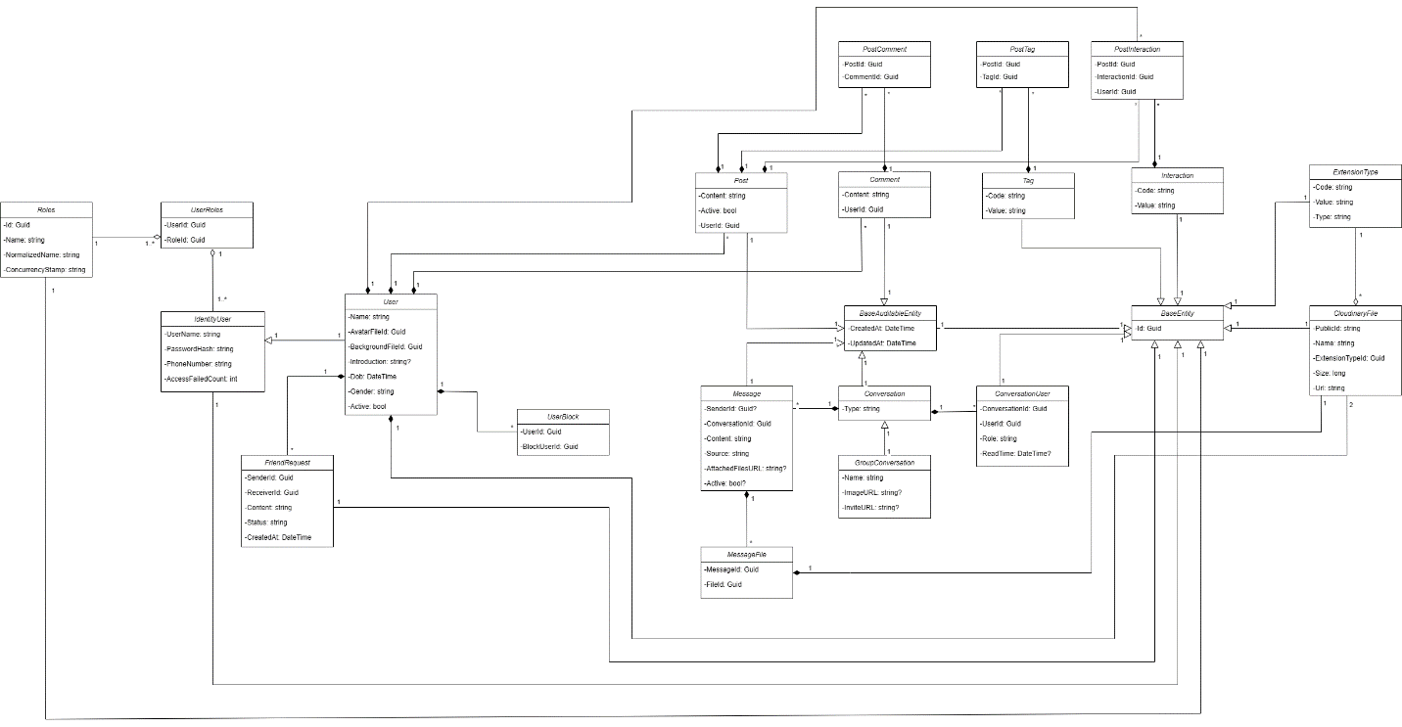

# SEQUENCE DIAGRAM

## Conversation

### CreateGroupConversation

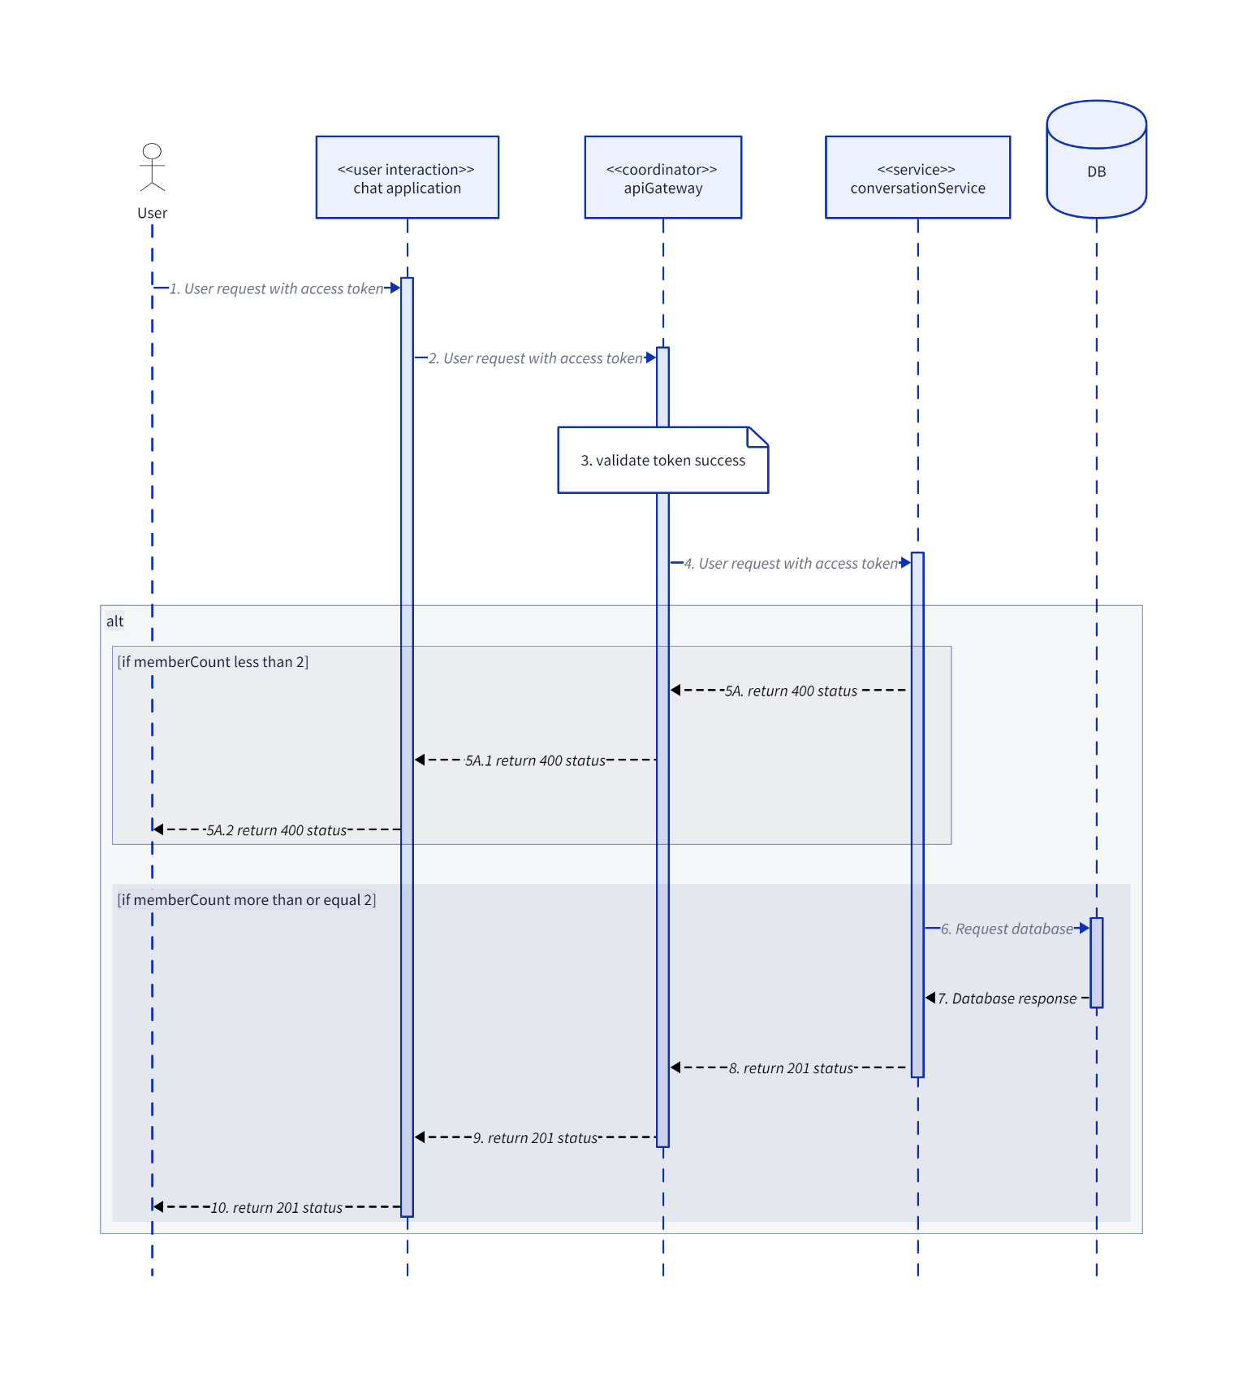

### DeleteConversation

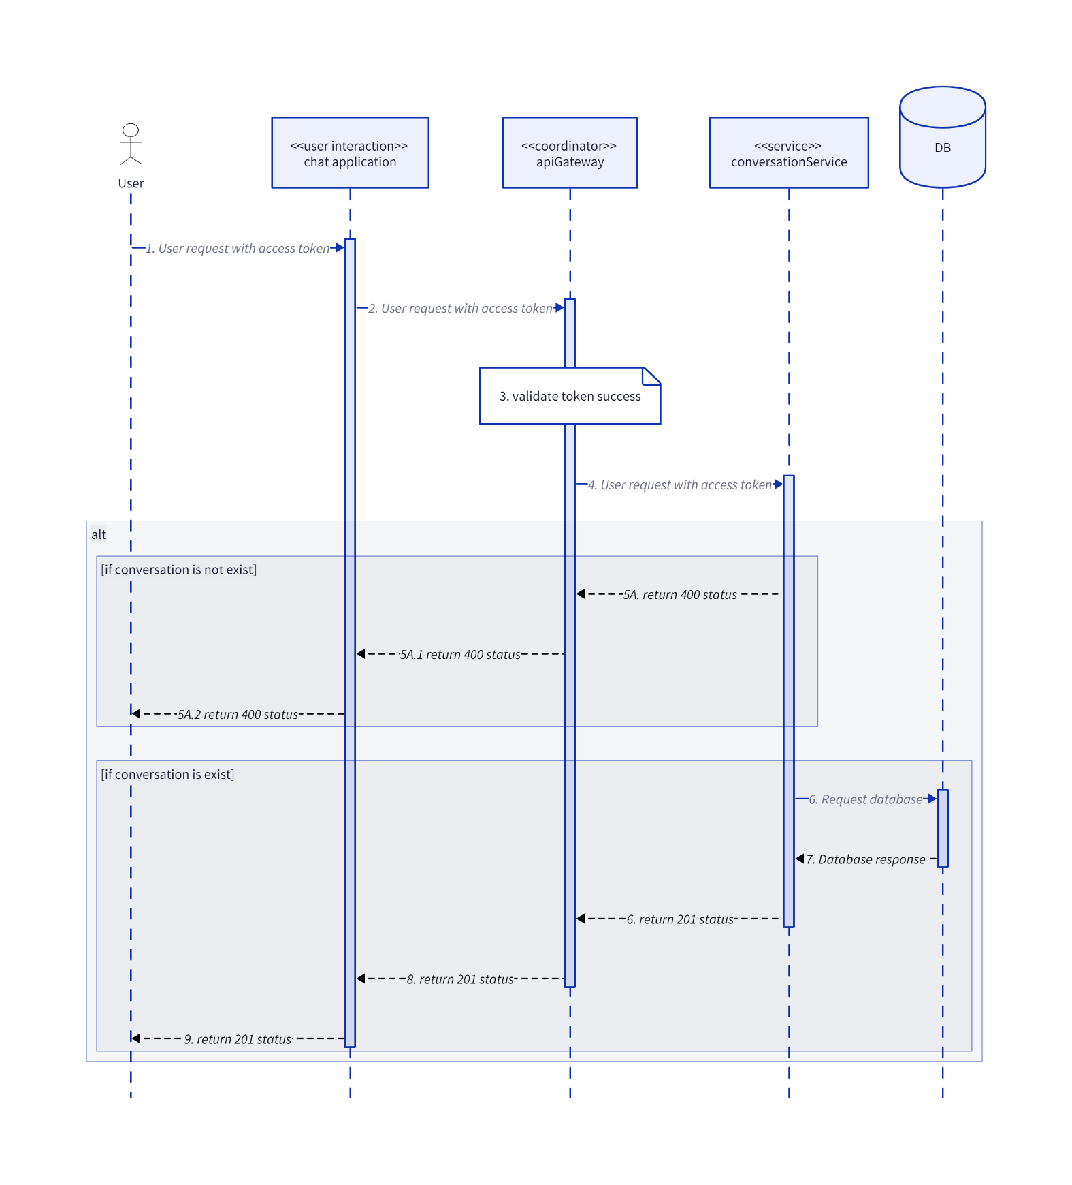

### GetConversation

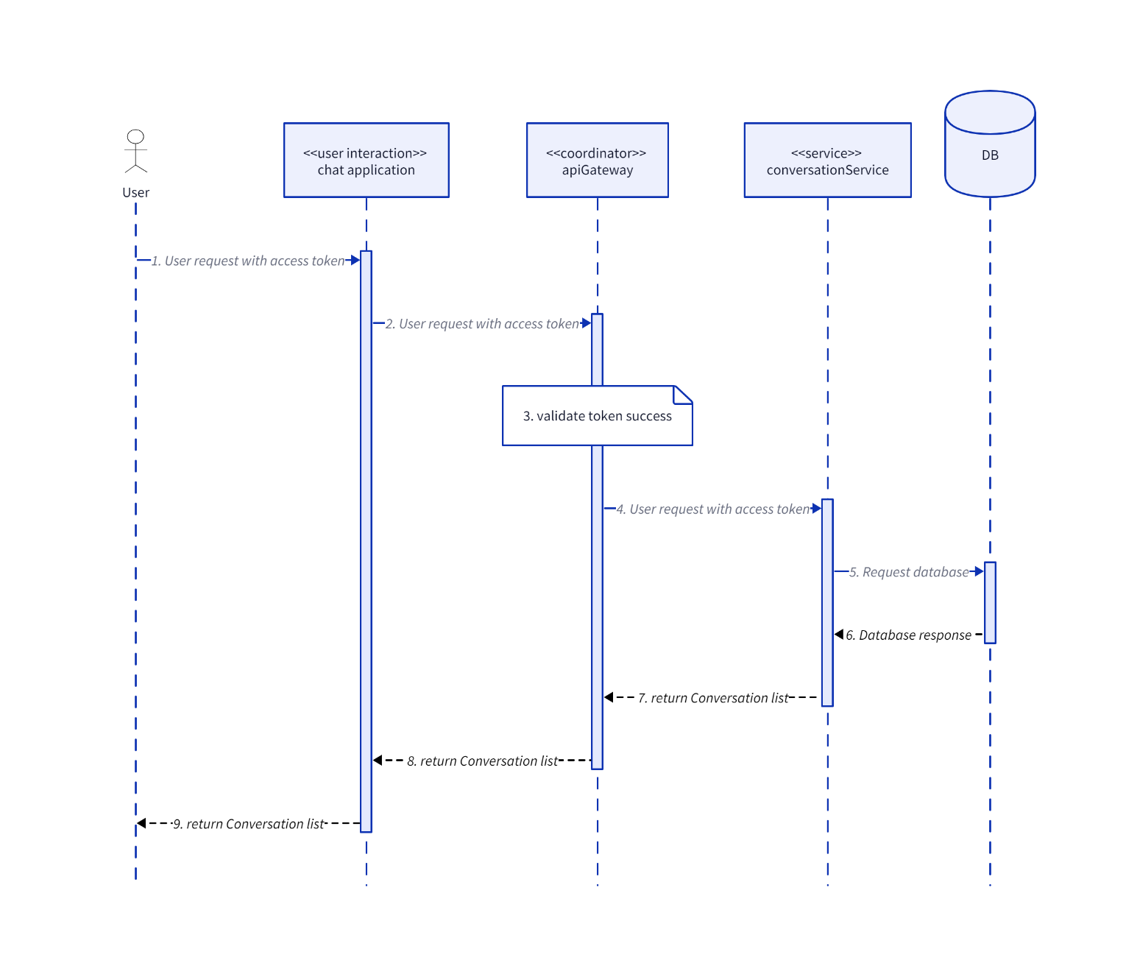

### GetMemberListByConversationId

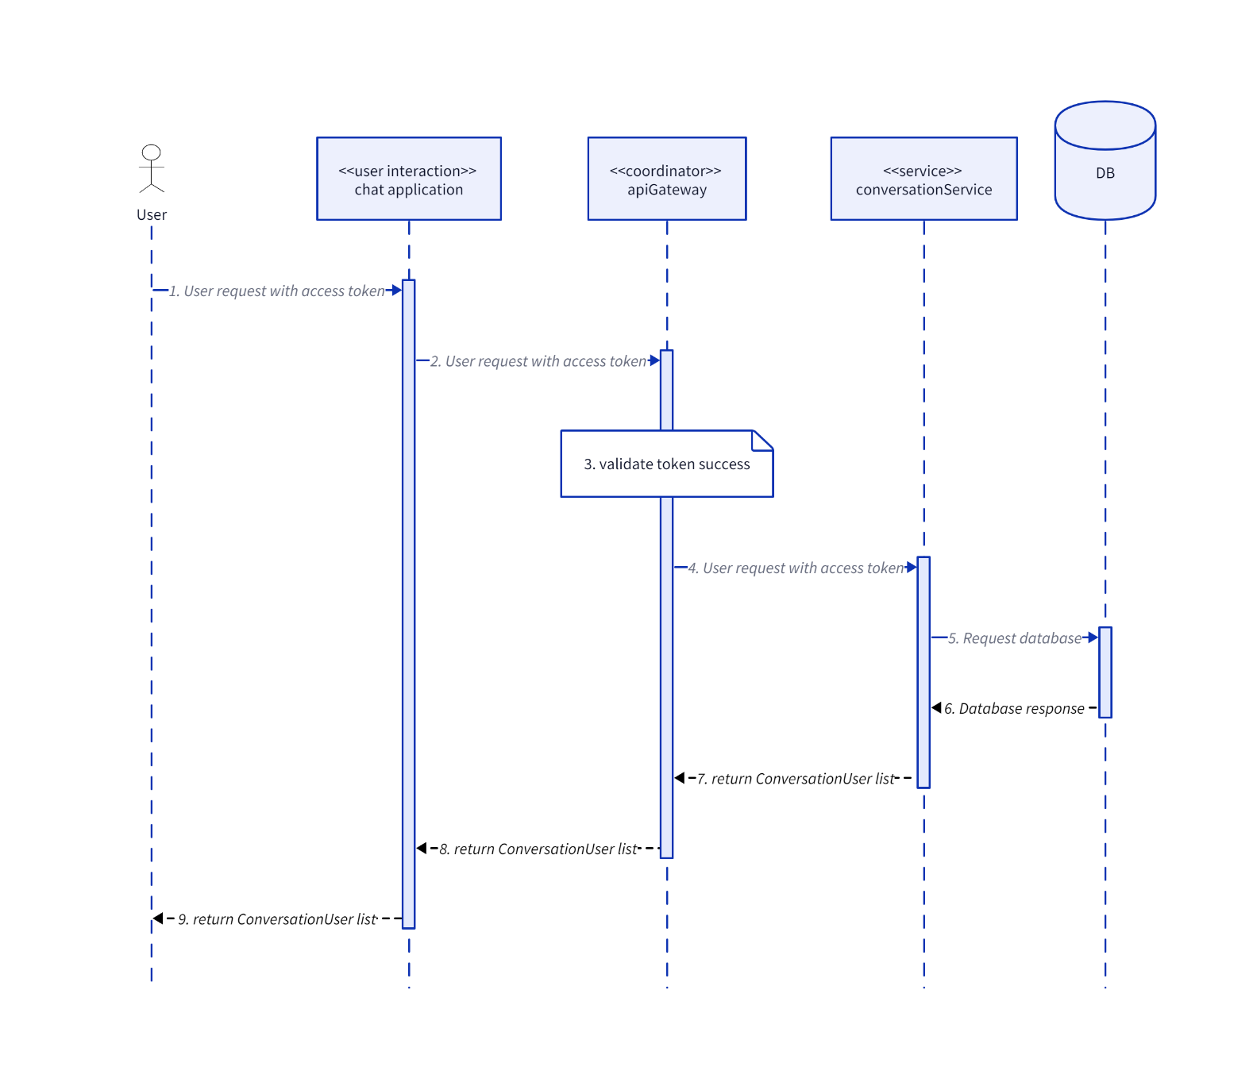

### GroupAddUser

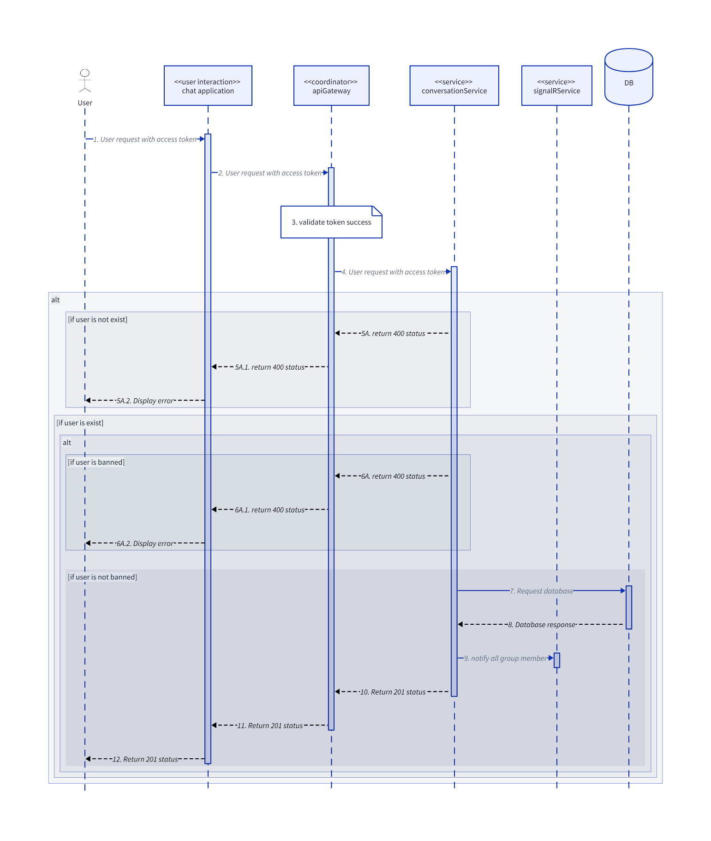

### GroupBlockUser

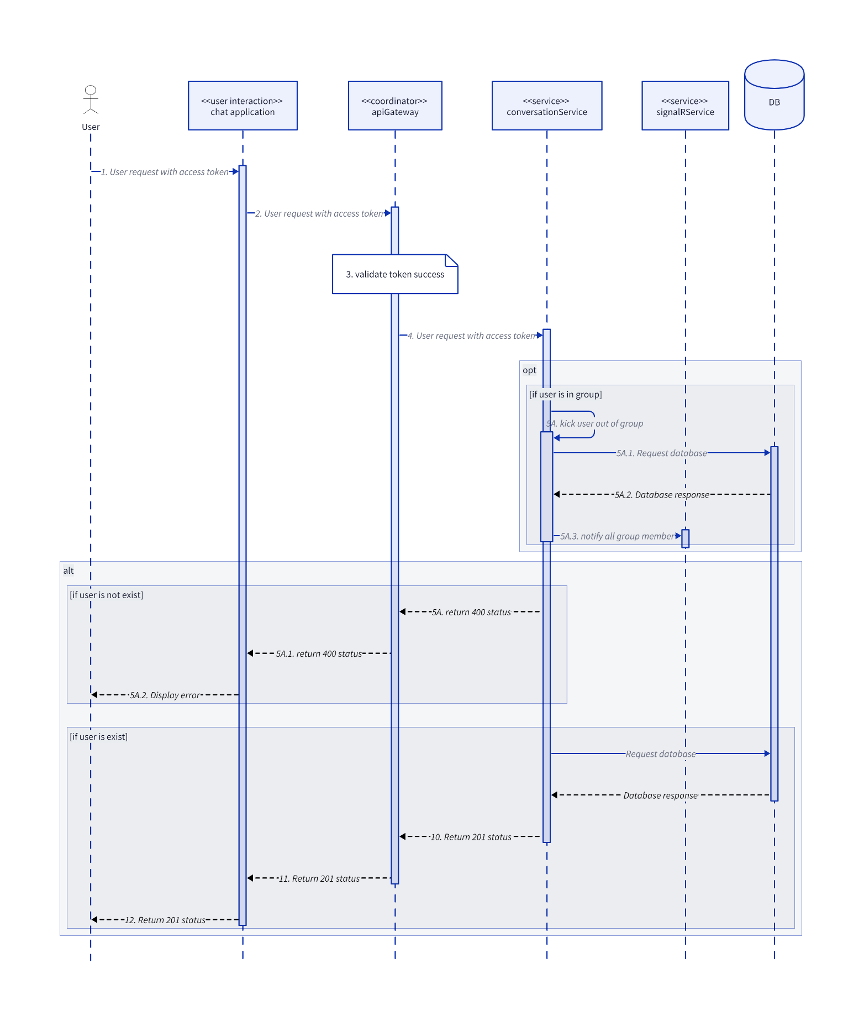

### GroupDisband

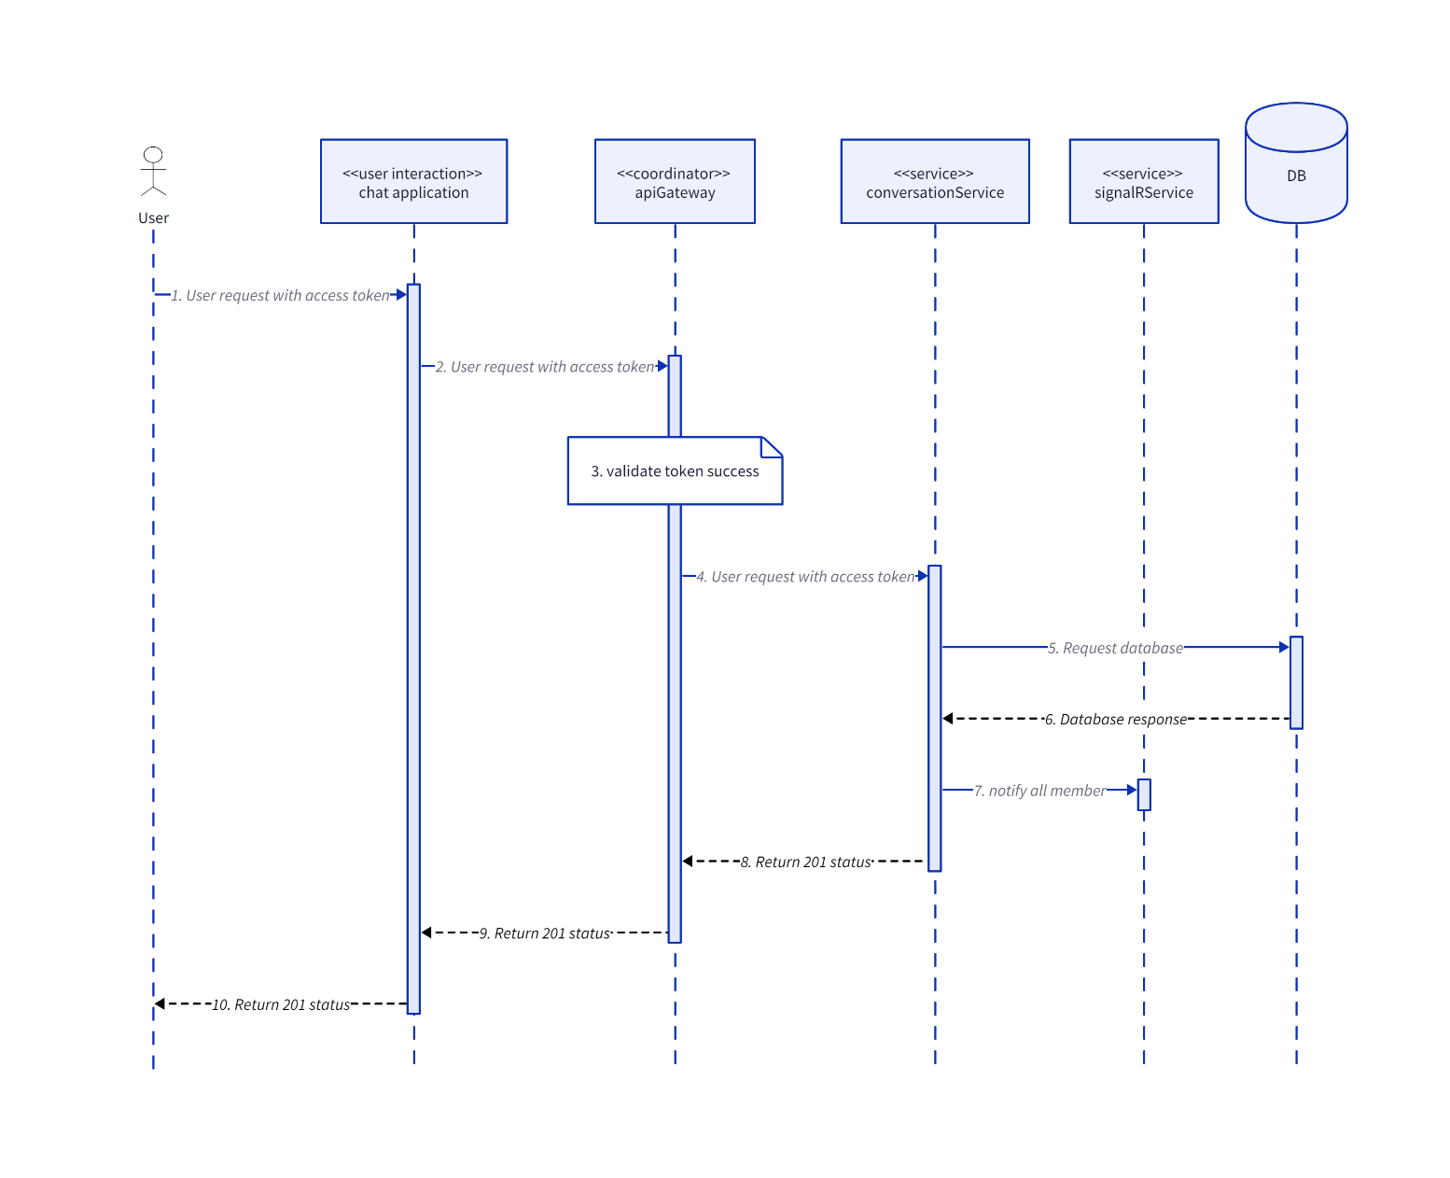

### SendClientMessage

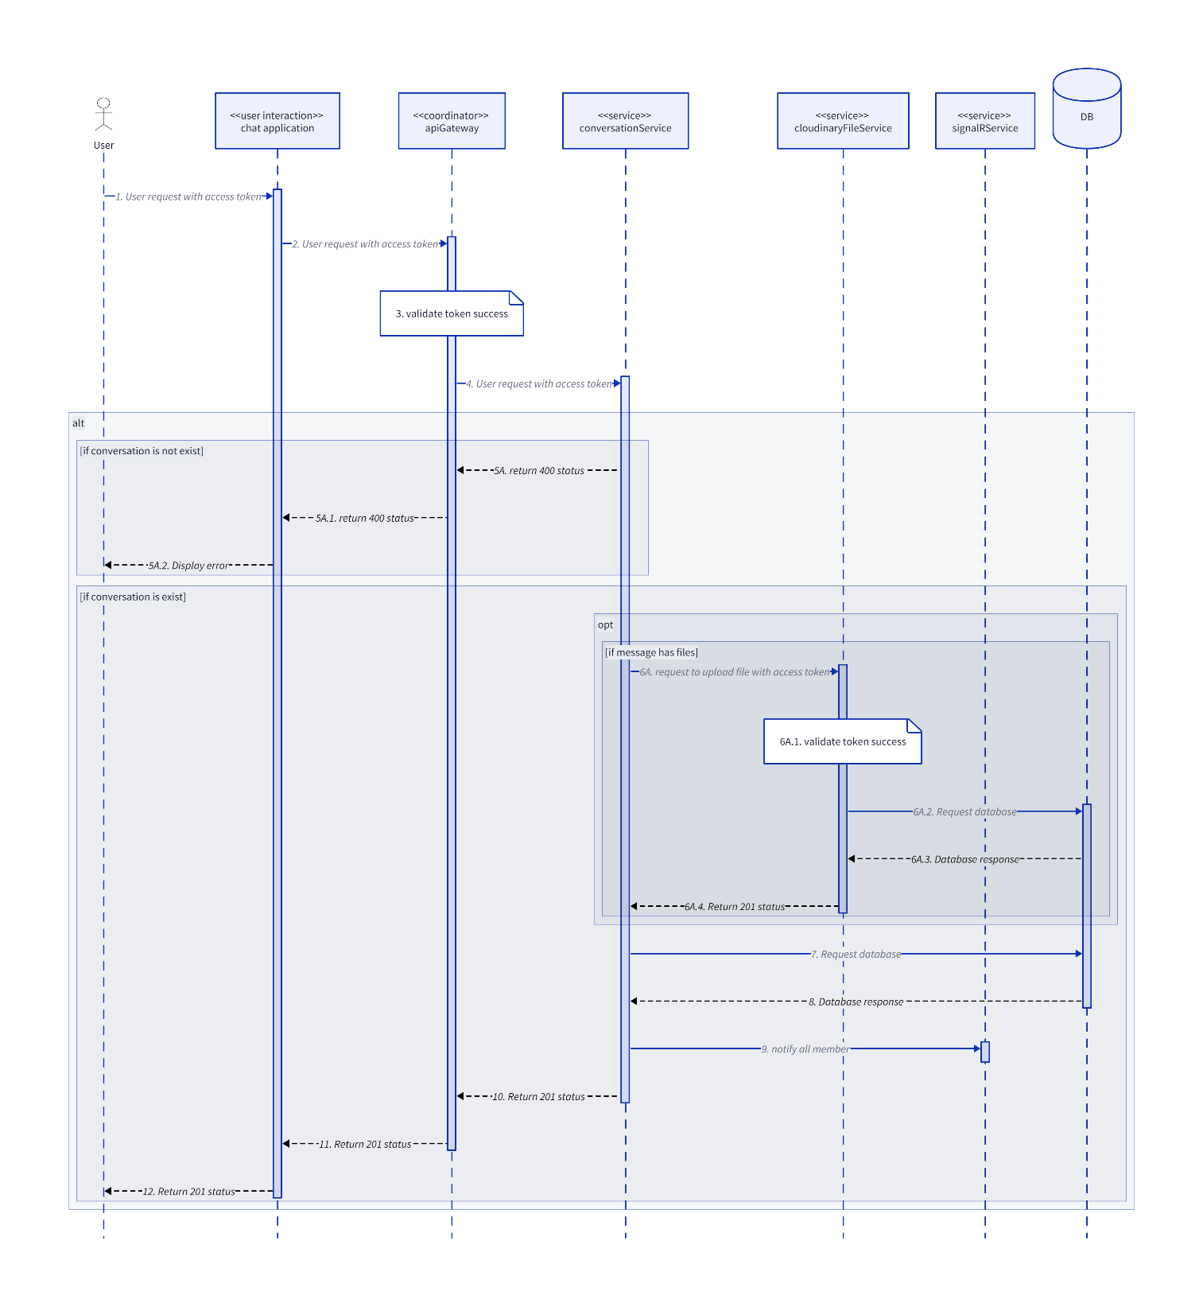

### UpdateGroupConversation

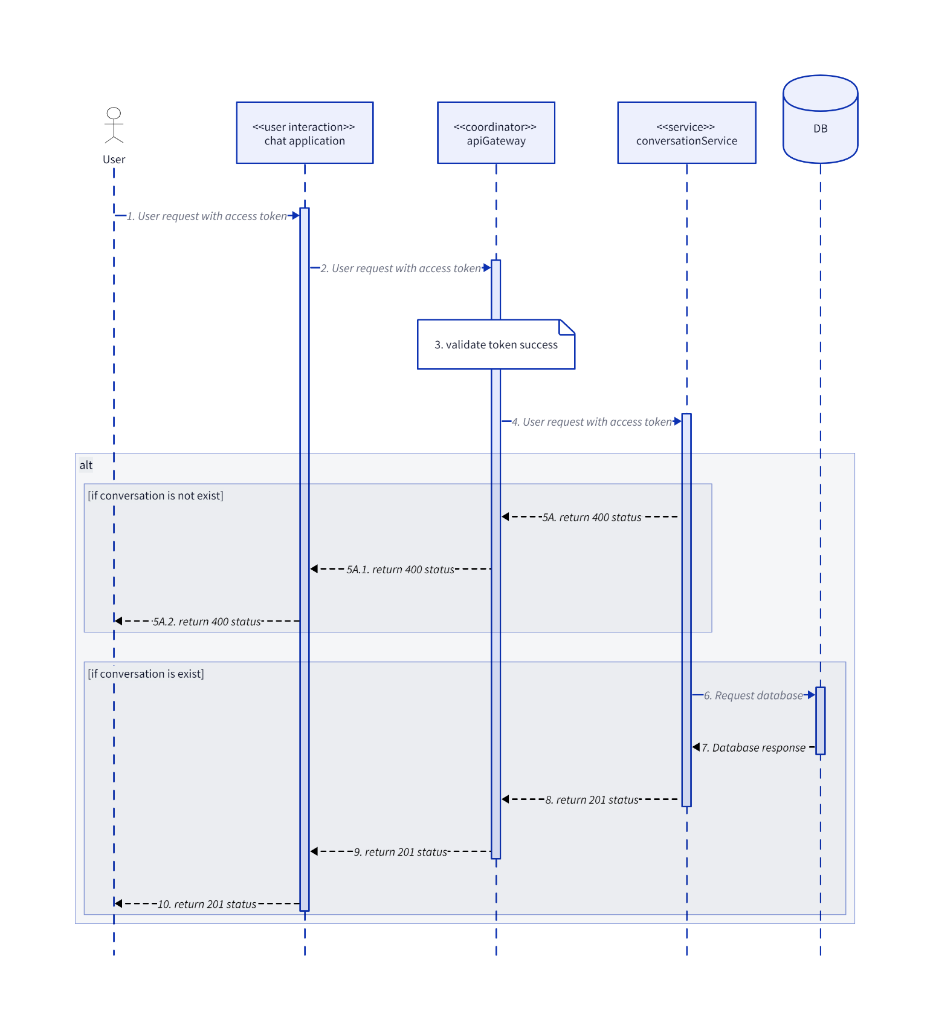

### UserExitGroup

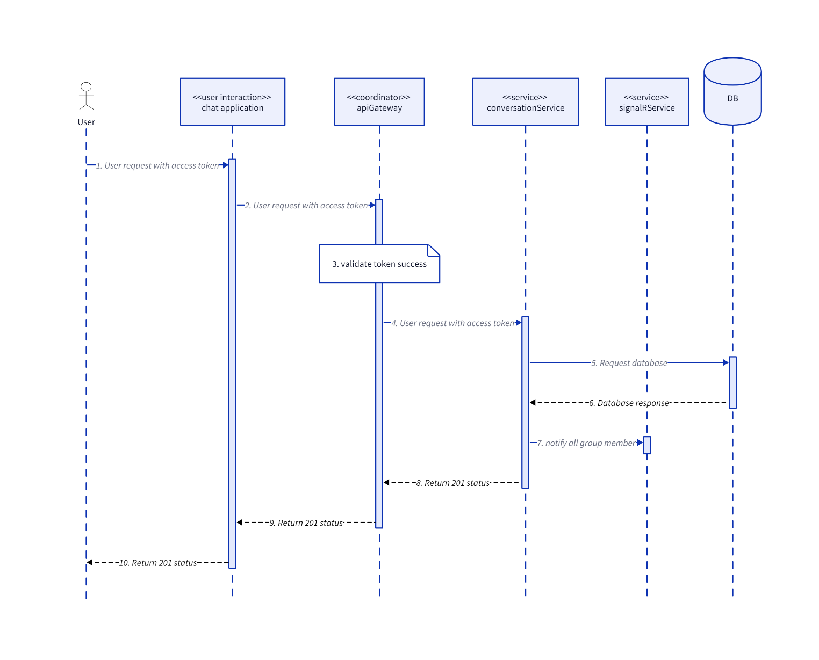

### UserJoinGroup

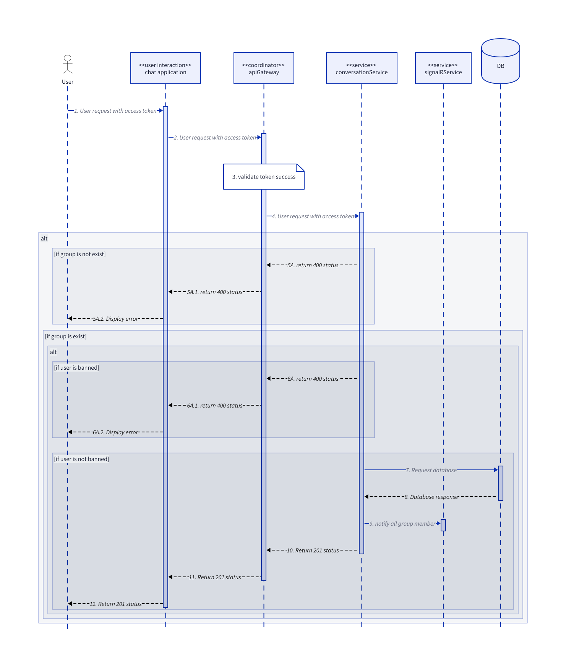

## Identity

### AcceptFriendRequest

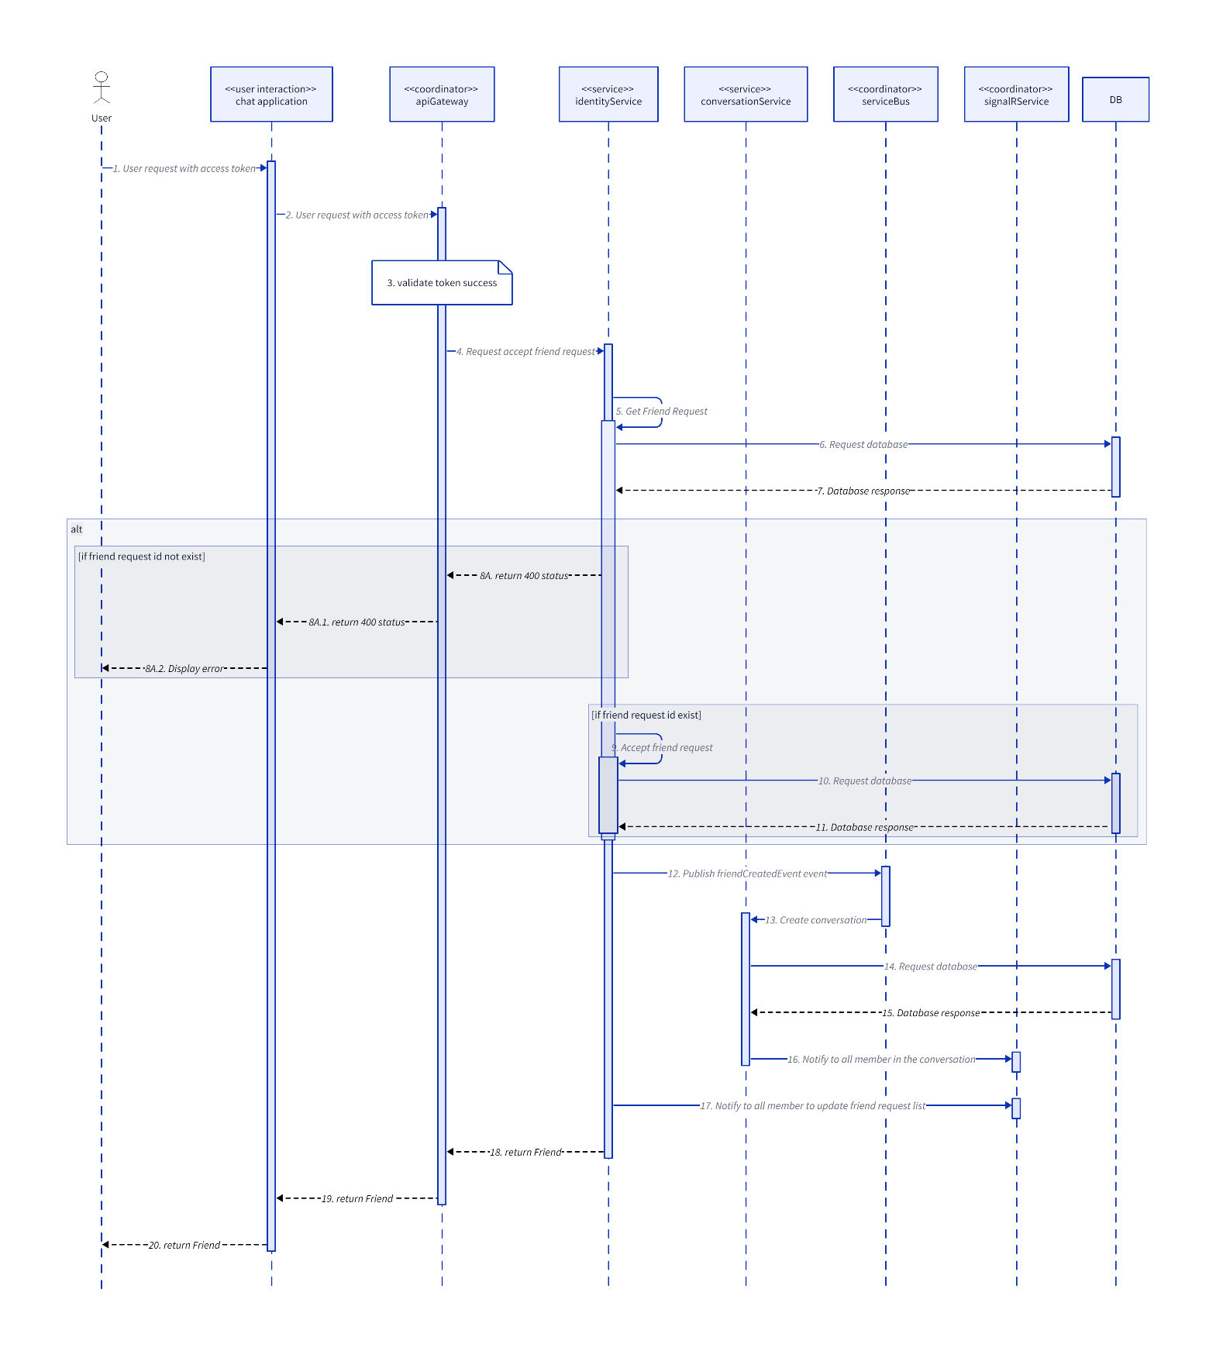

### BlockUser

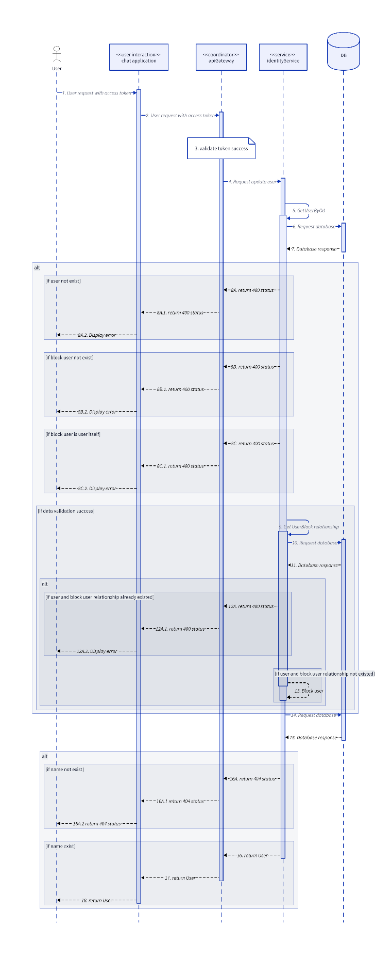

### DeleteFriend

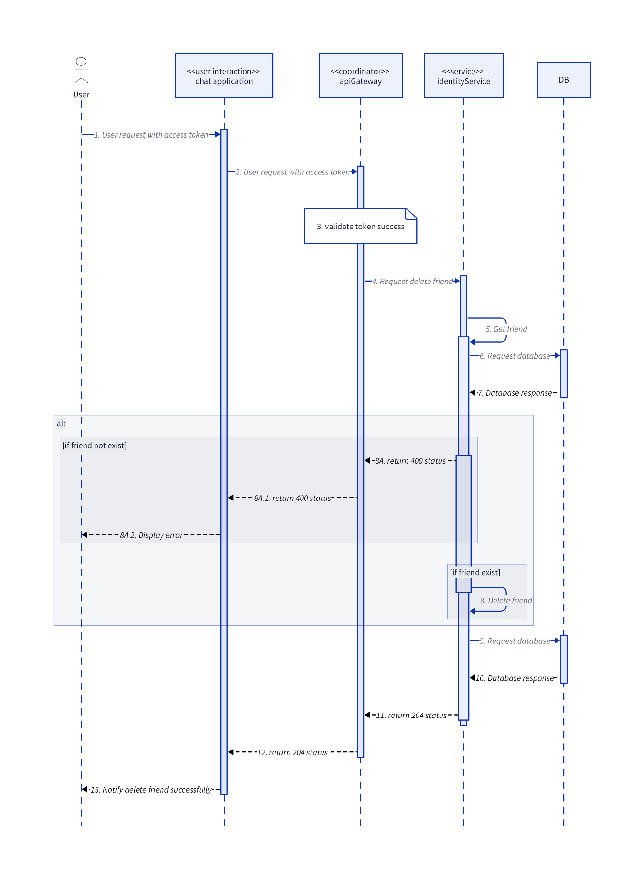

### DeleteFriendRequest

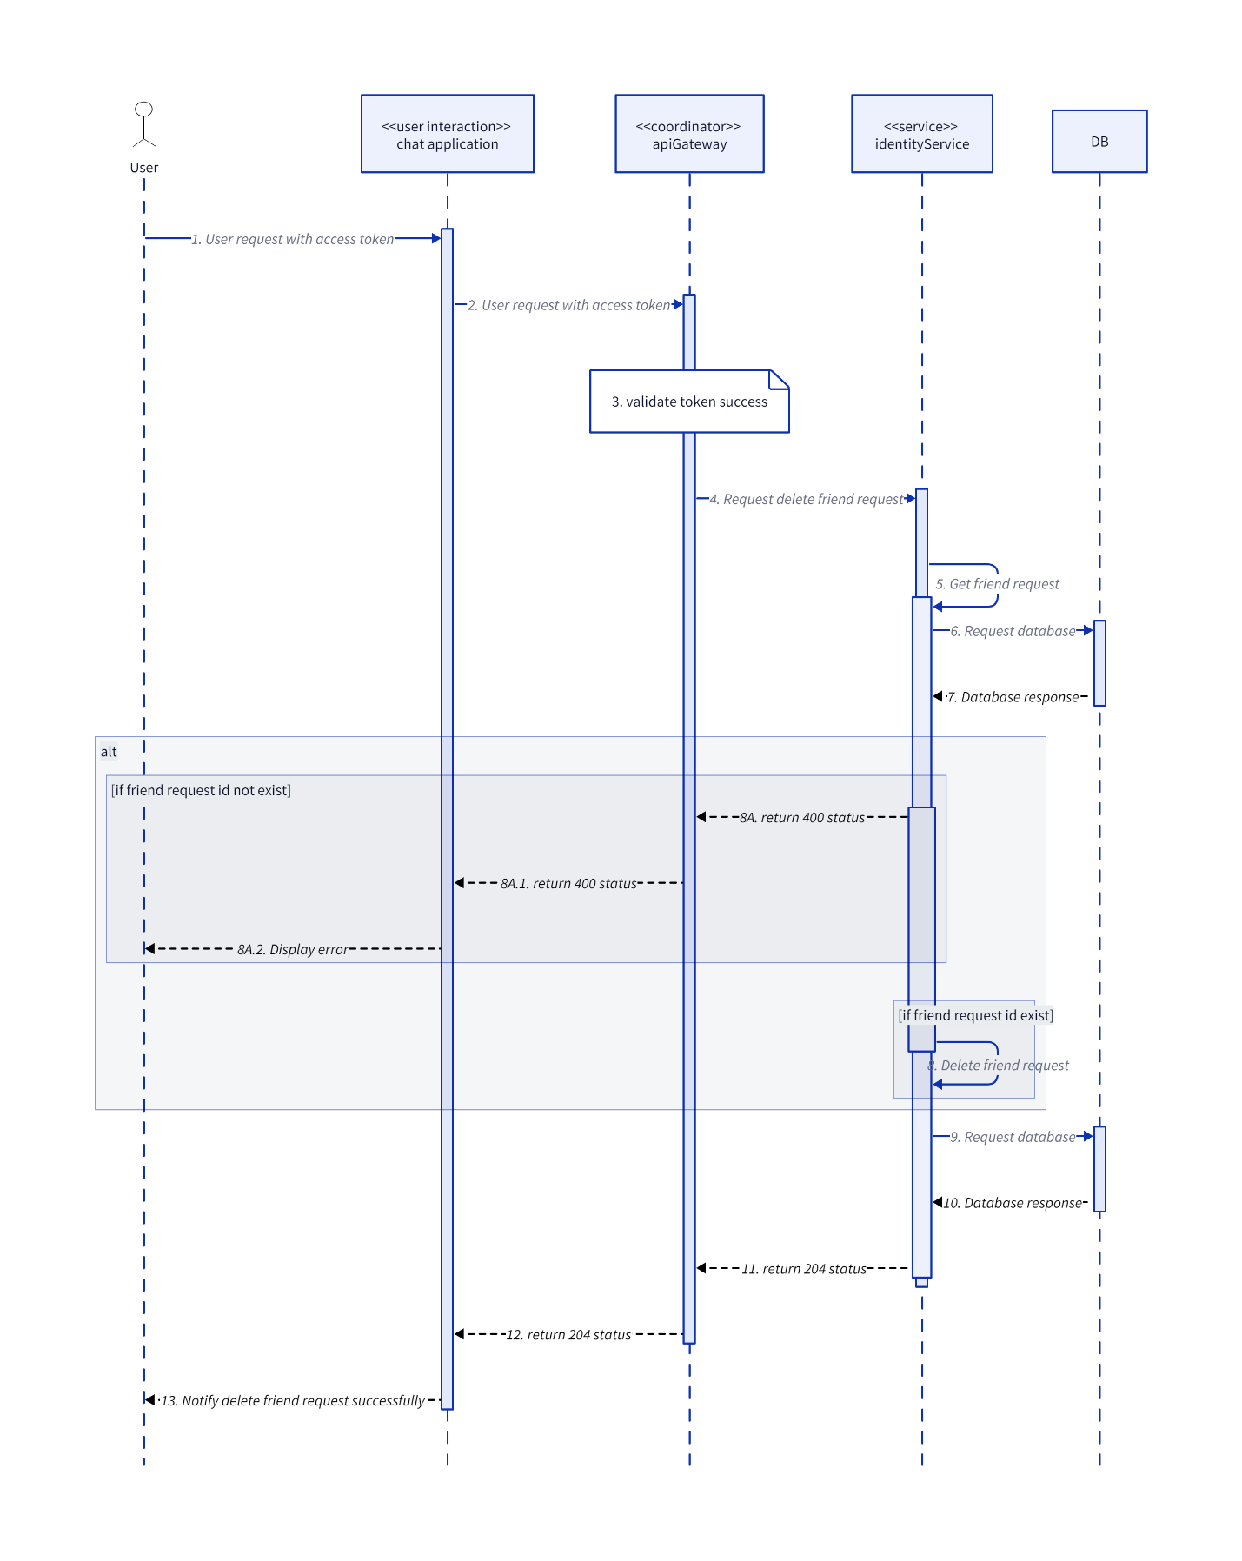

### GetFriendListByUserId

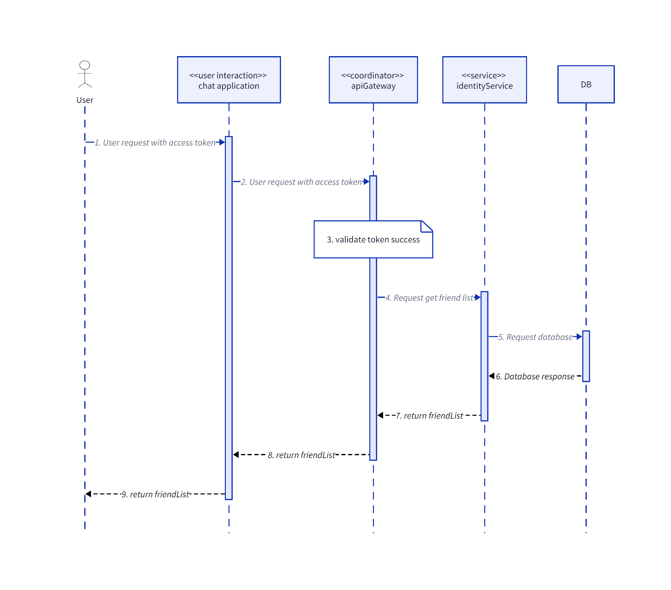

### GetFriendRequestByUserId

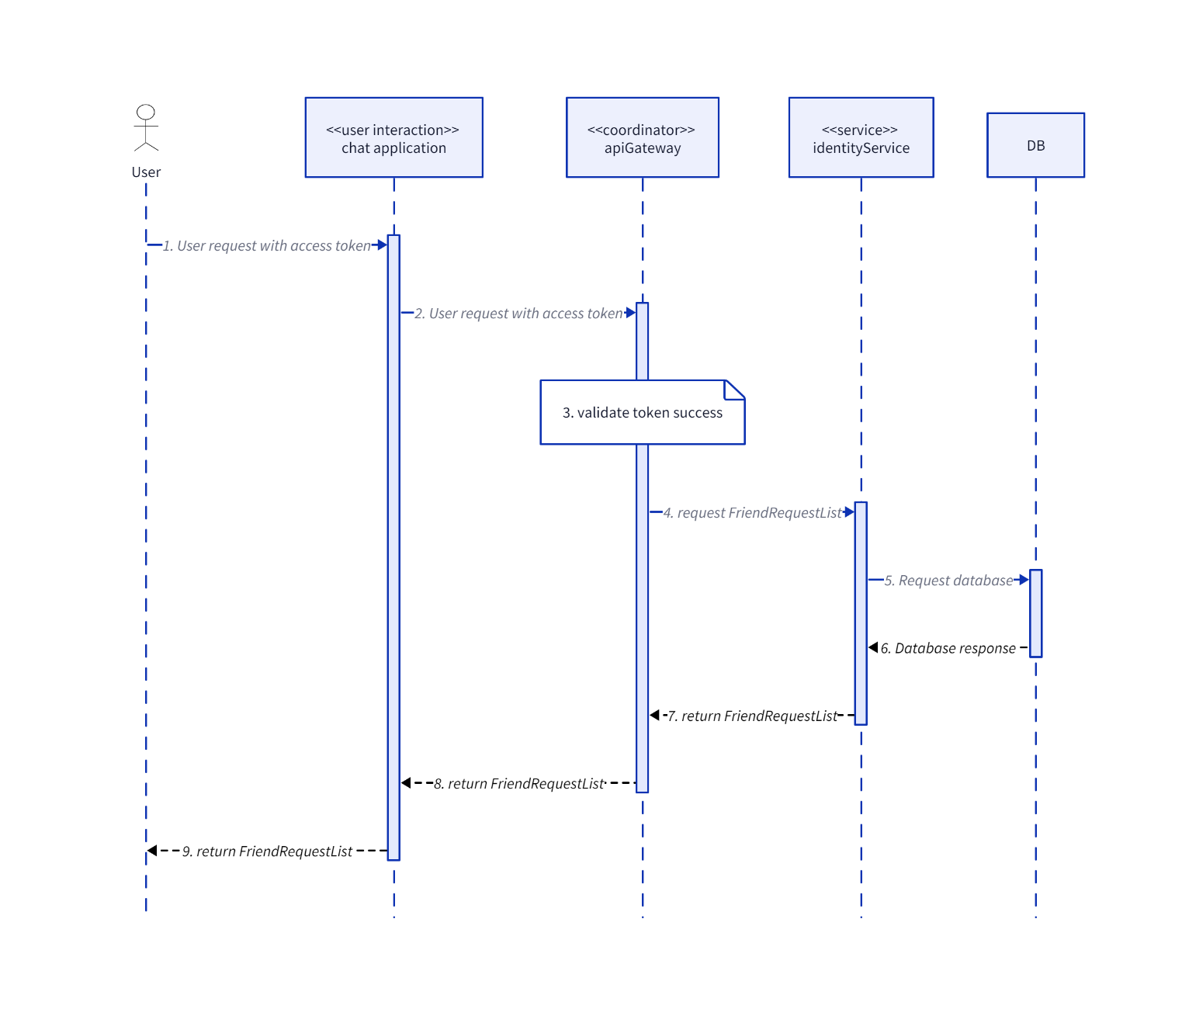

### GetUserById

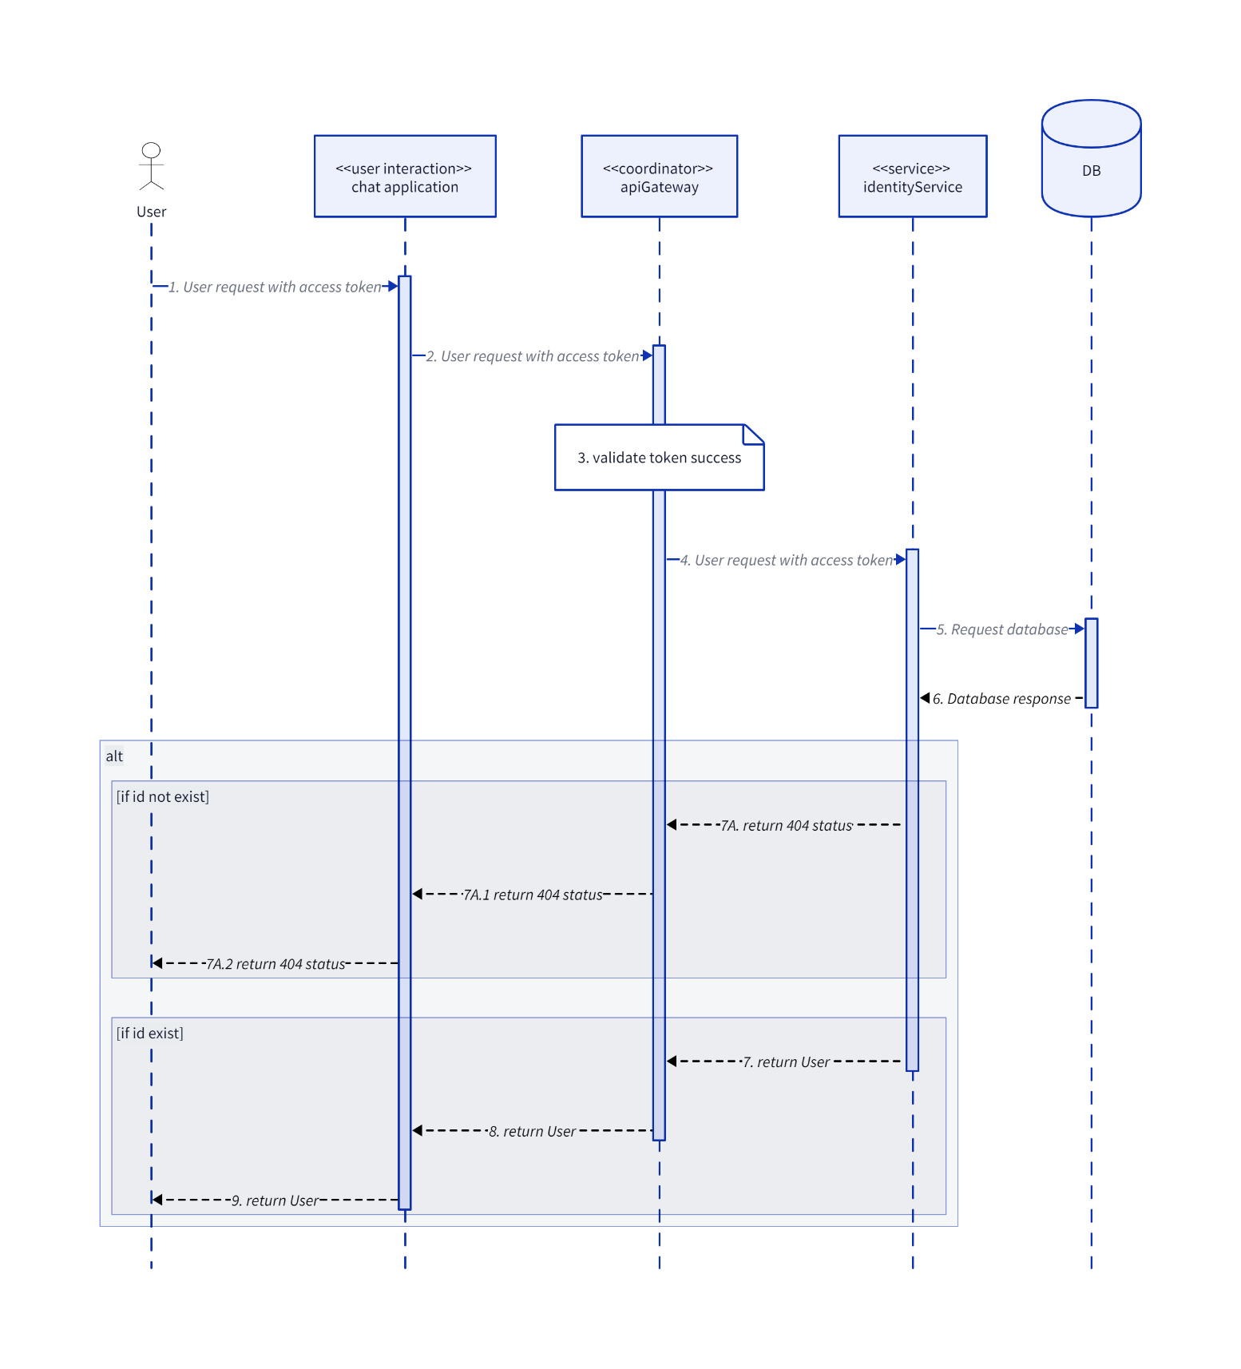

### HelperSequenceDiagram

#### UserUnauthorized

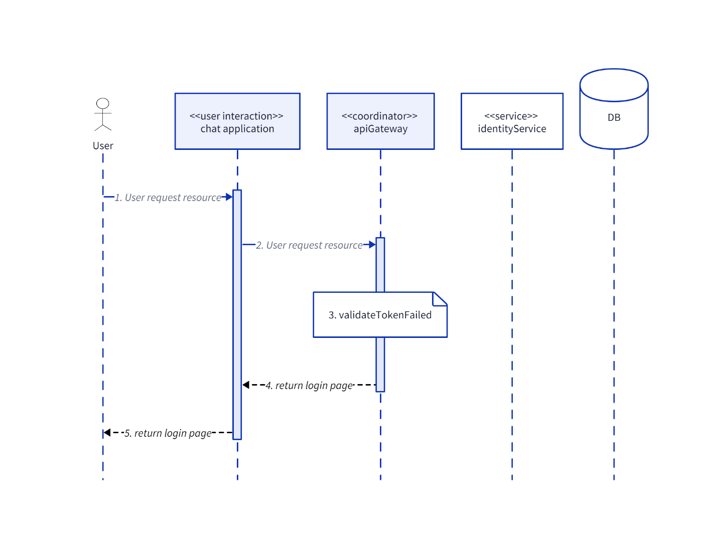

#### ValidateToken

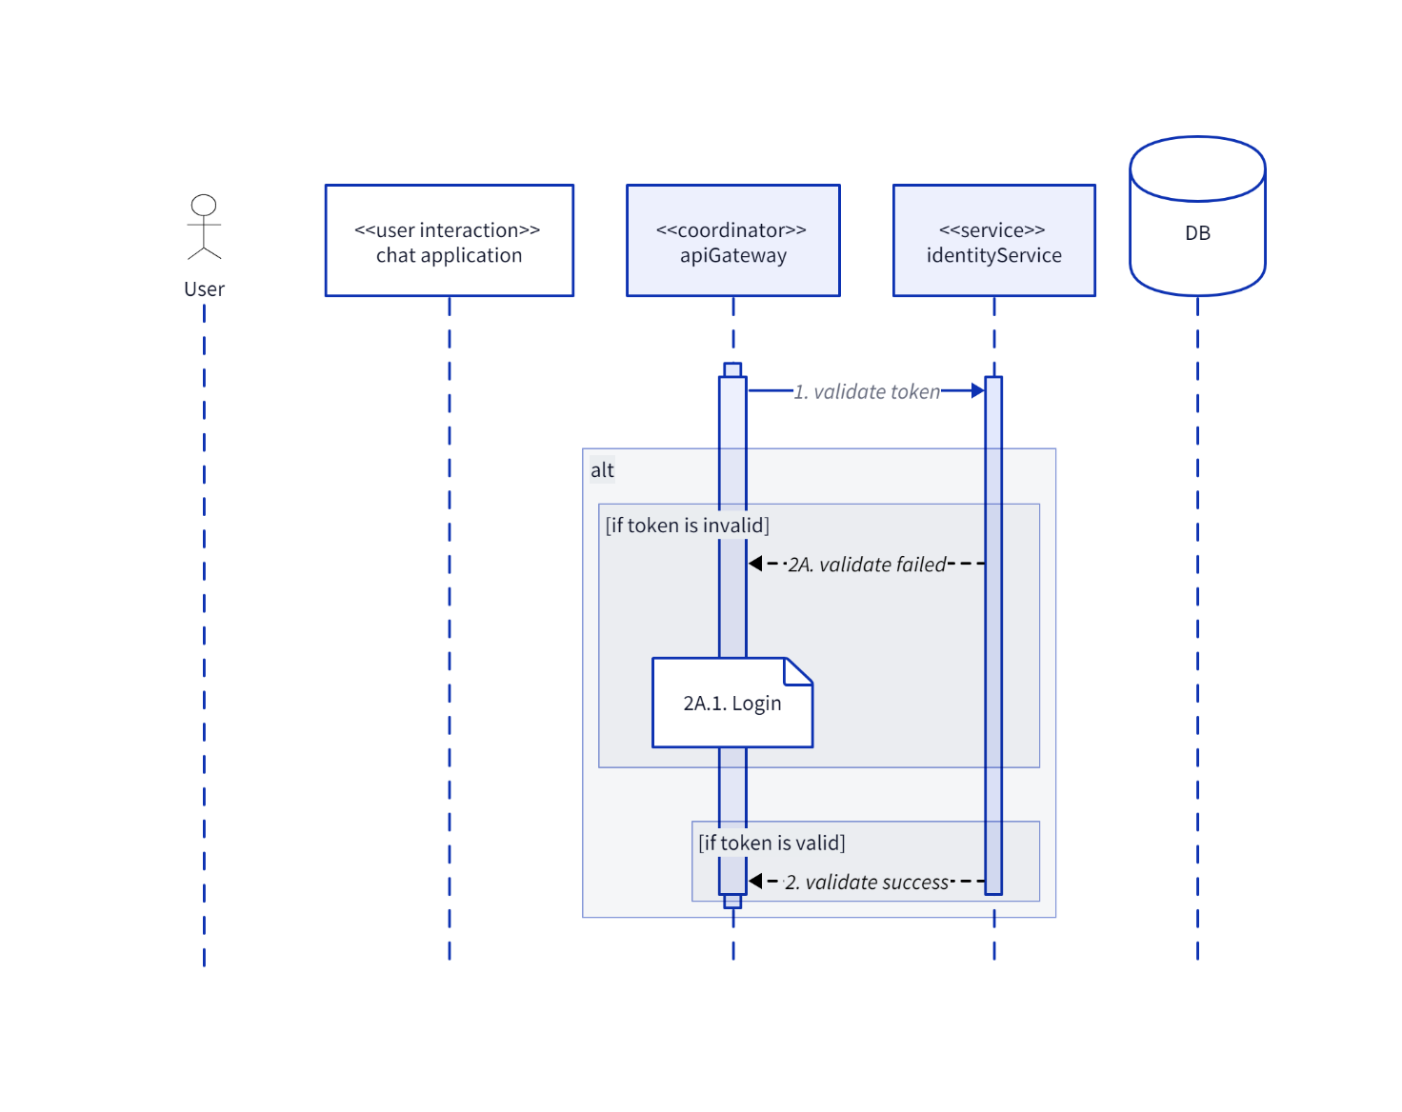

### Login

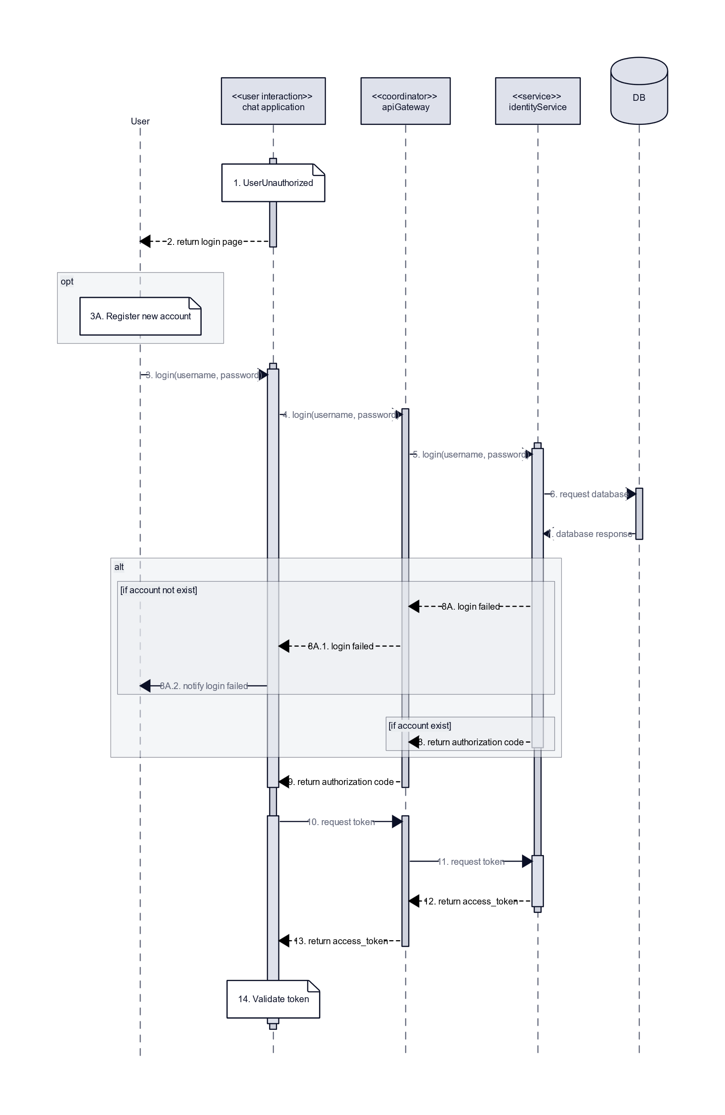

### Register

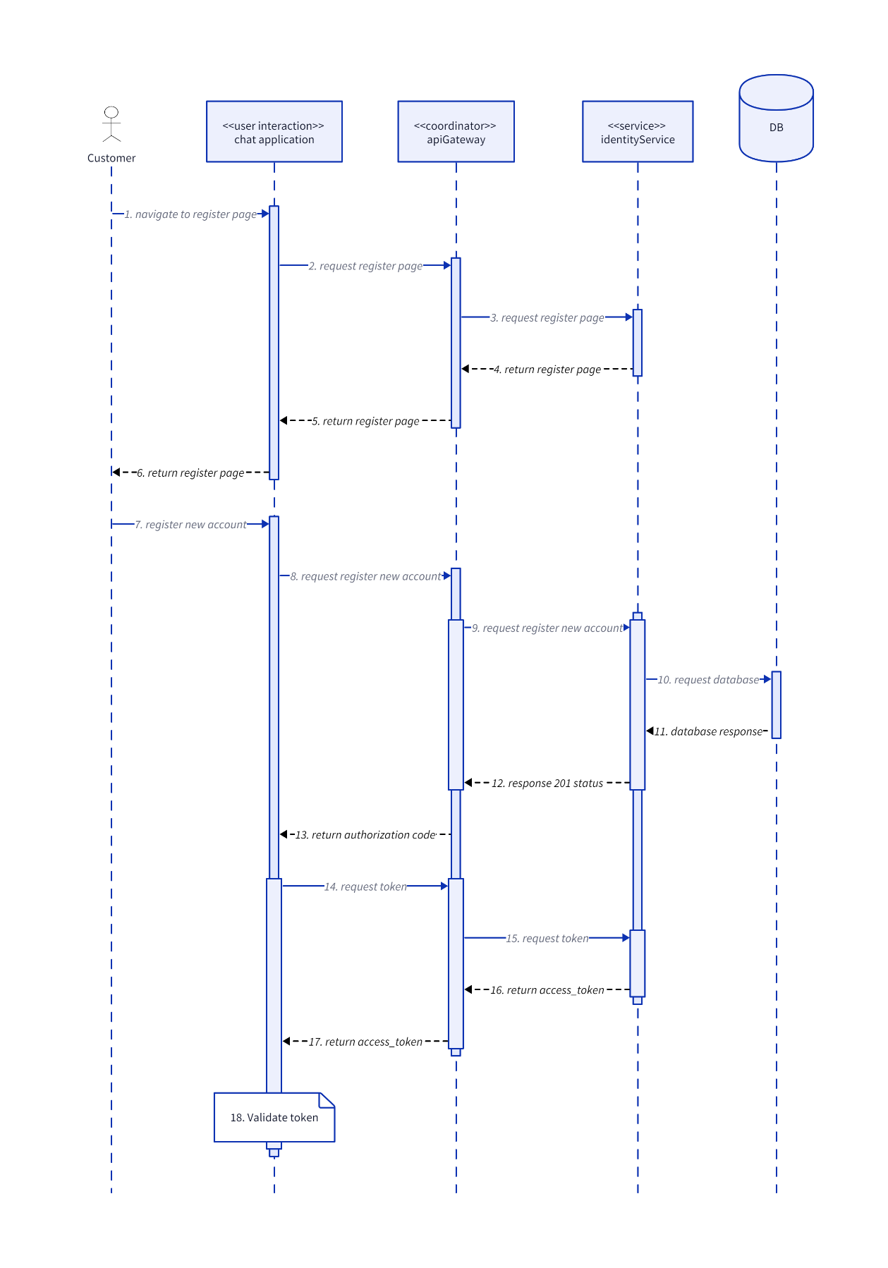

### SearchUser

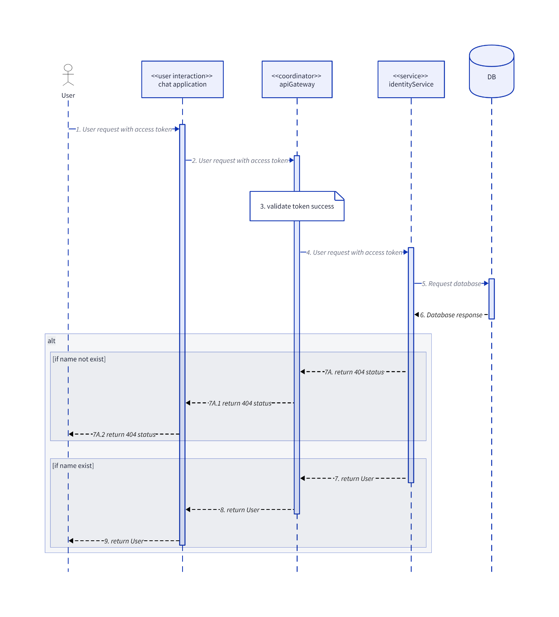

### SendFriendRequest

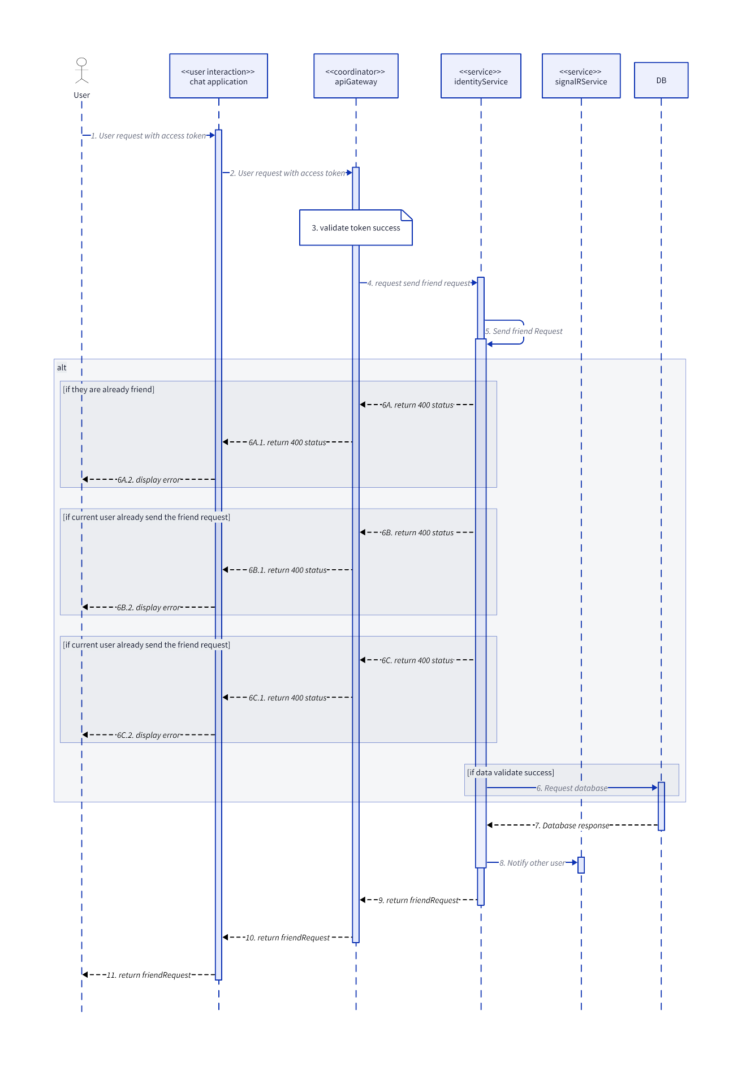

### UnblockUser

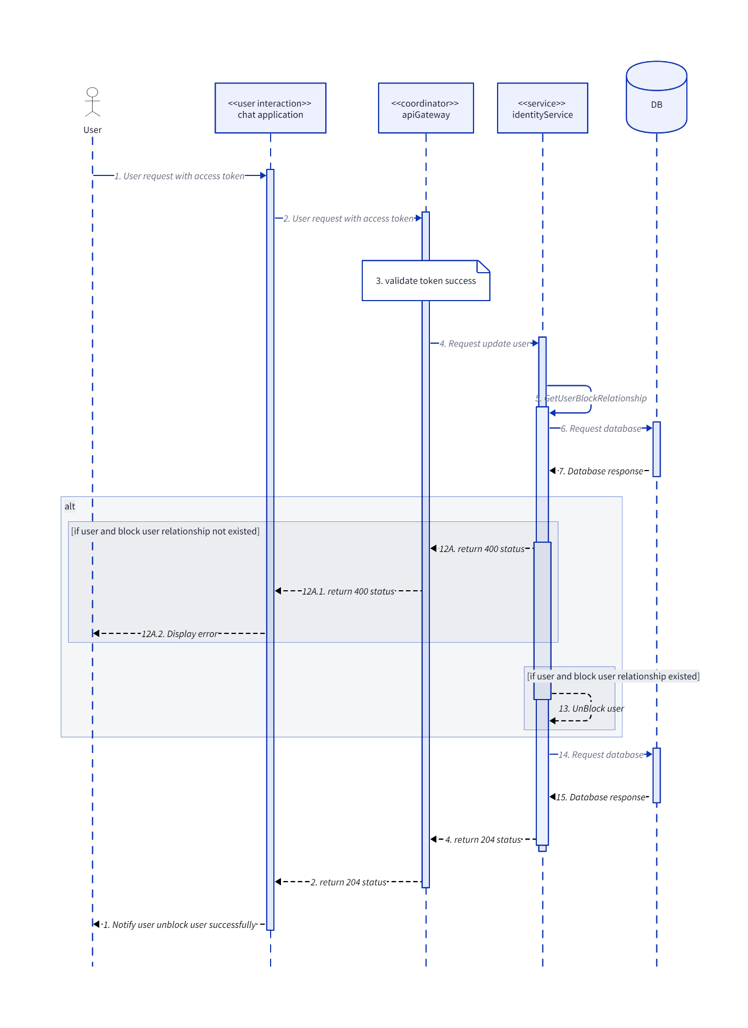

### UpdateUser

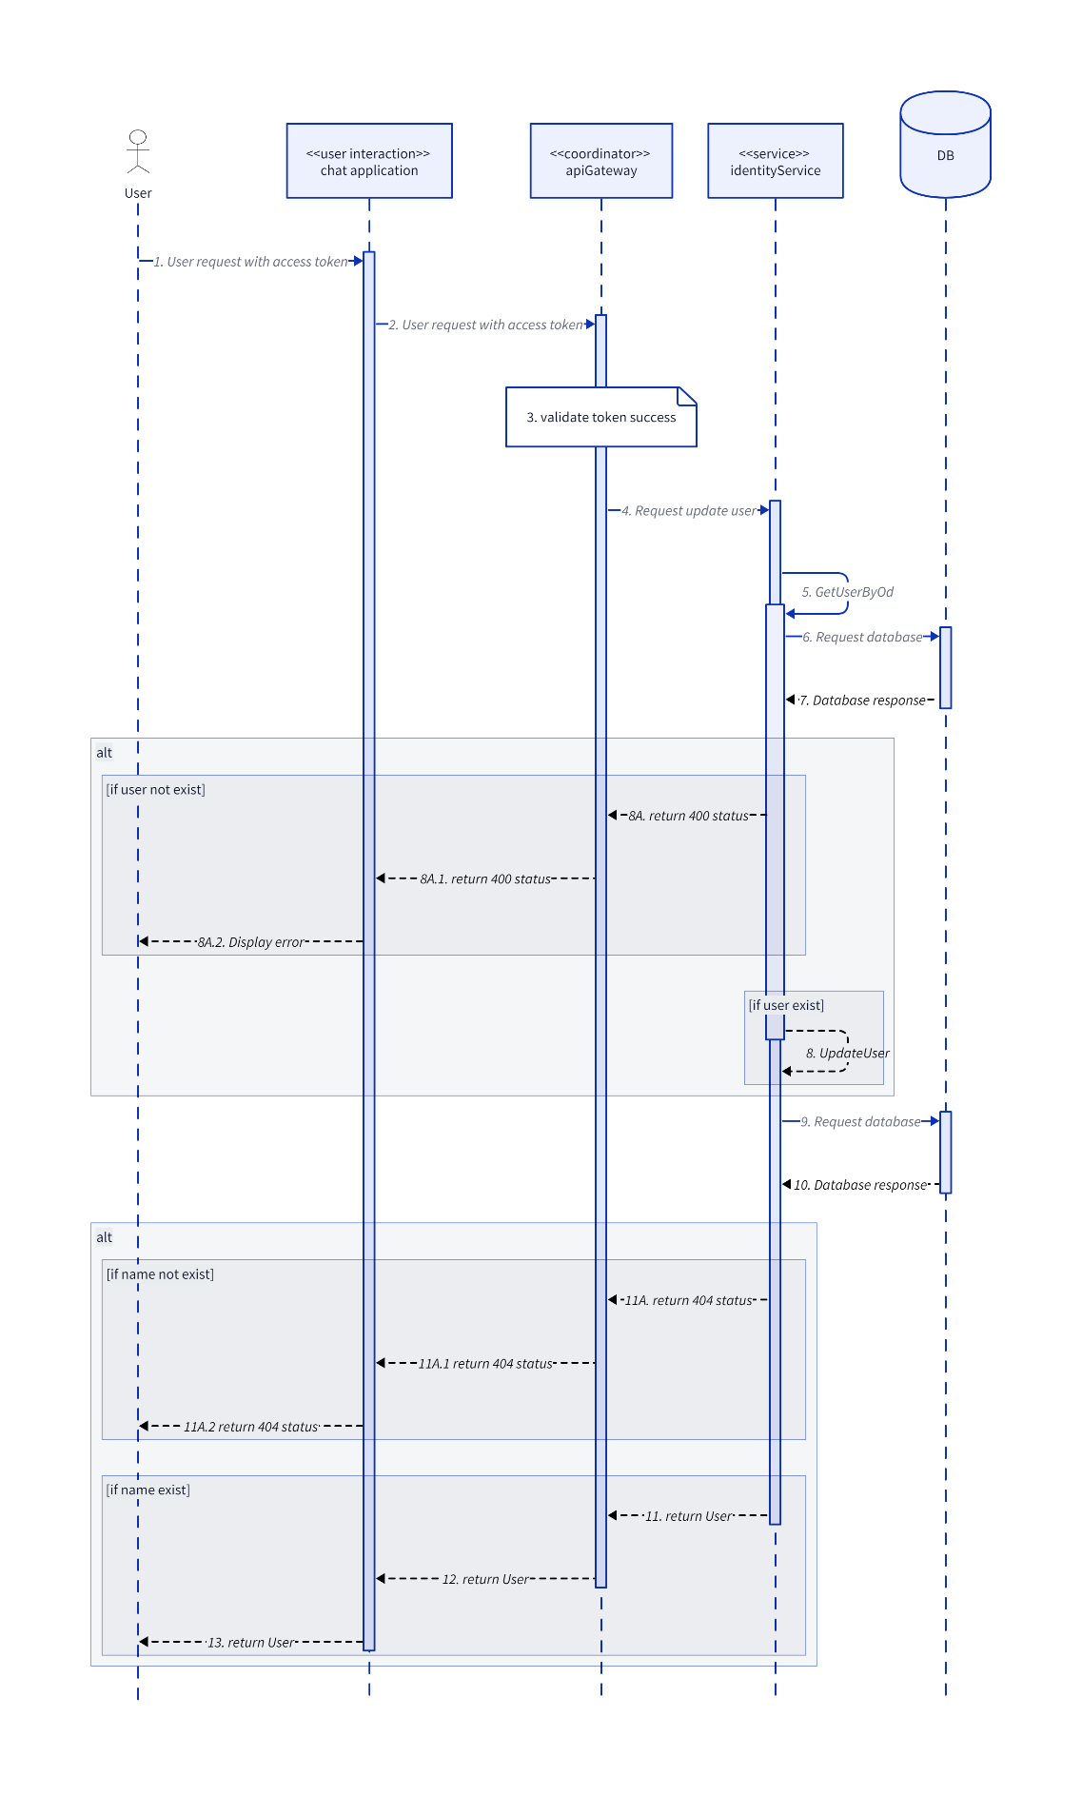

## Notification

### UpdateNotificationStatus

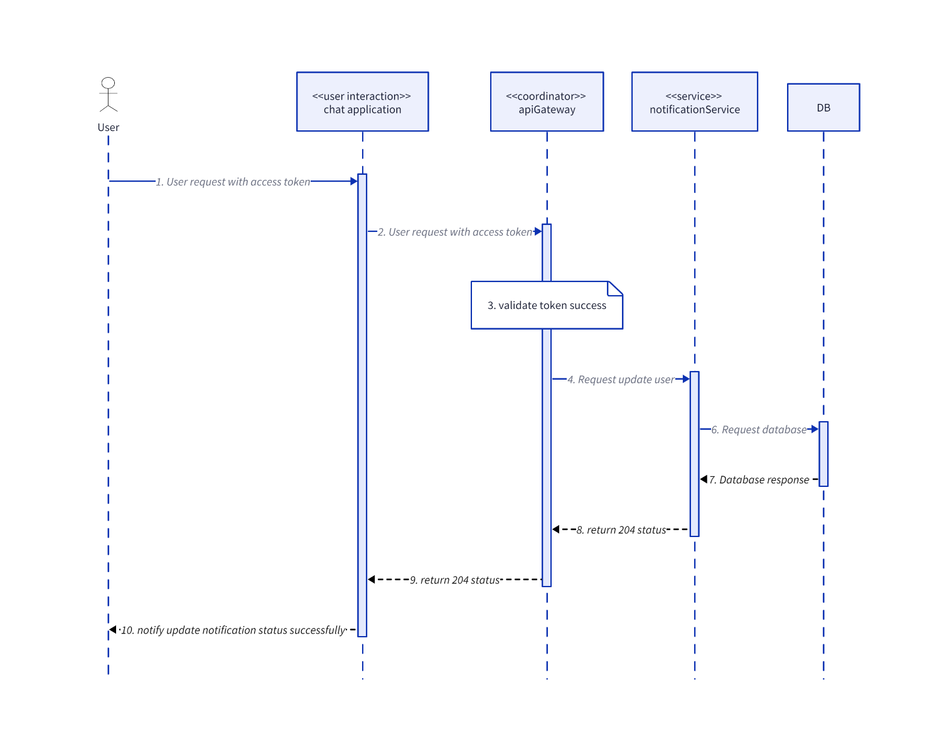

## Post

### CreateComment

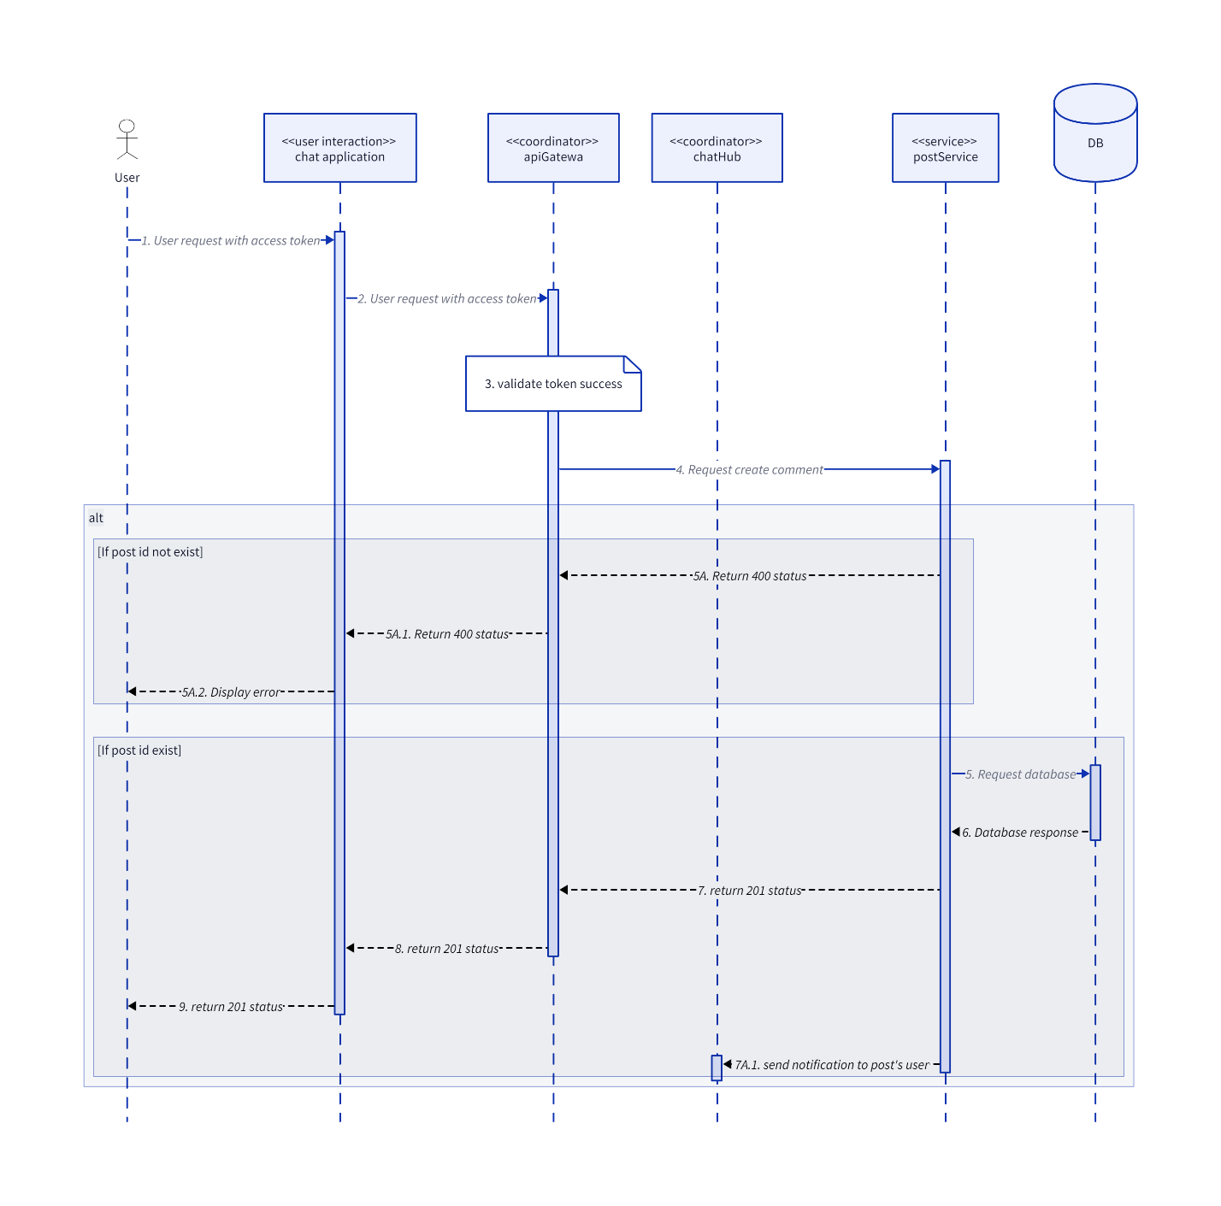

### CreateInteractionEmoji

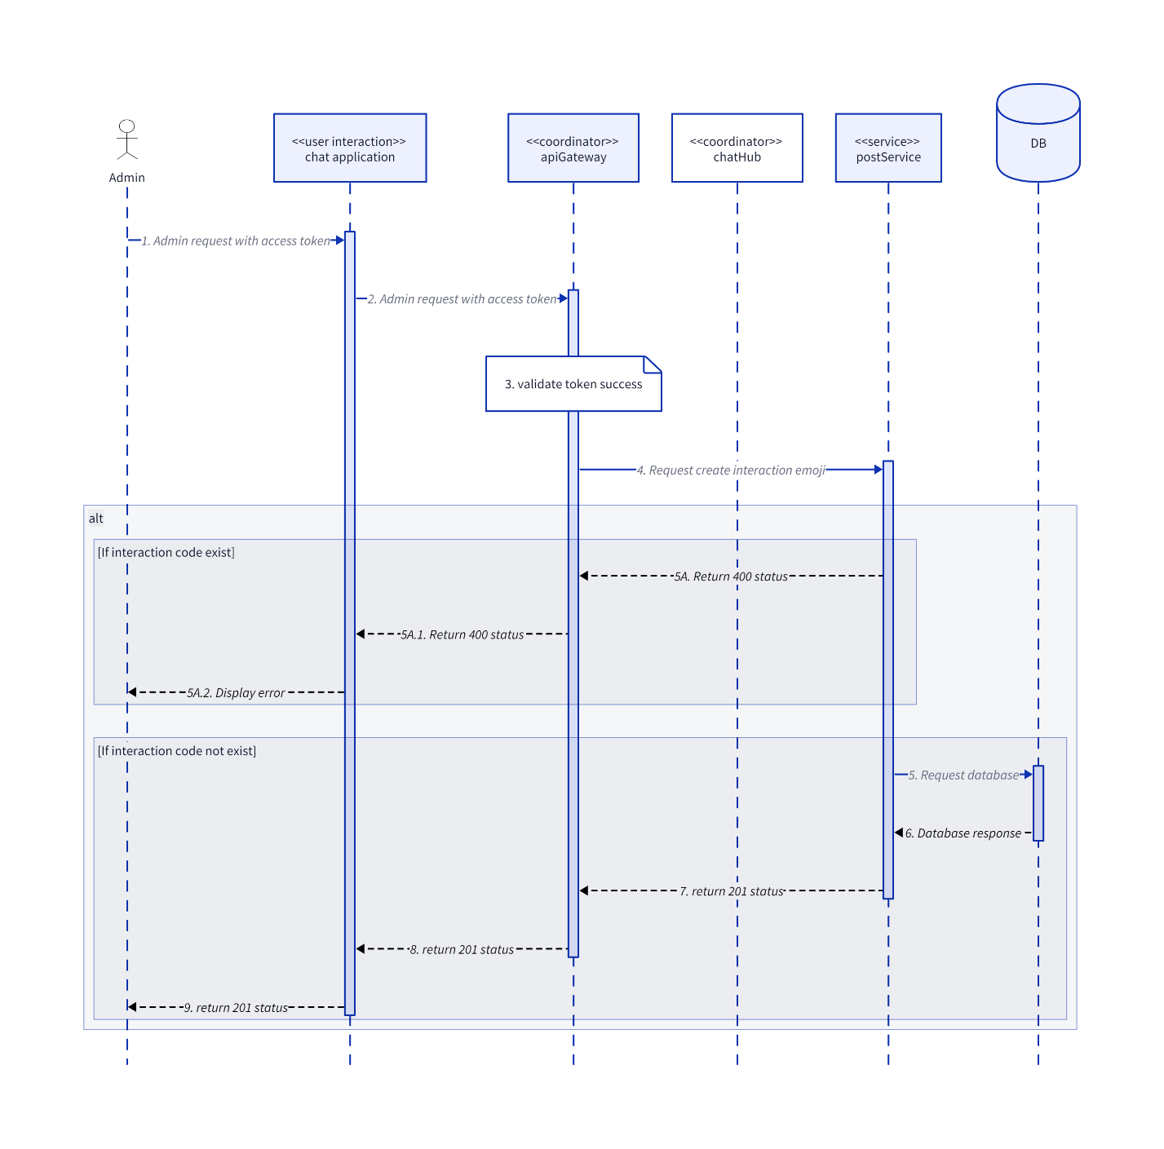

### CreatePost

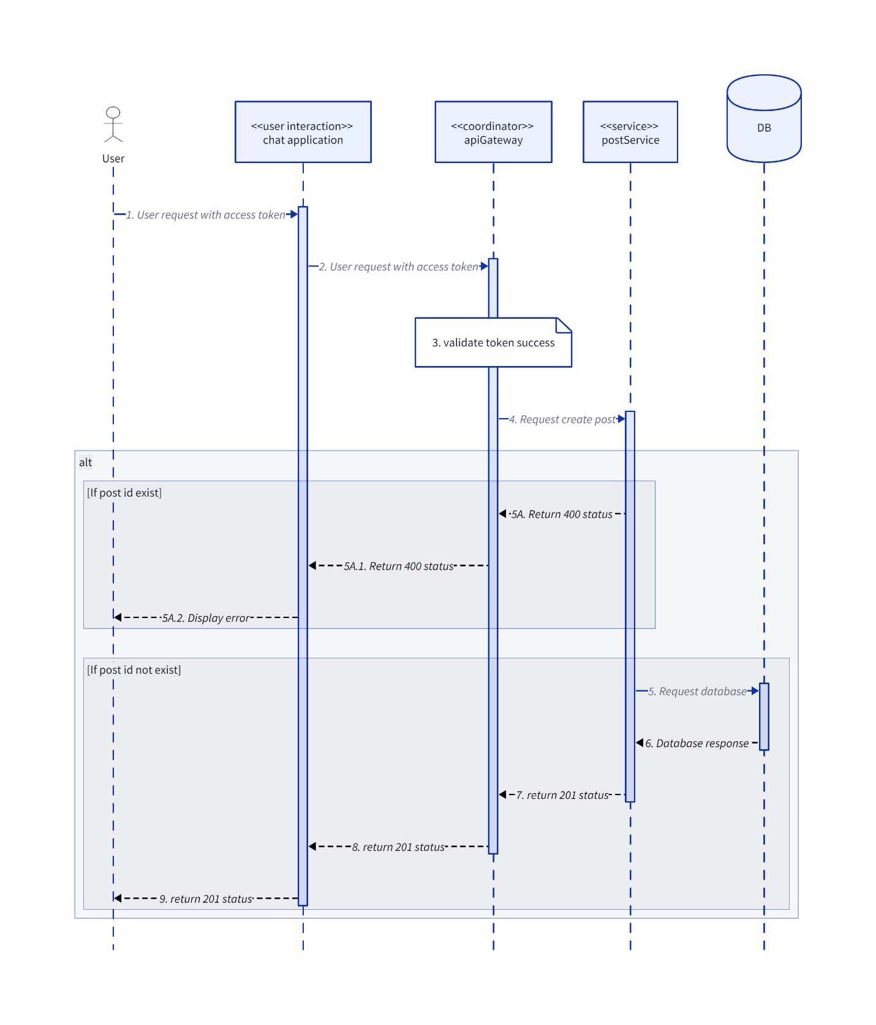

### CreatePostInteraction

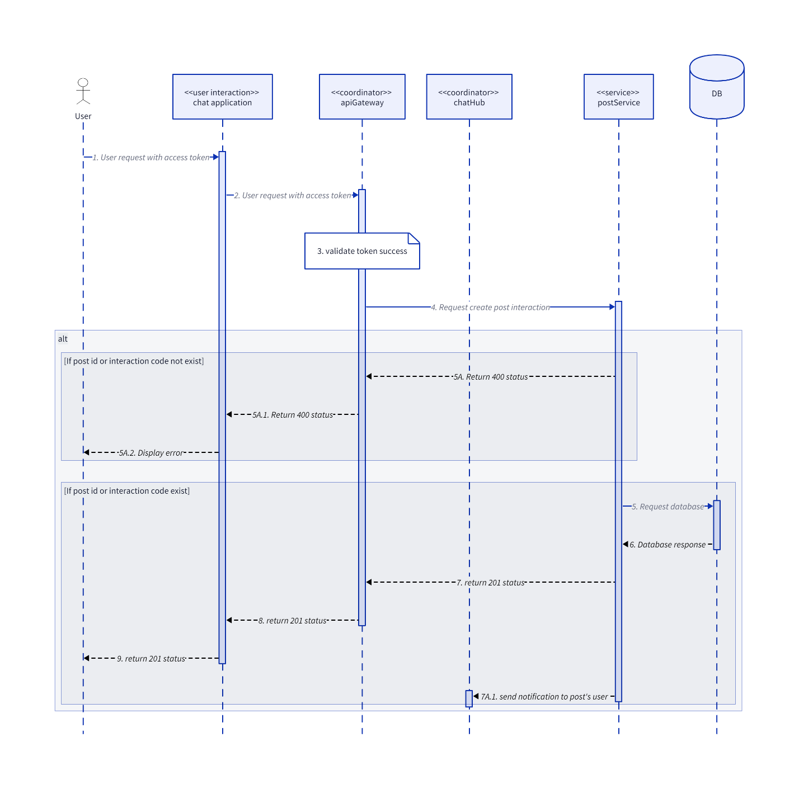

### CreatePostReport

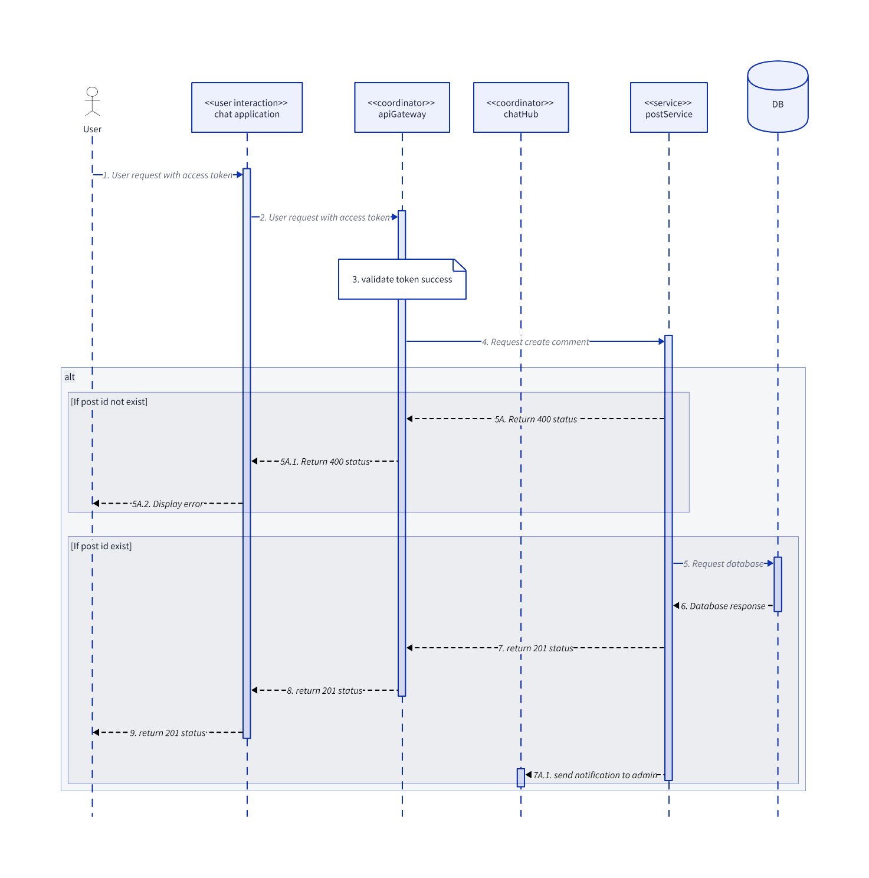

### CreateTag

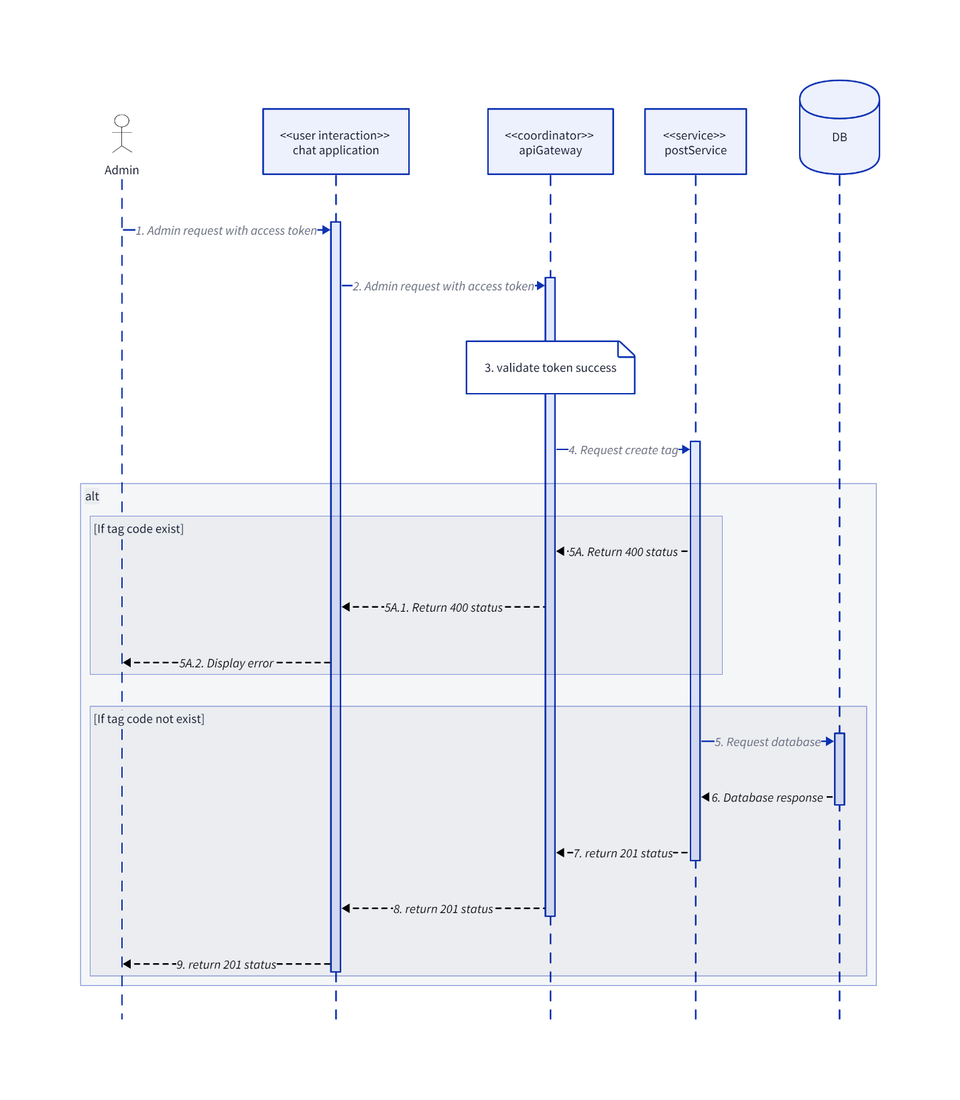

### DeleteInteractionEmoji

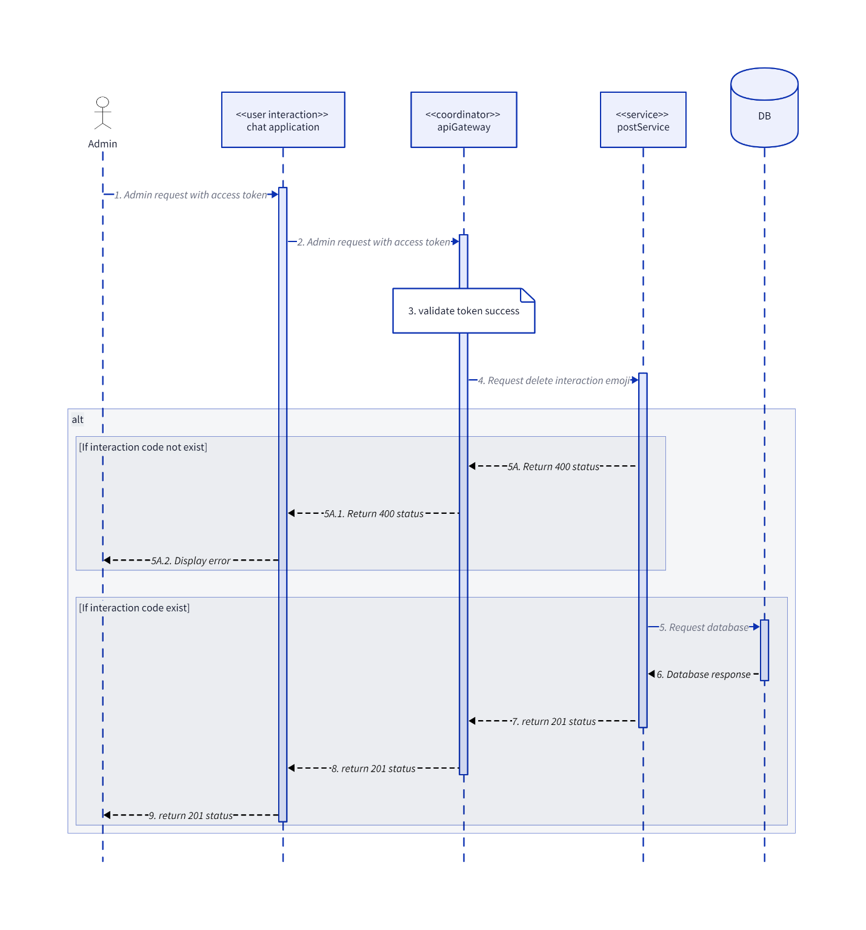

### DeleteTag

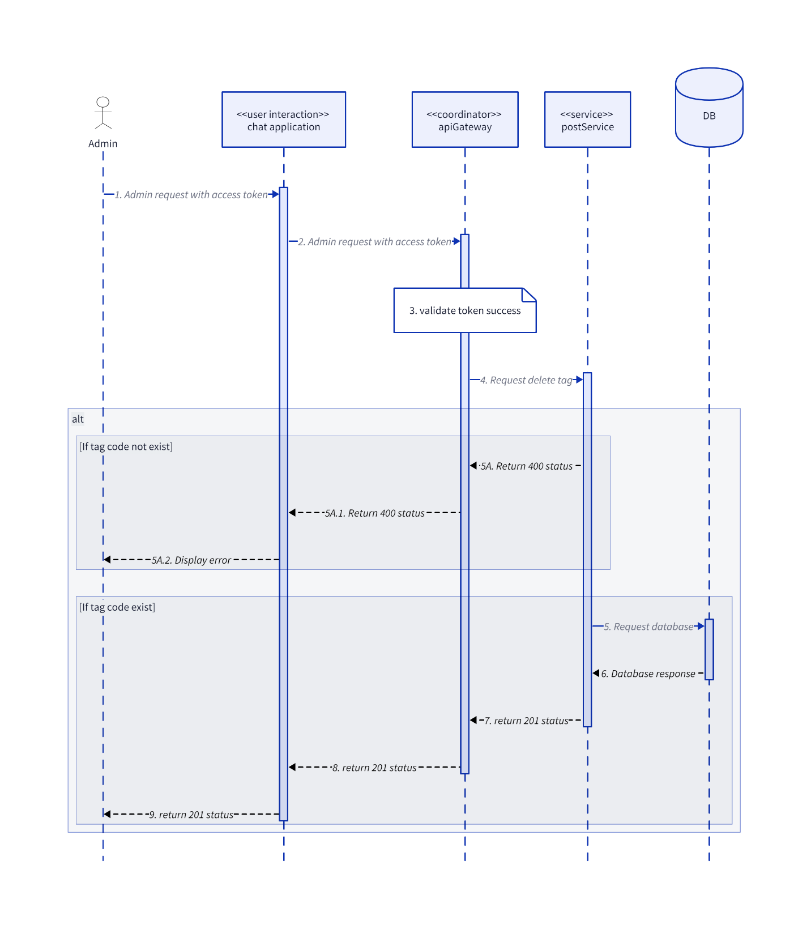

### DisablePost

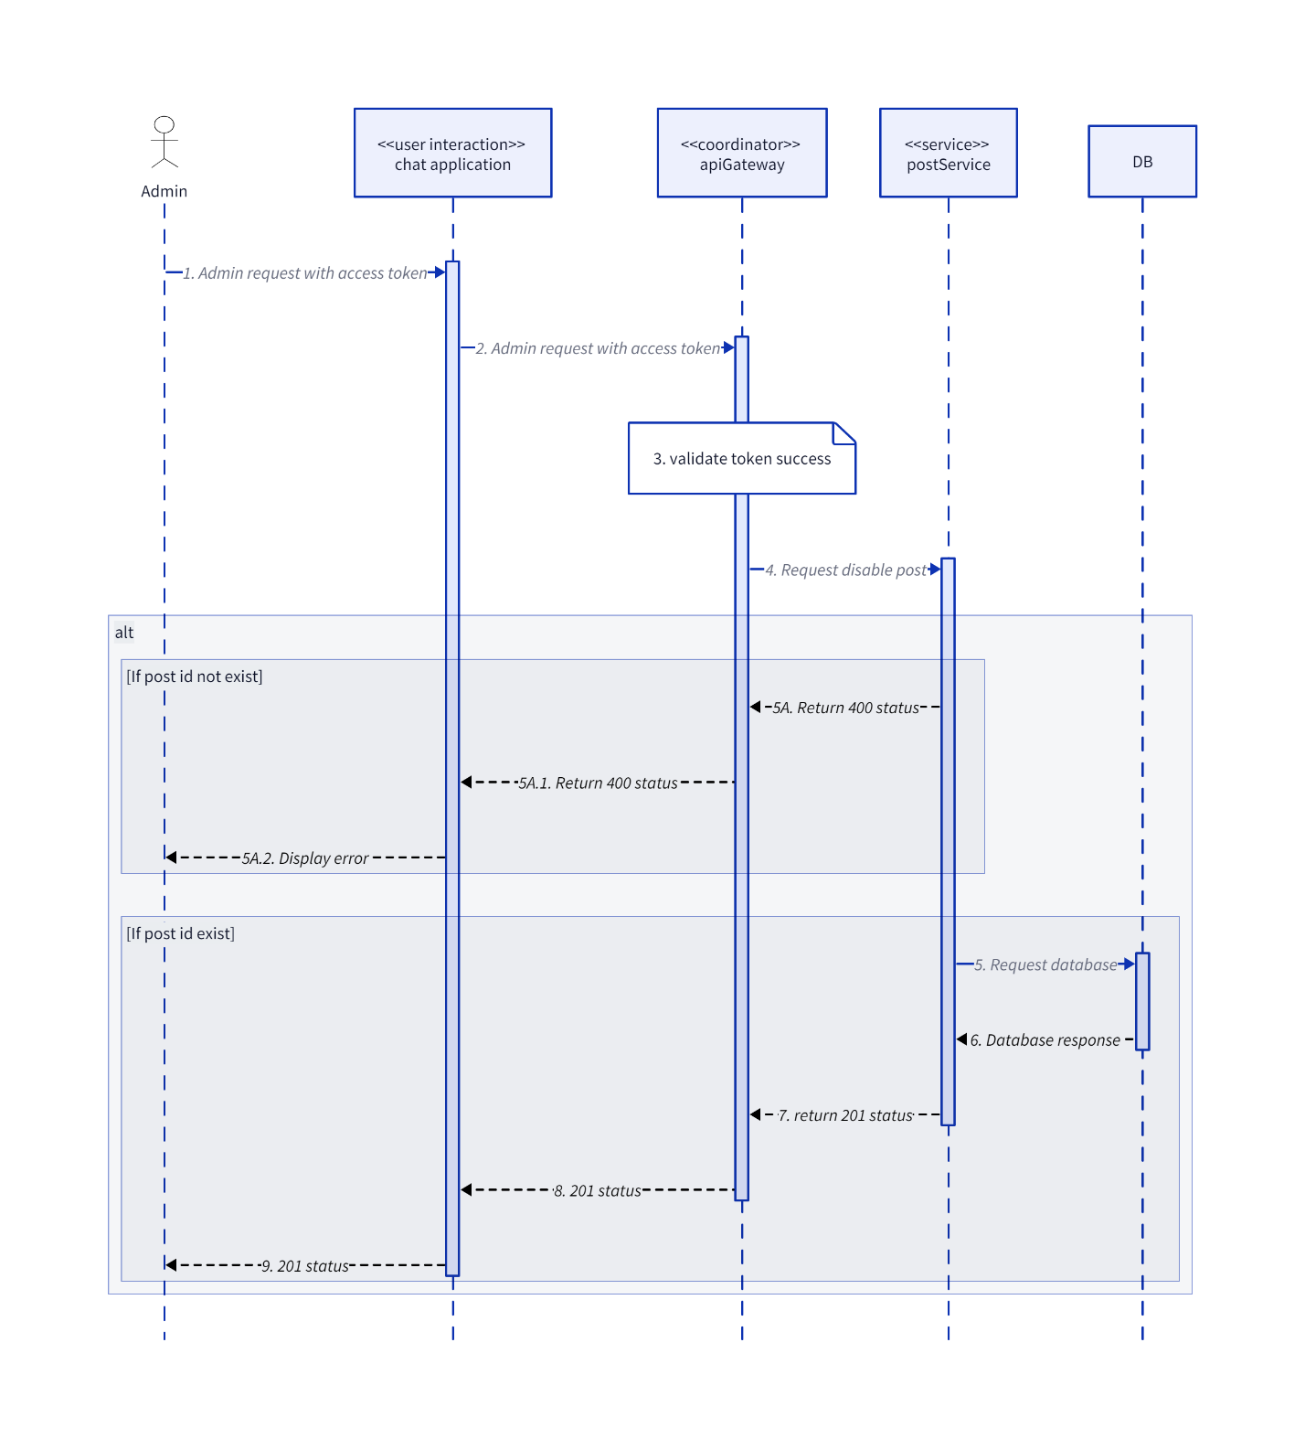

### GetListInteractionEmoji

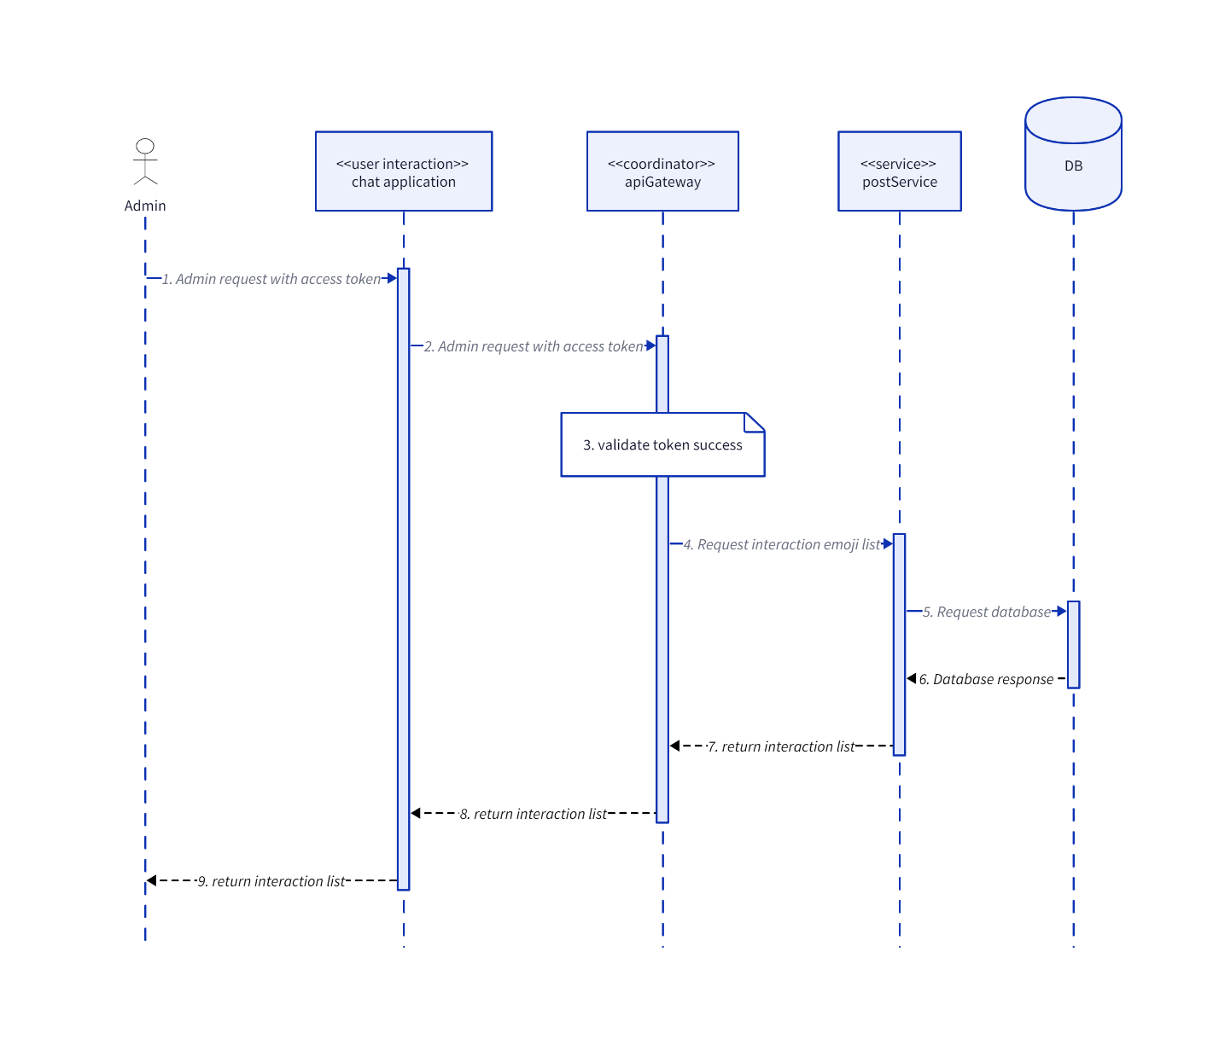

### GetPostById

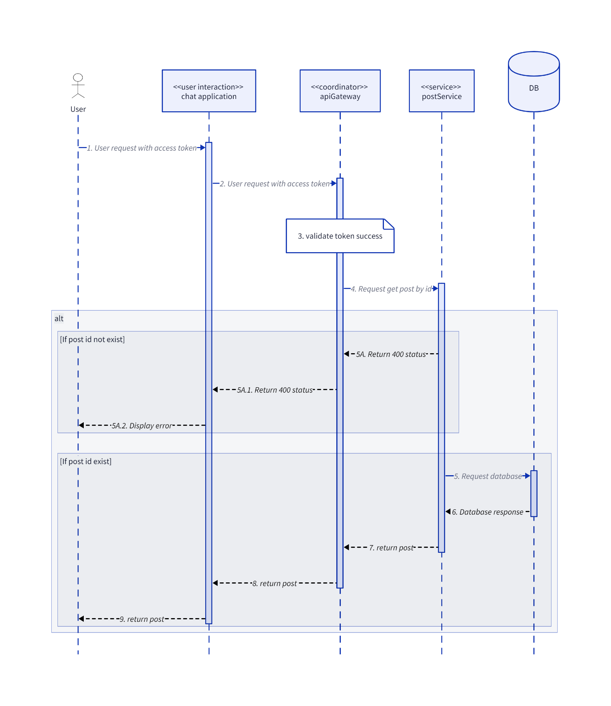

### GetReportPostList

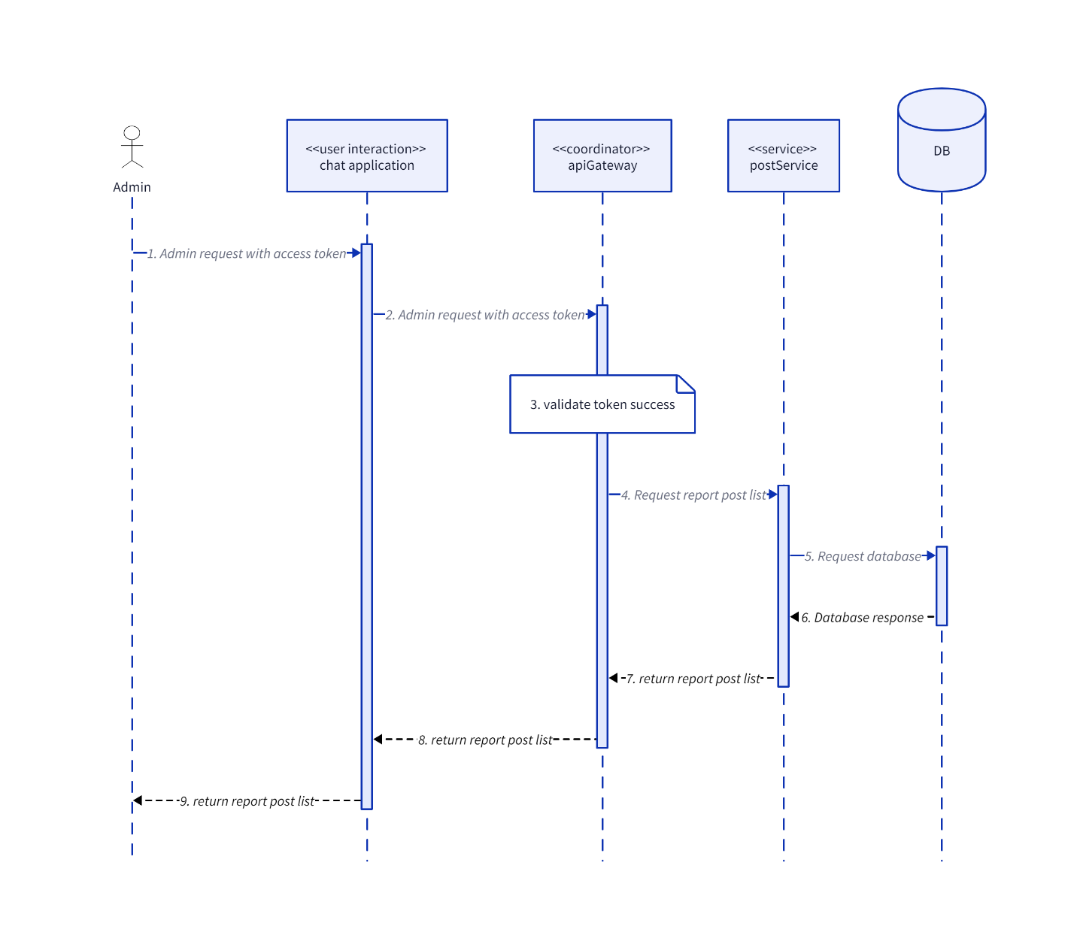

### GetTagList

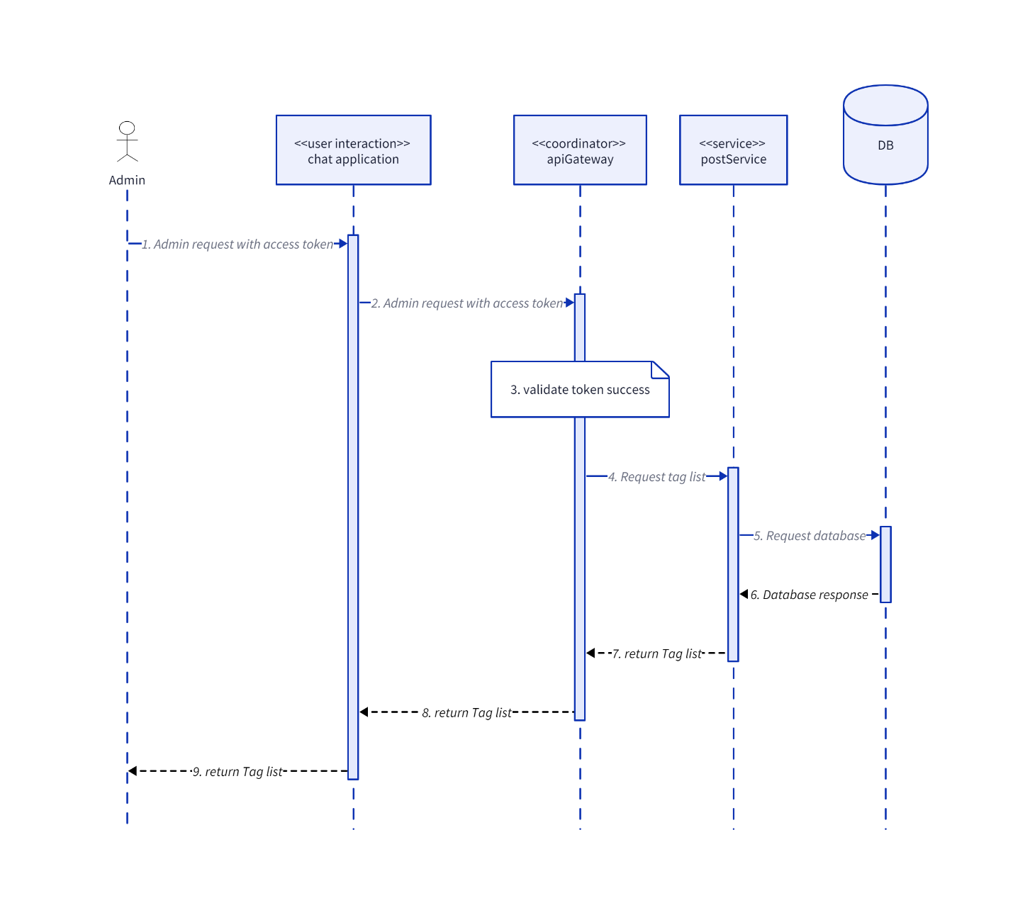

### UpdateInteractionEmoji

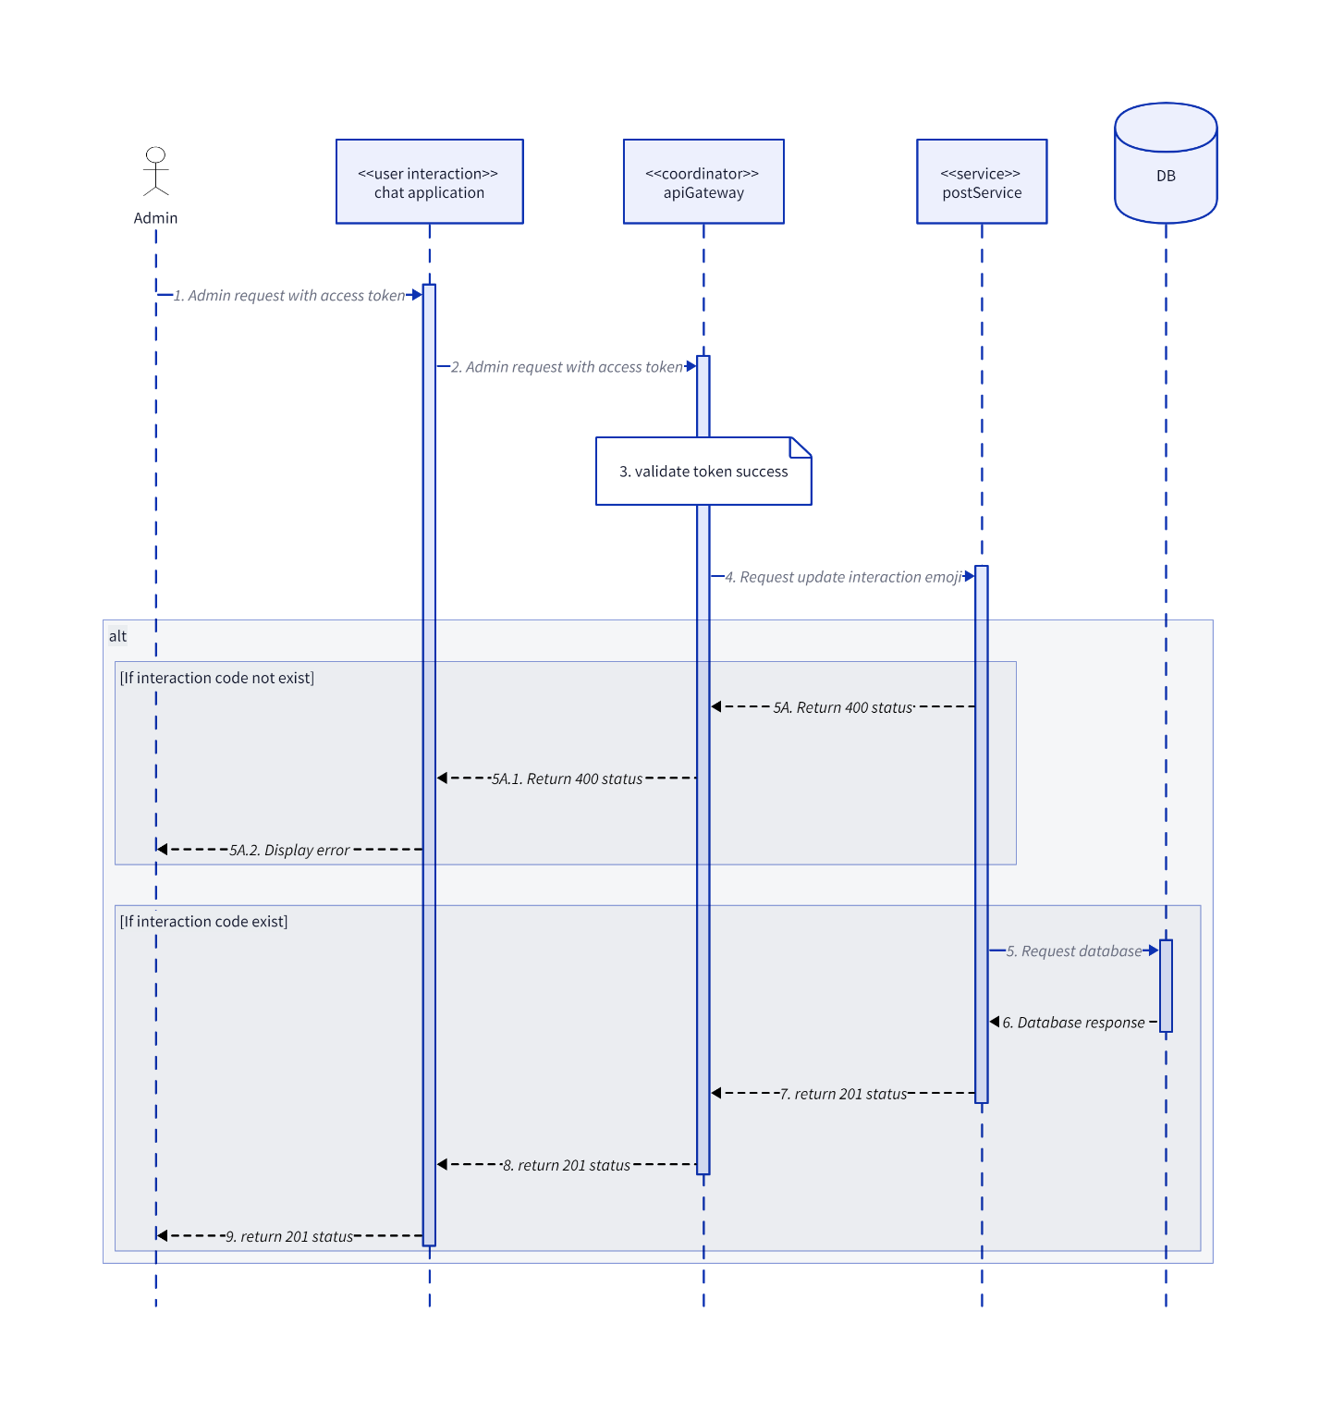

### UpdatePost

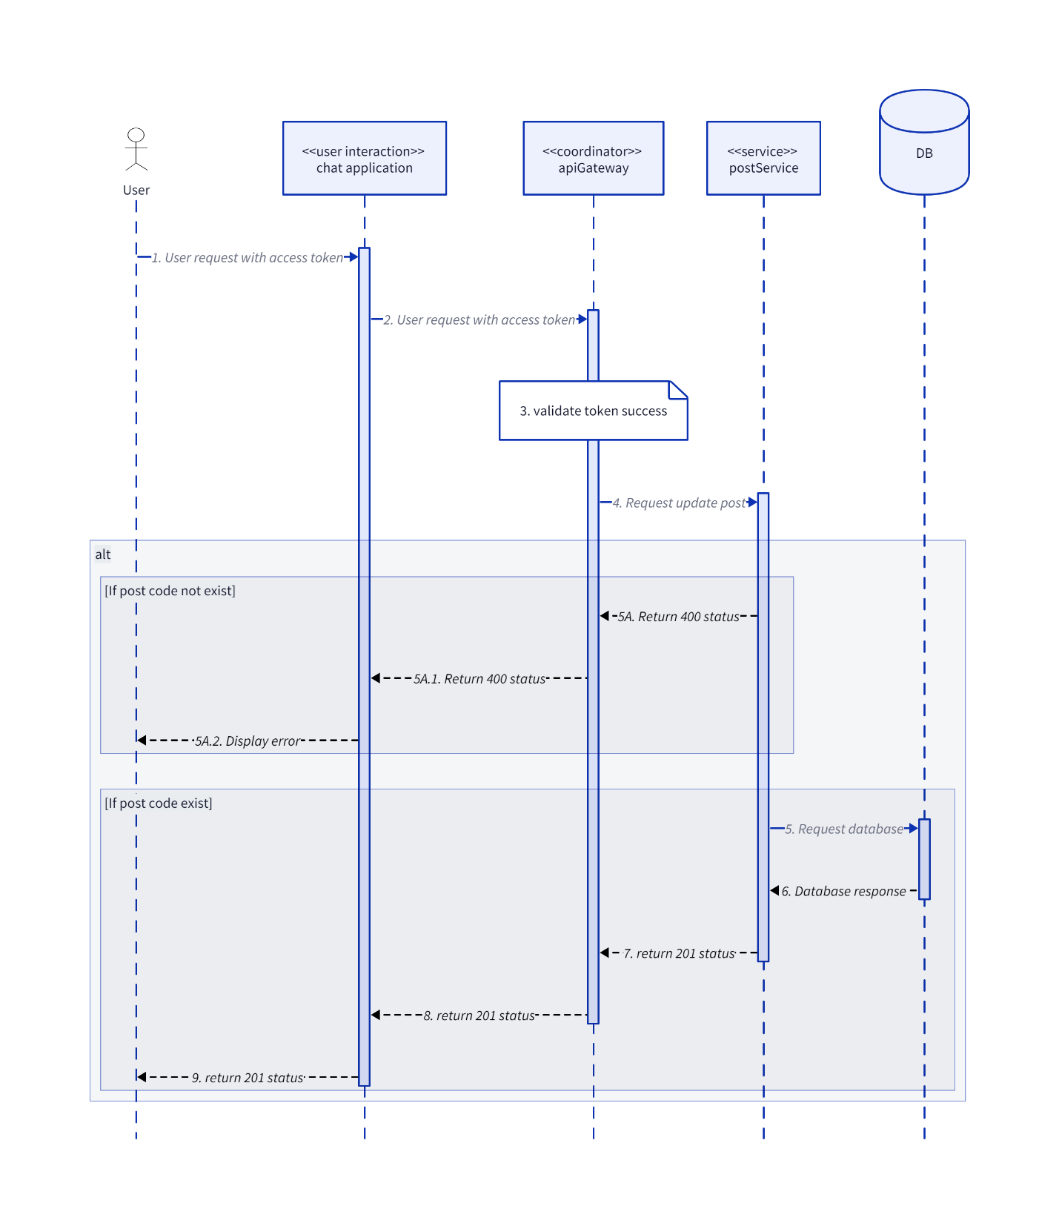

### UpdateTag

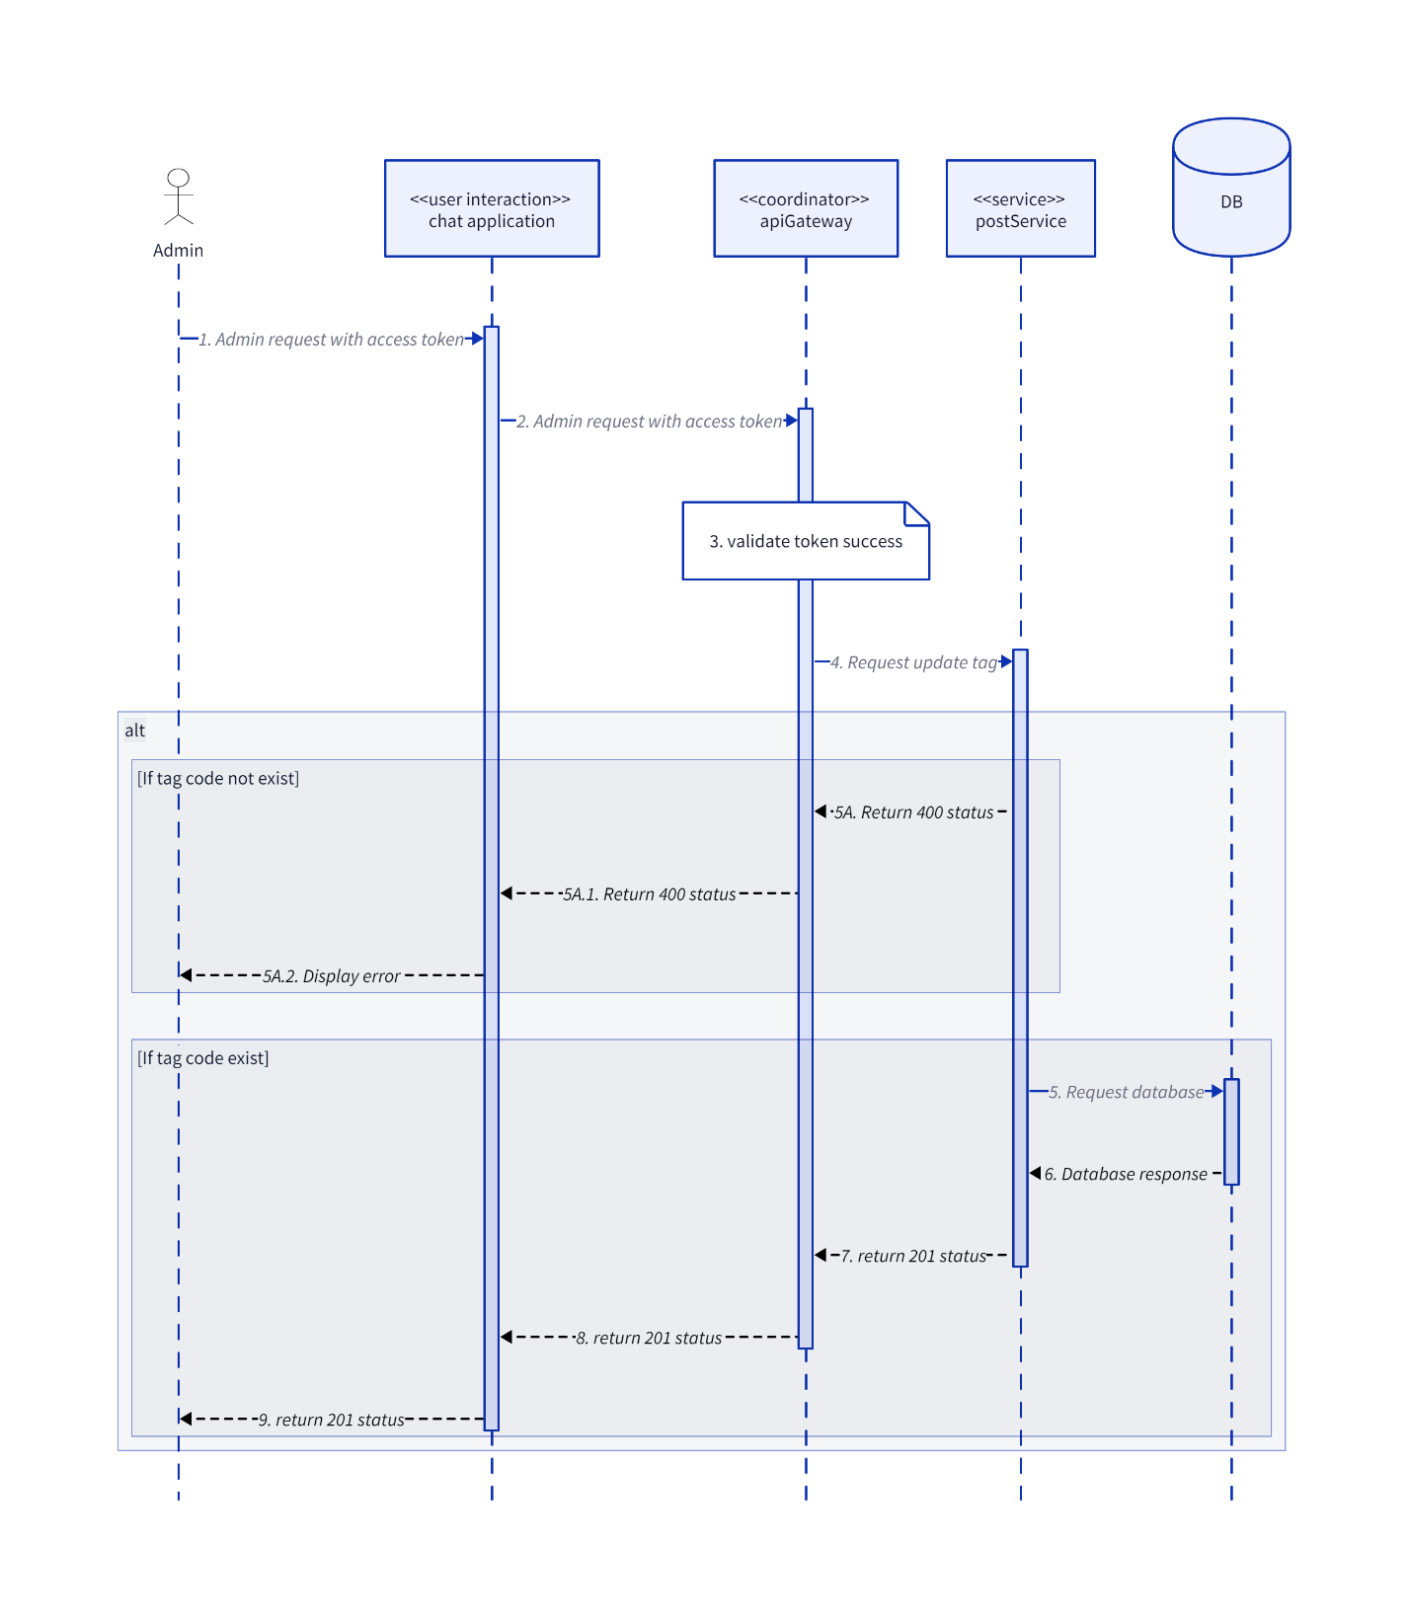

## Websocket

### Call

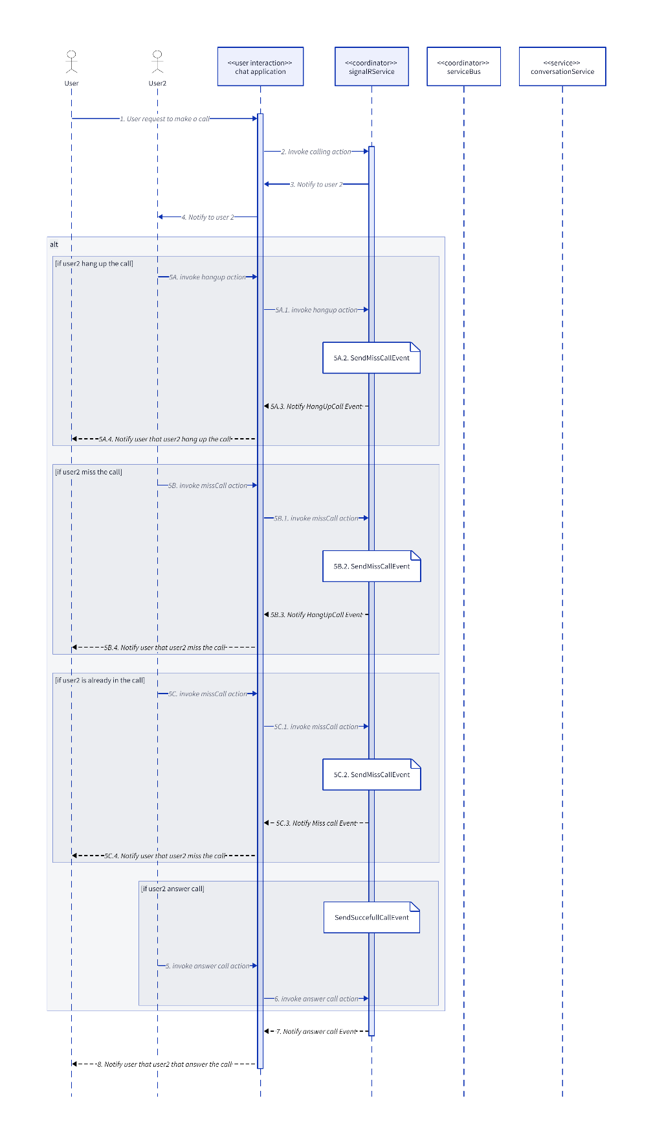

### SendCallEventMessageToClient

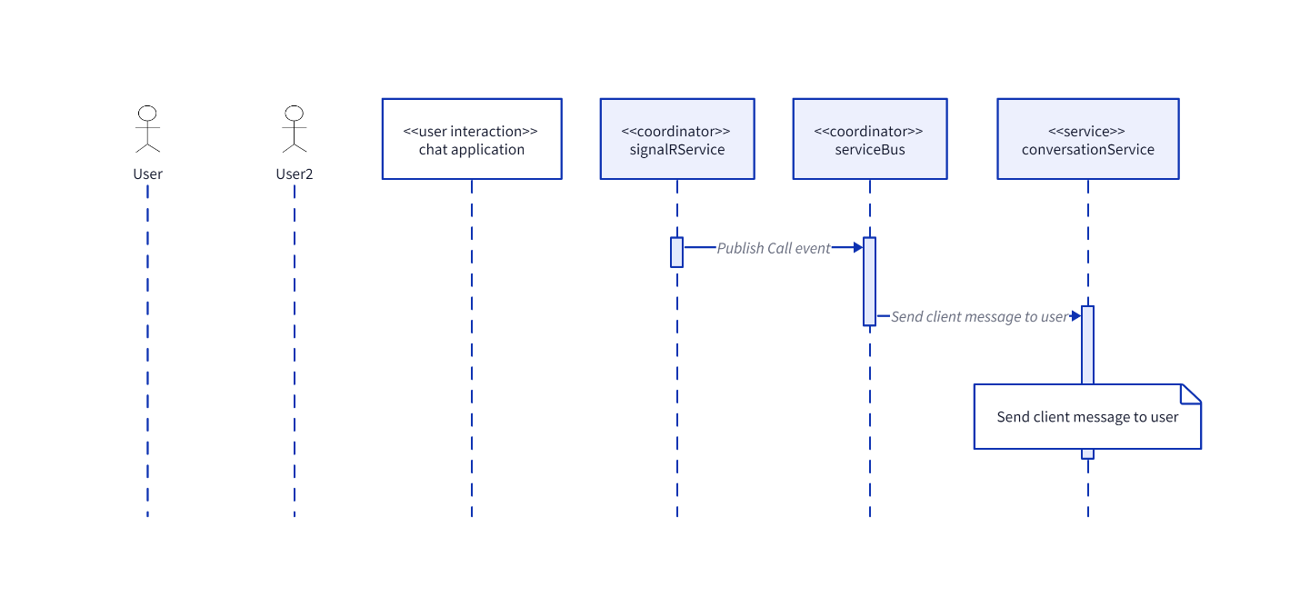

1. **Architecture Diagram**

- Independent deployment and scaling: Each feature can be deployed and scaled separately.

- Enhanced fault isolation: Failures in one service don't impact others.

- Technology diversity: Various languages for each component.

- Streamlined development and maintenance: Teams can work on individual services independently.

- Faster innovation: Enables quicker updates and new feature implementations.

- Higher availability and reliability: Ensures a more resilient and stable application.

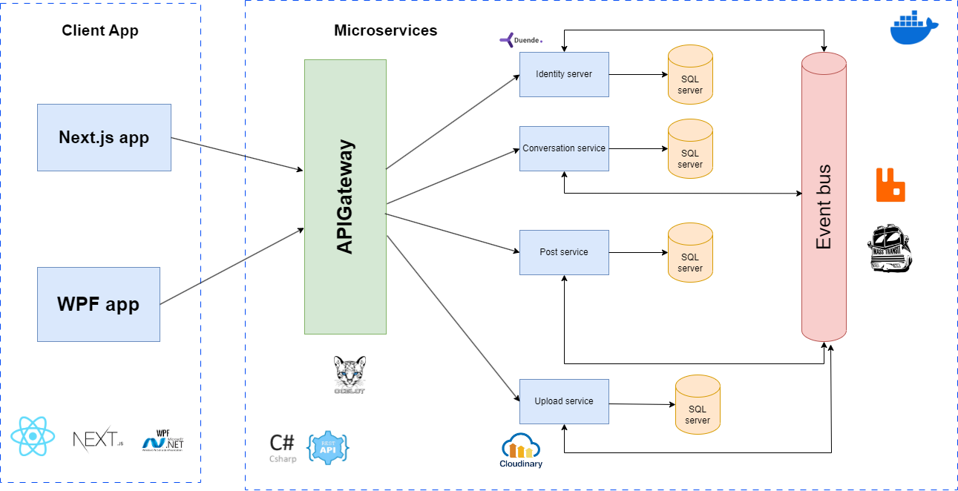

1. **Subsystem Diagram**
   1. **High Level**

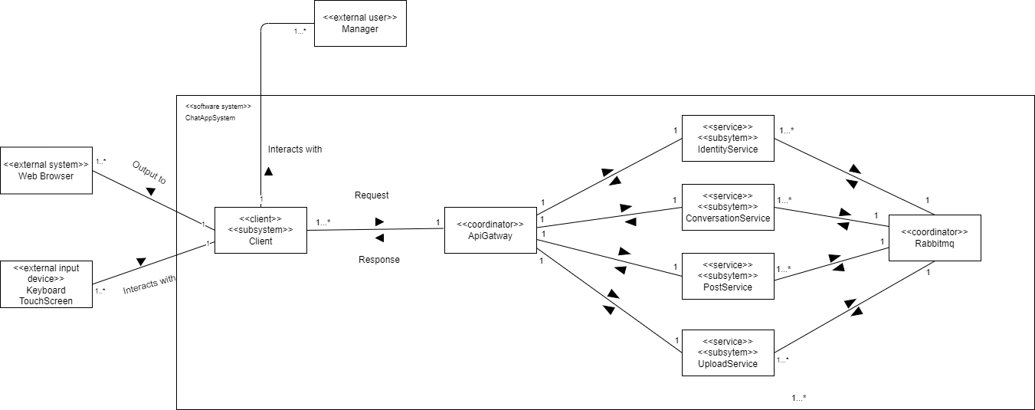

* 1. **Identity**

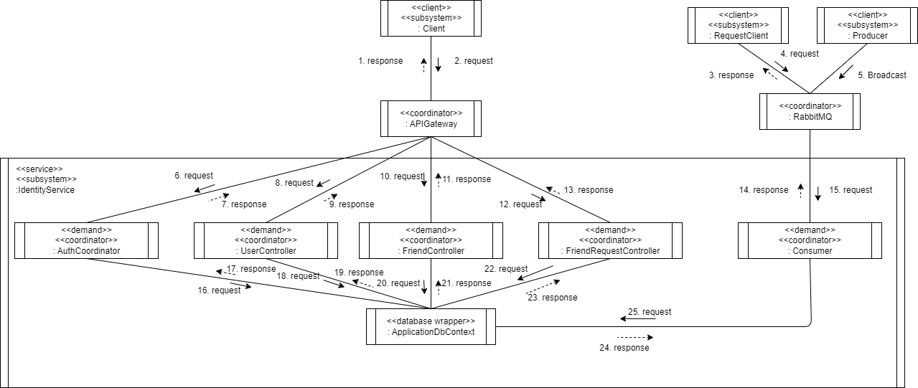

* 1. **Conversation**

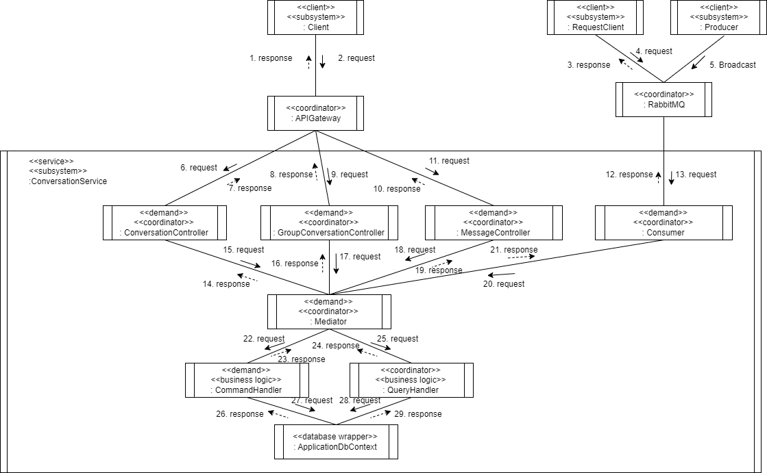

* 1. **Upload**

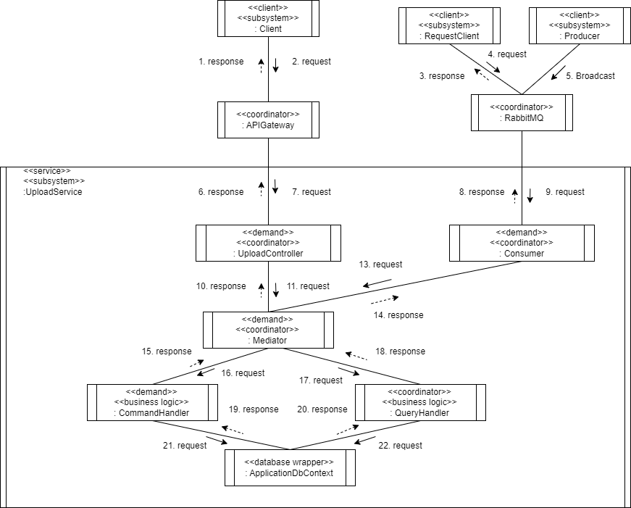

* 1. **Post**

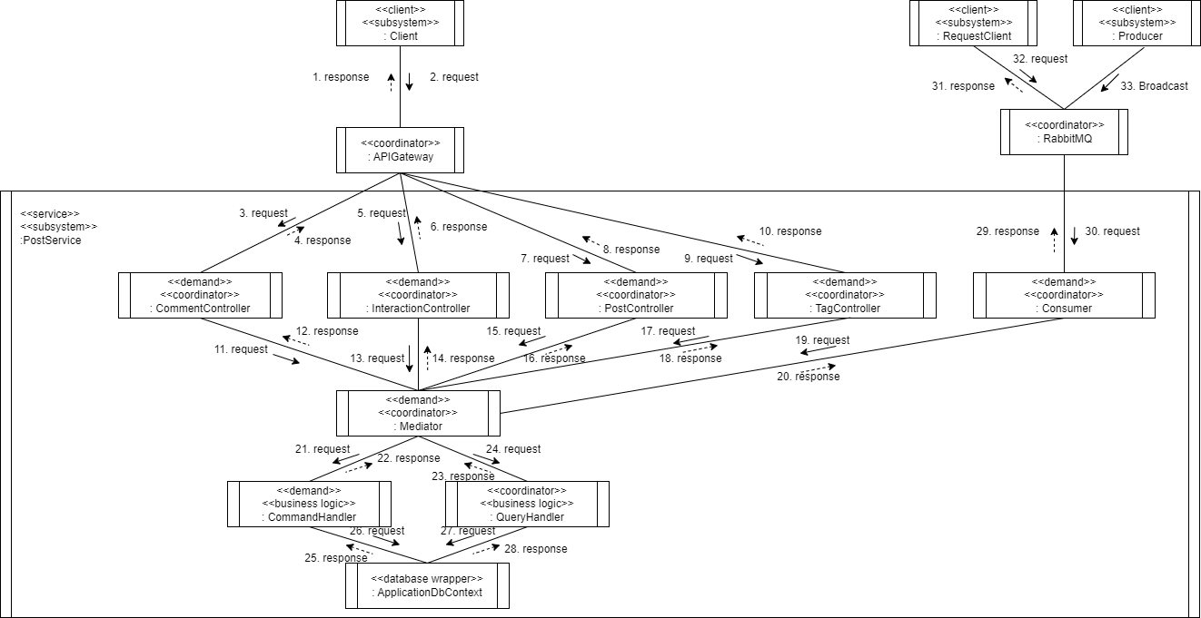

1. **Class Diagram**
   1. **Identity**
      1. **Accept Friend Request**

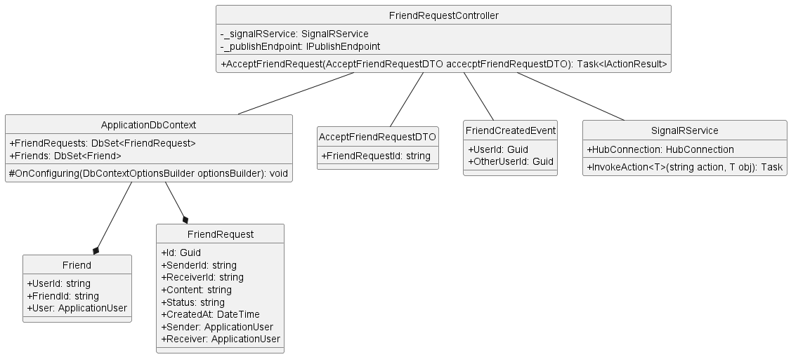

* + 1. **Block User**

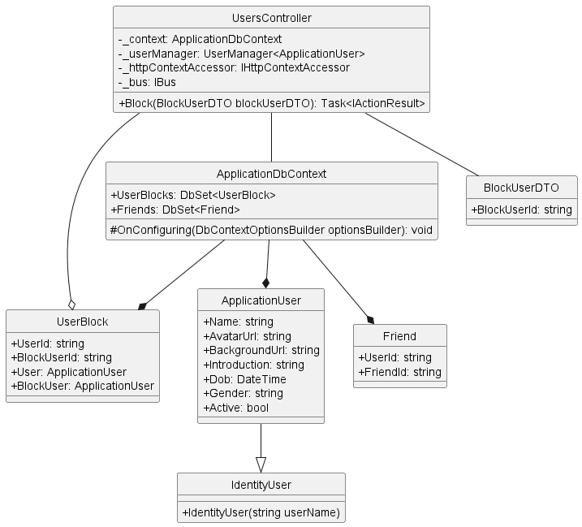

* + 1. **Delete Friend**

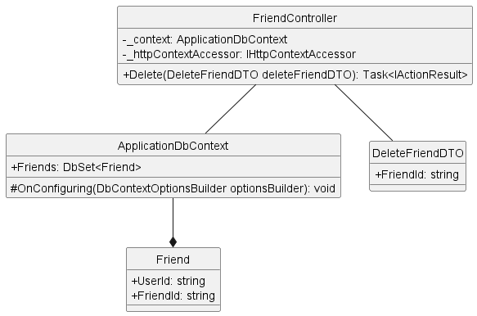

* + 1. **Delete Friend Request**

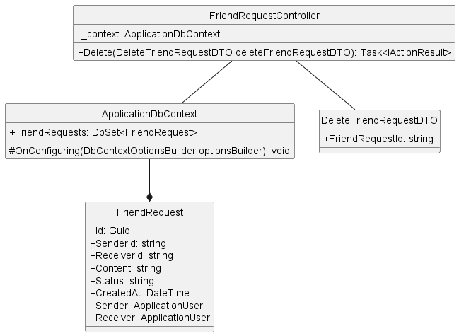

* + 1. **Get Friend List By User Id**

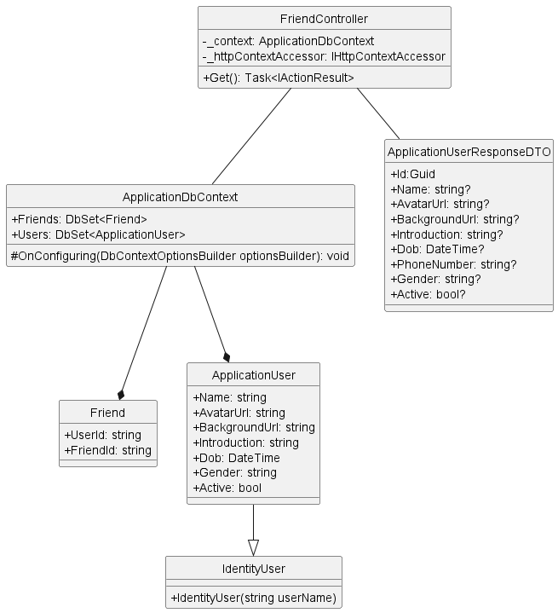

* + 1. **Get Friend Request List**

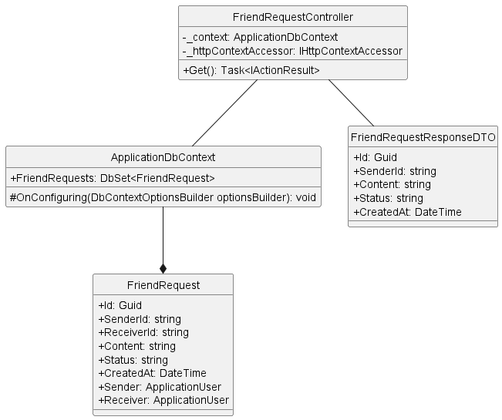

* + 1. **Get User By Id**

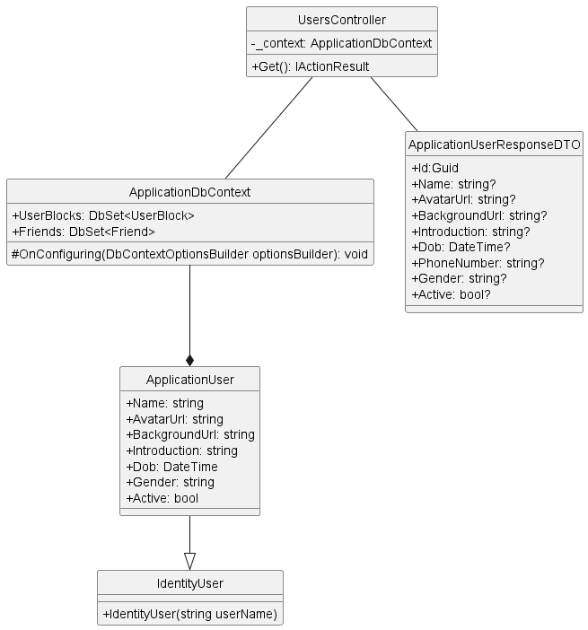

* + 1. **Login**

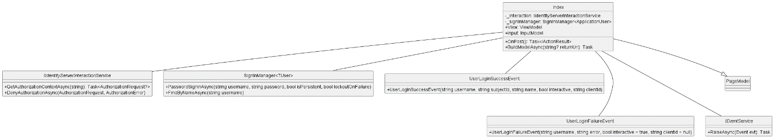

* + 1. **Register**

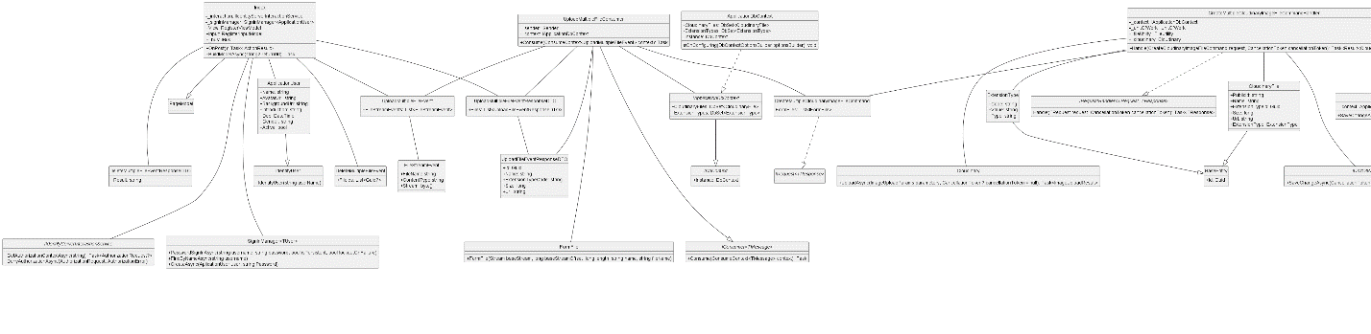

* + 1. **Search User**

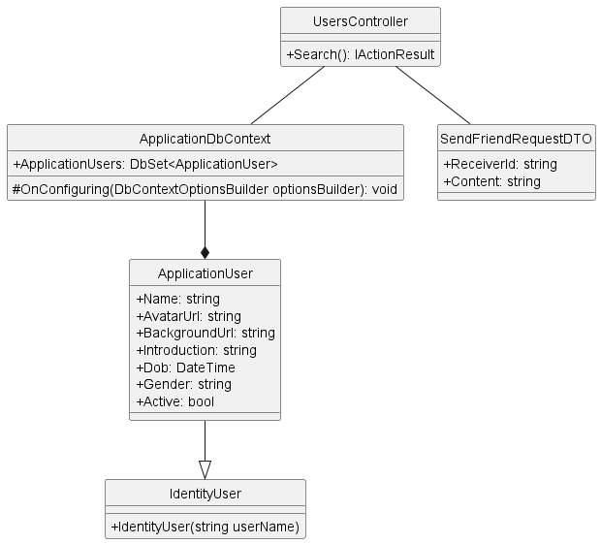

* + 1. **Send Friend Request**

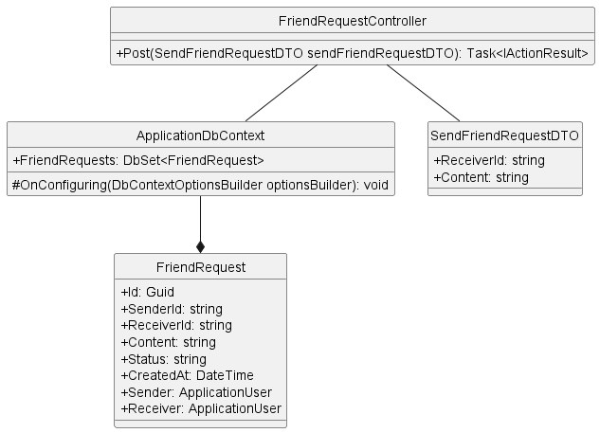

* + 1. **Unblock User**

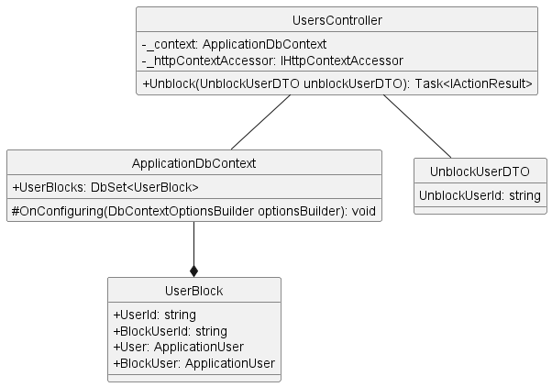

* + 1. **Update User**

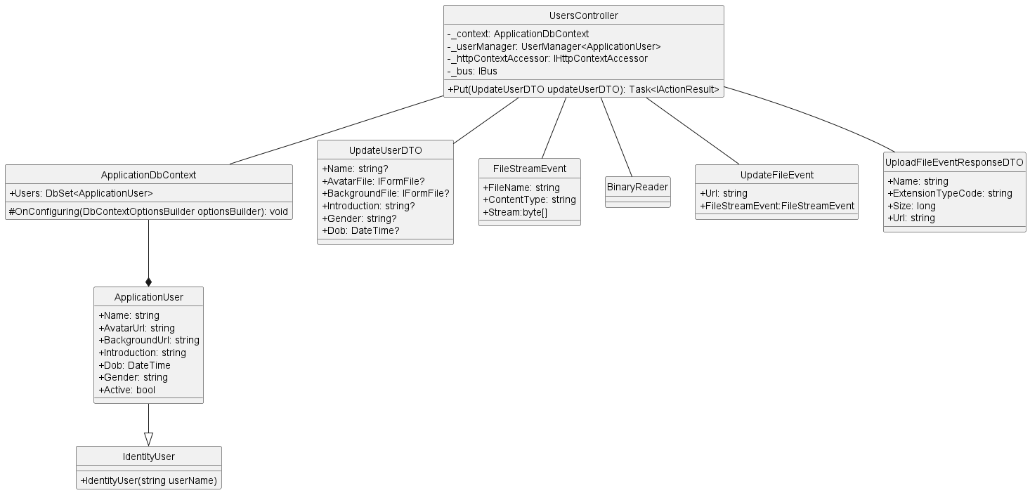

* 1. **Conversation**
     1. **Create Group Conversation**

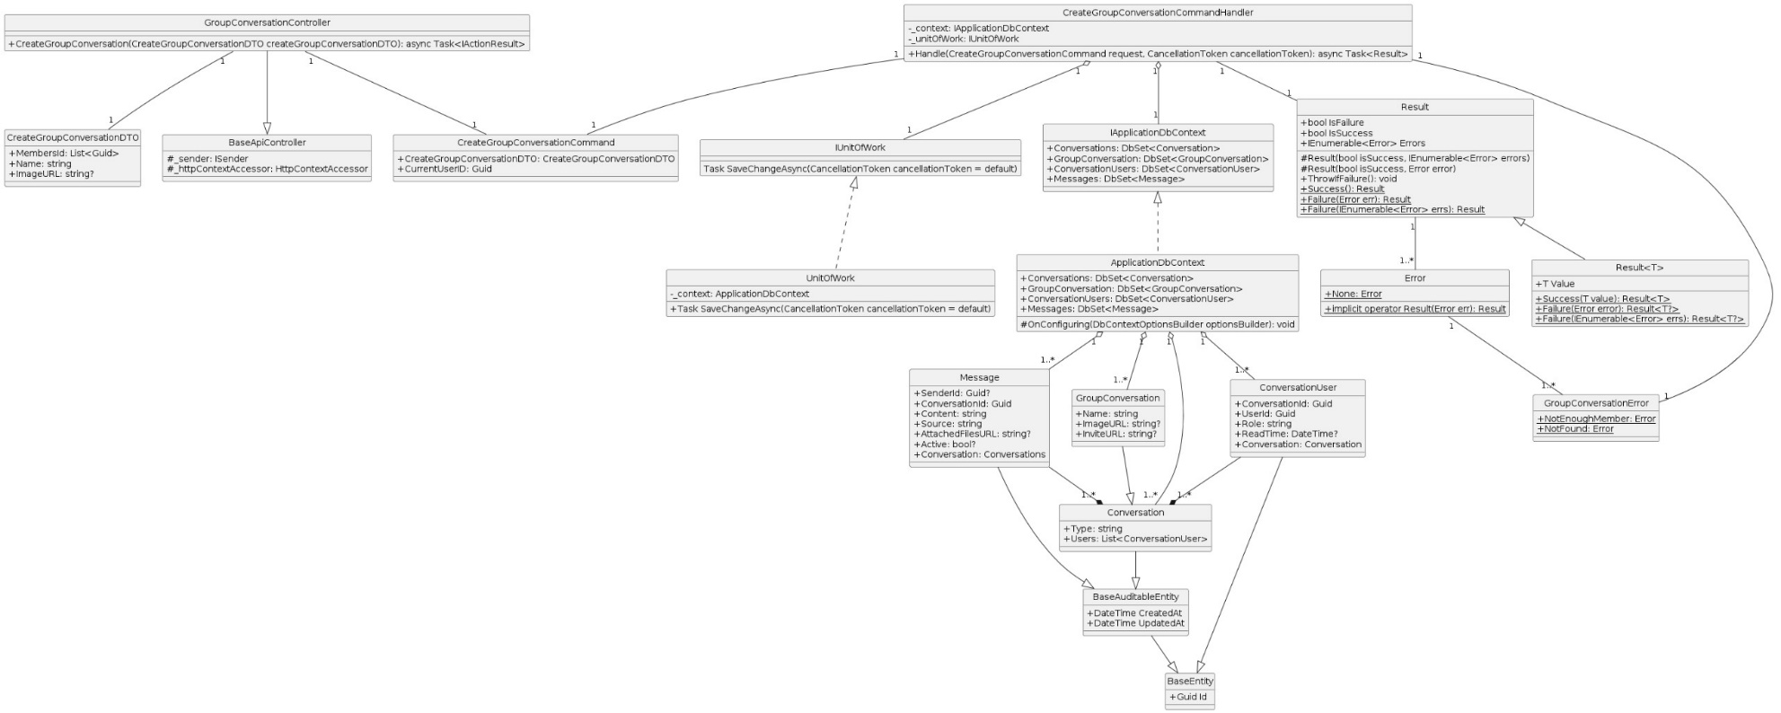

* + 1. **Delete Conversation**

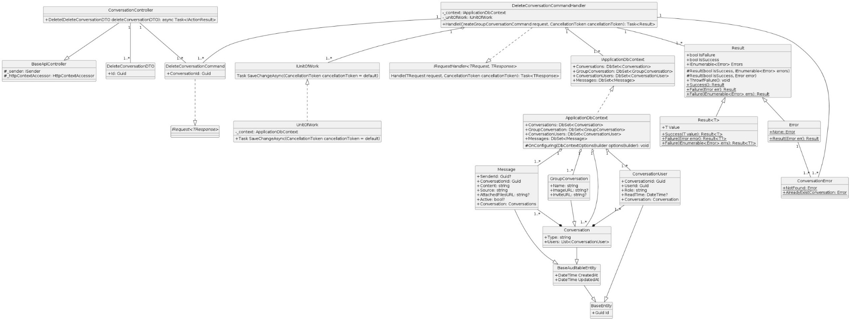

* + 1. **Get All**

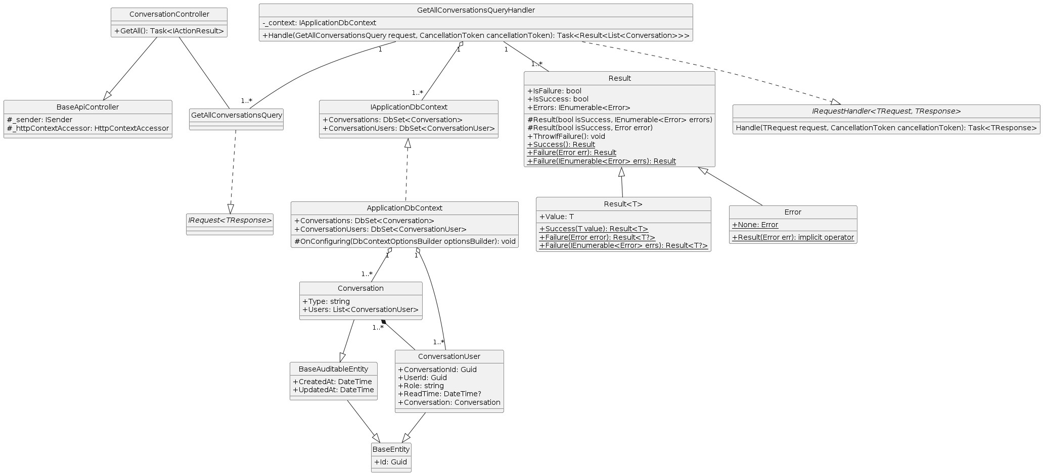

* + 1. **Get By Id**

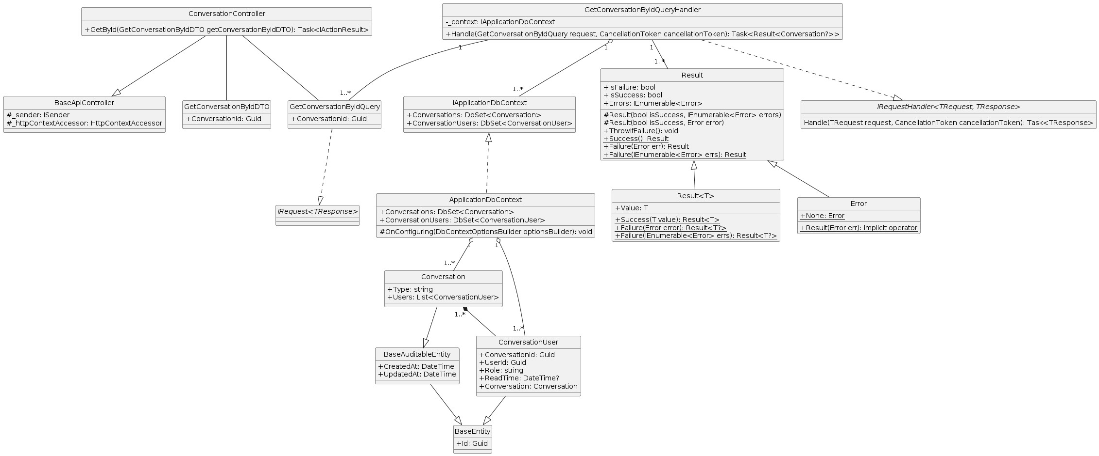

* + 1. **Get Conversation List By User Id**

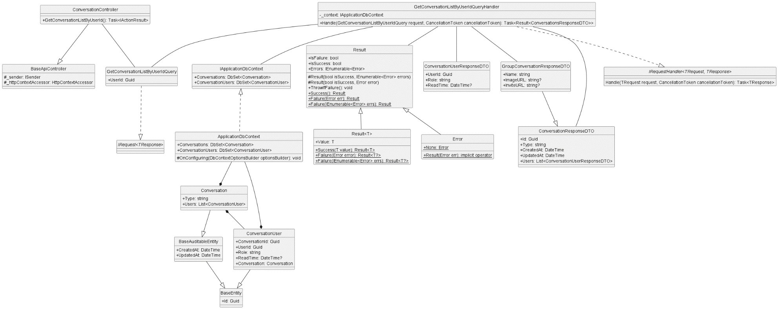

* + 1. **Get Member List By Conversation Id**

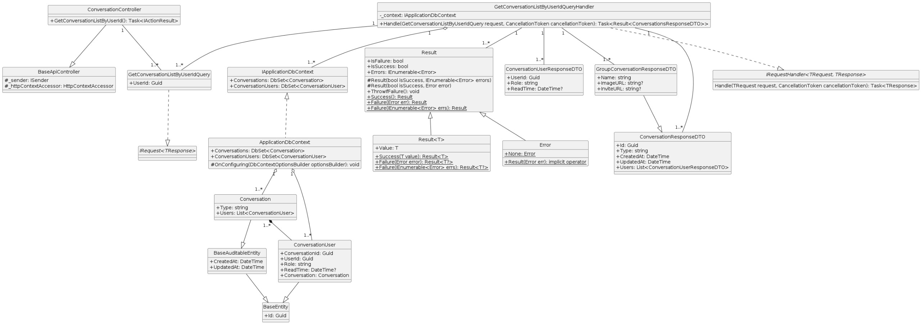

* + 1. **Group Add User**

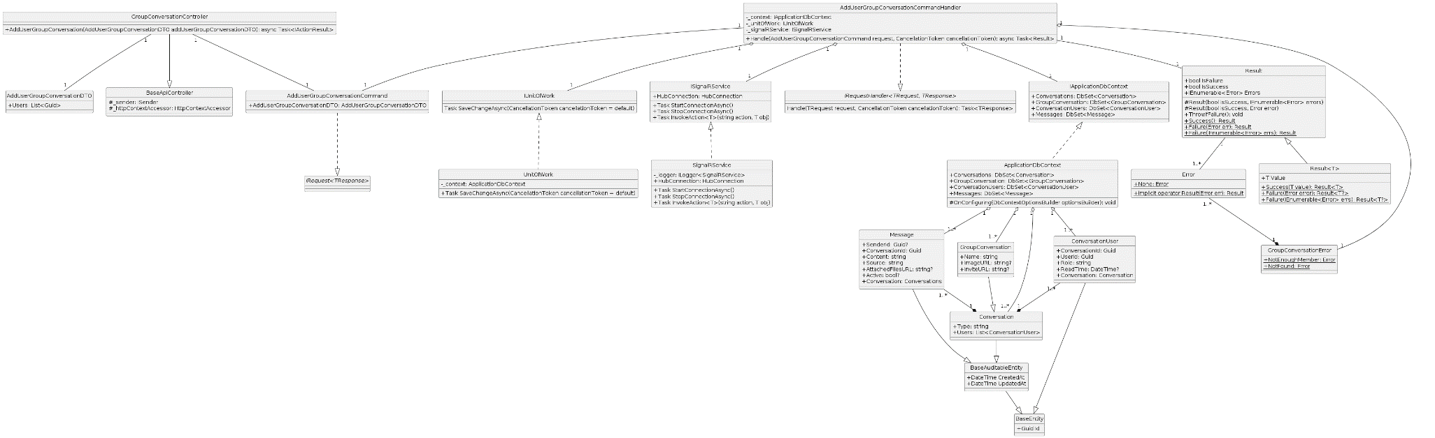

* + 1. **Group Block User**

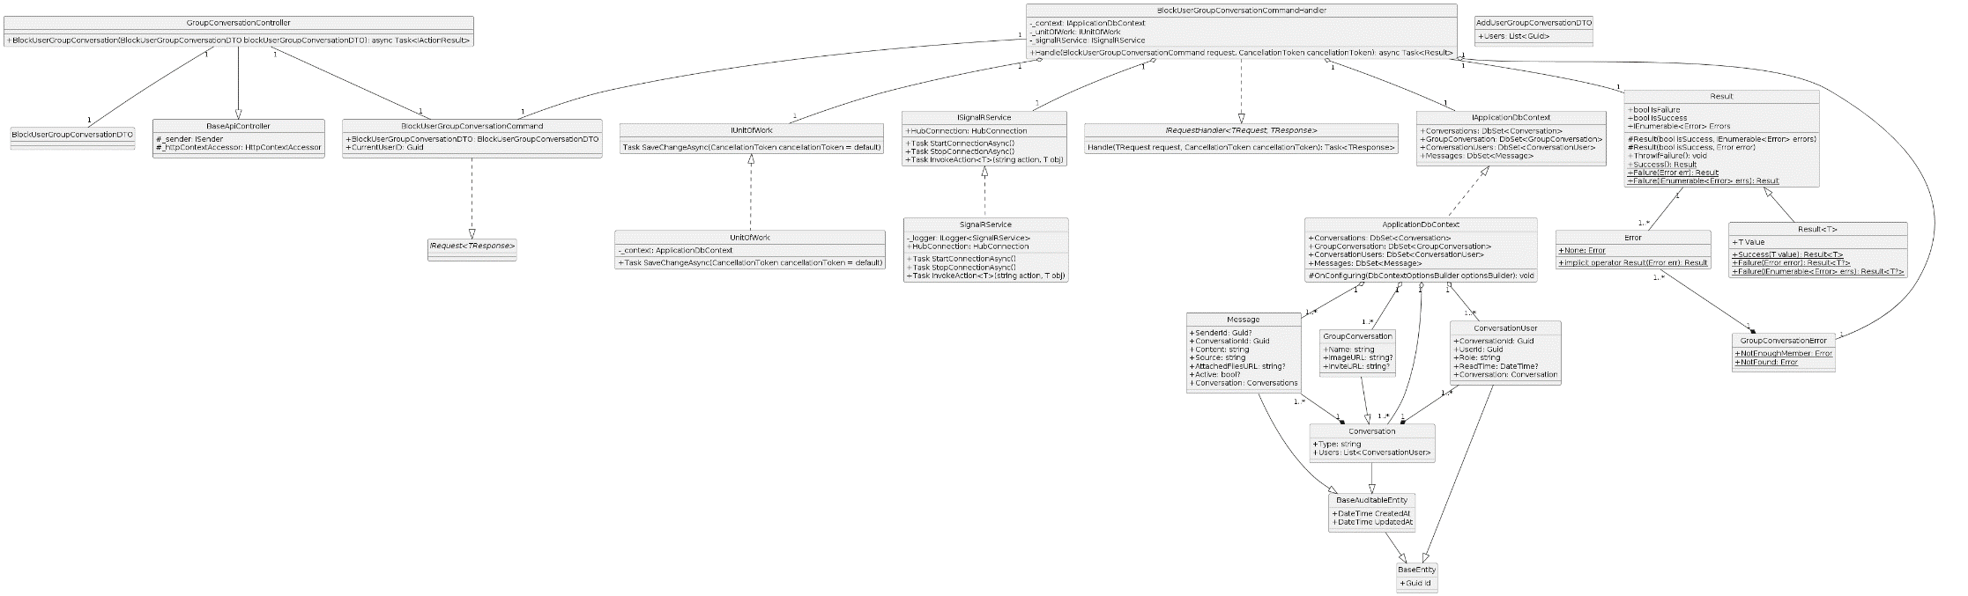

* + 1. **Group Disband**

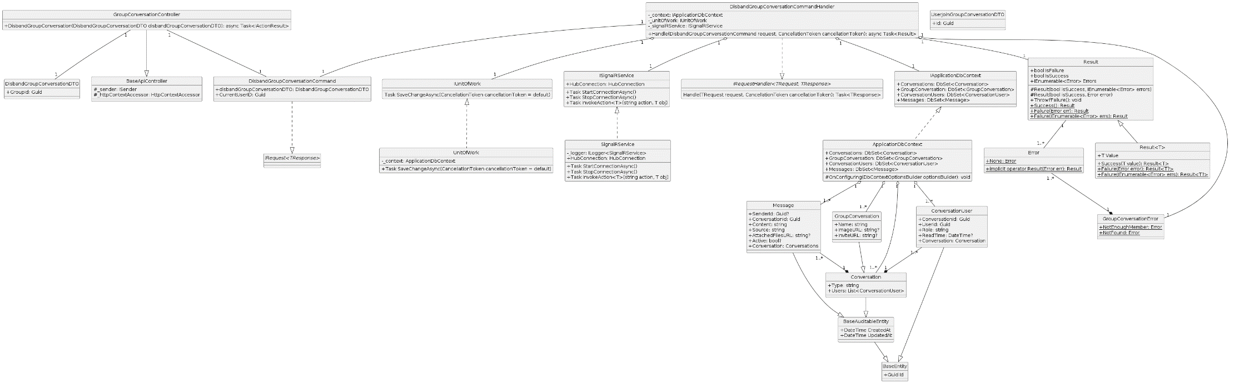

* + 1. **Send Client Message**

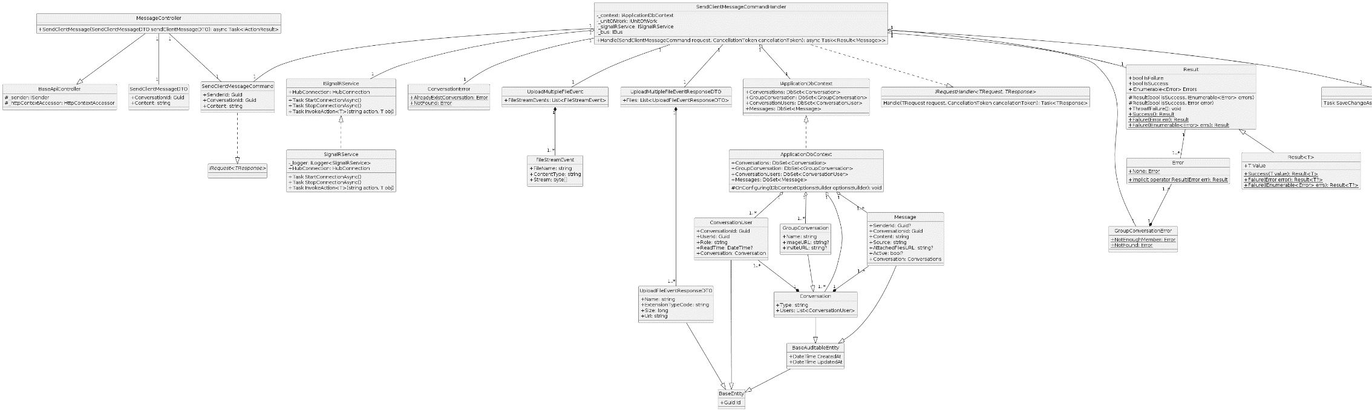

* + 1. **Update Group Conversation**

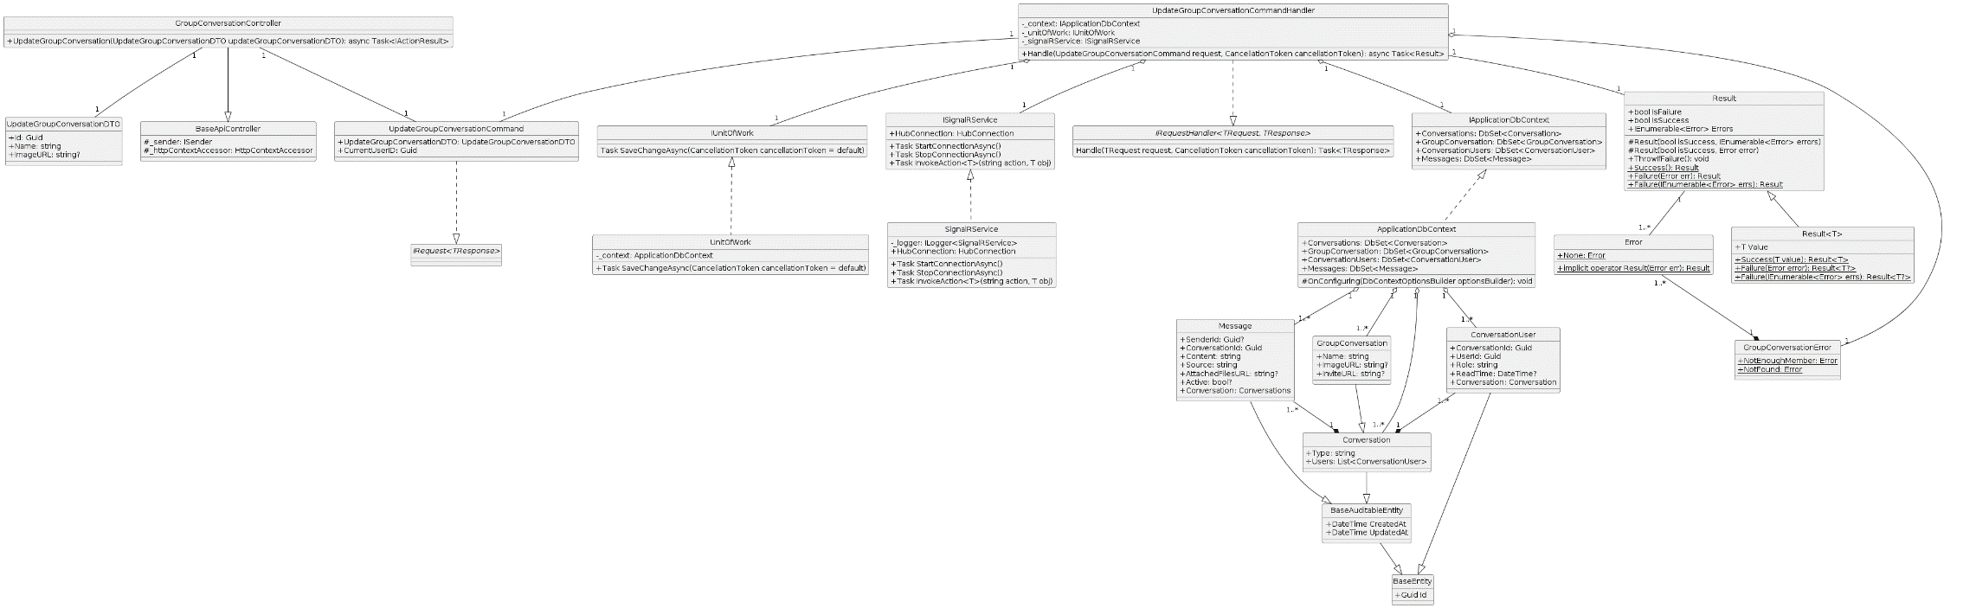

* + 1. **User Exit Group**

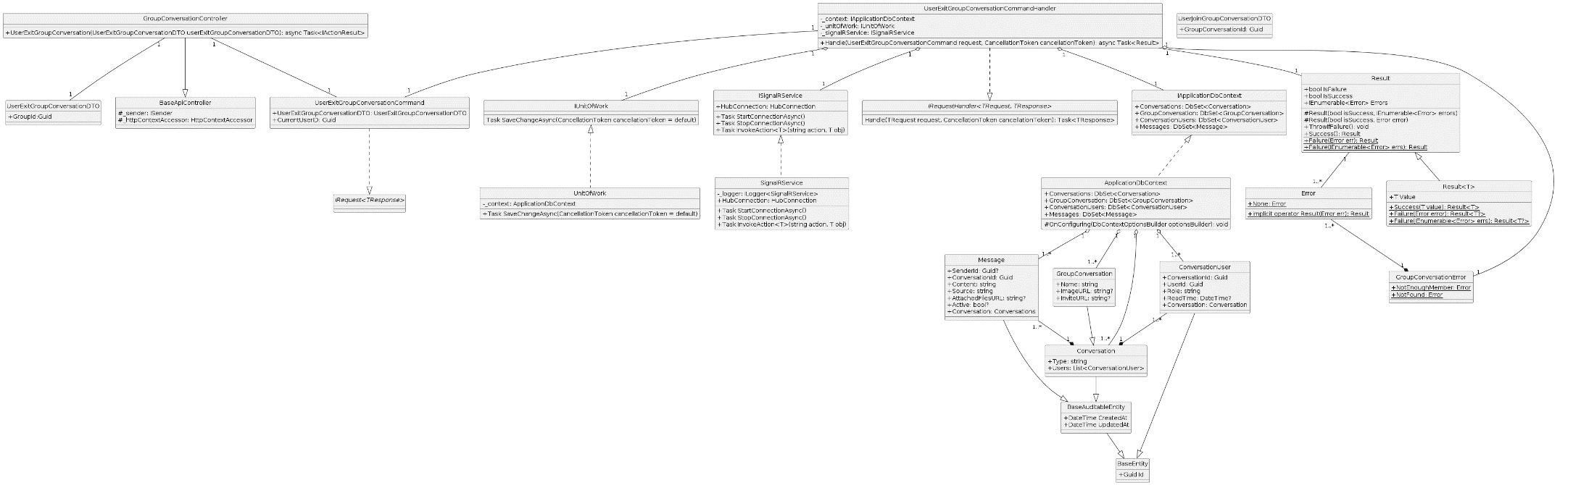

* + 1. **User Join Group**

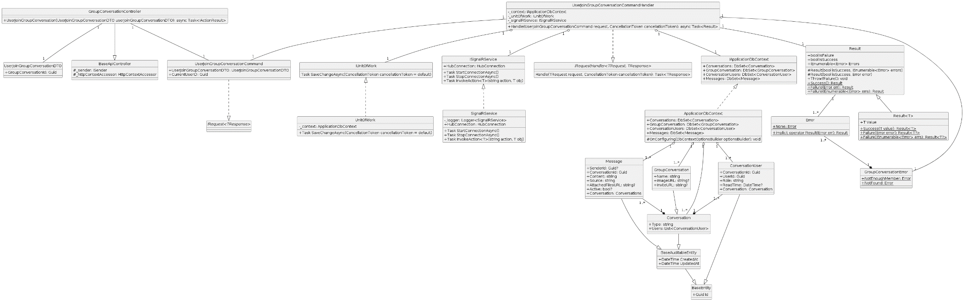

* 1. **Post**
     1. **Create Post**

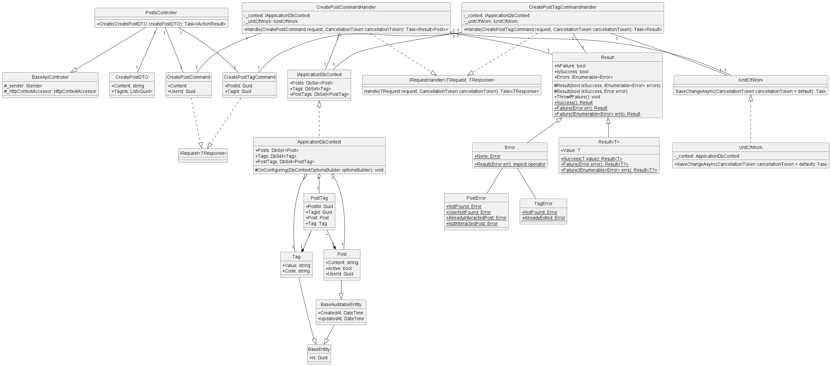

* + 1. **Create Post Interaction**

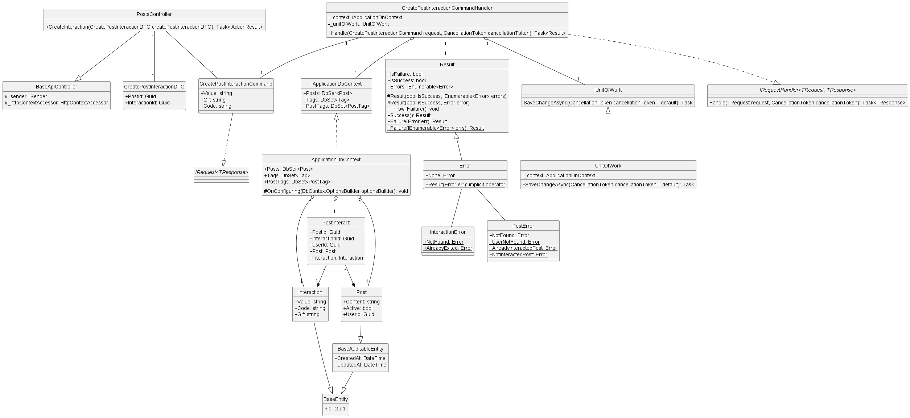

* + 1. **Create Report Post**

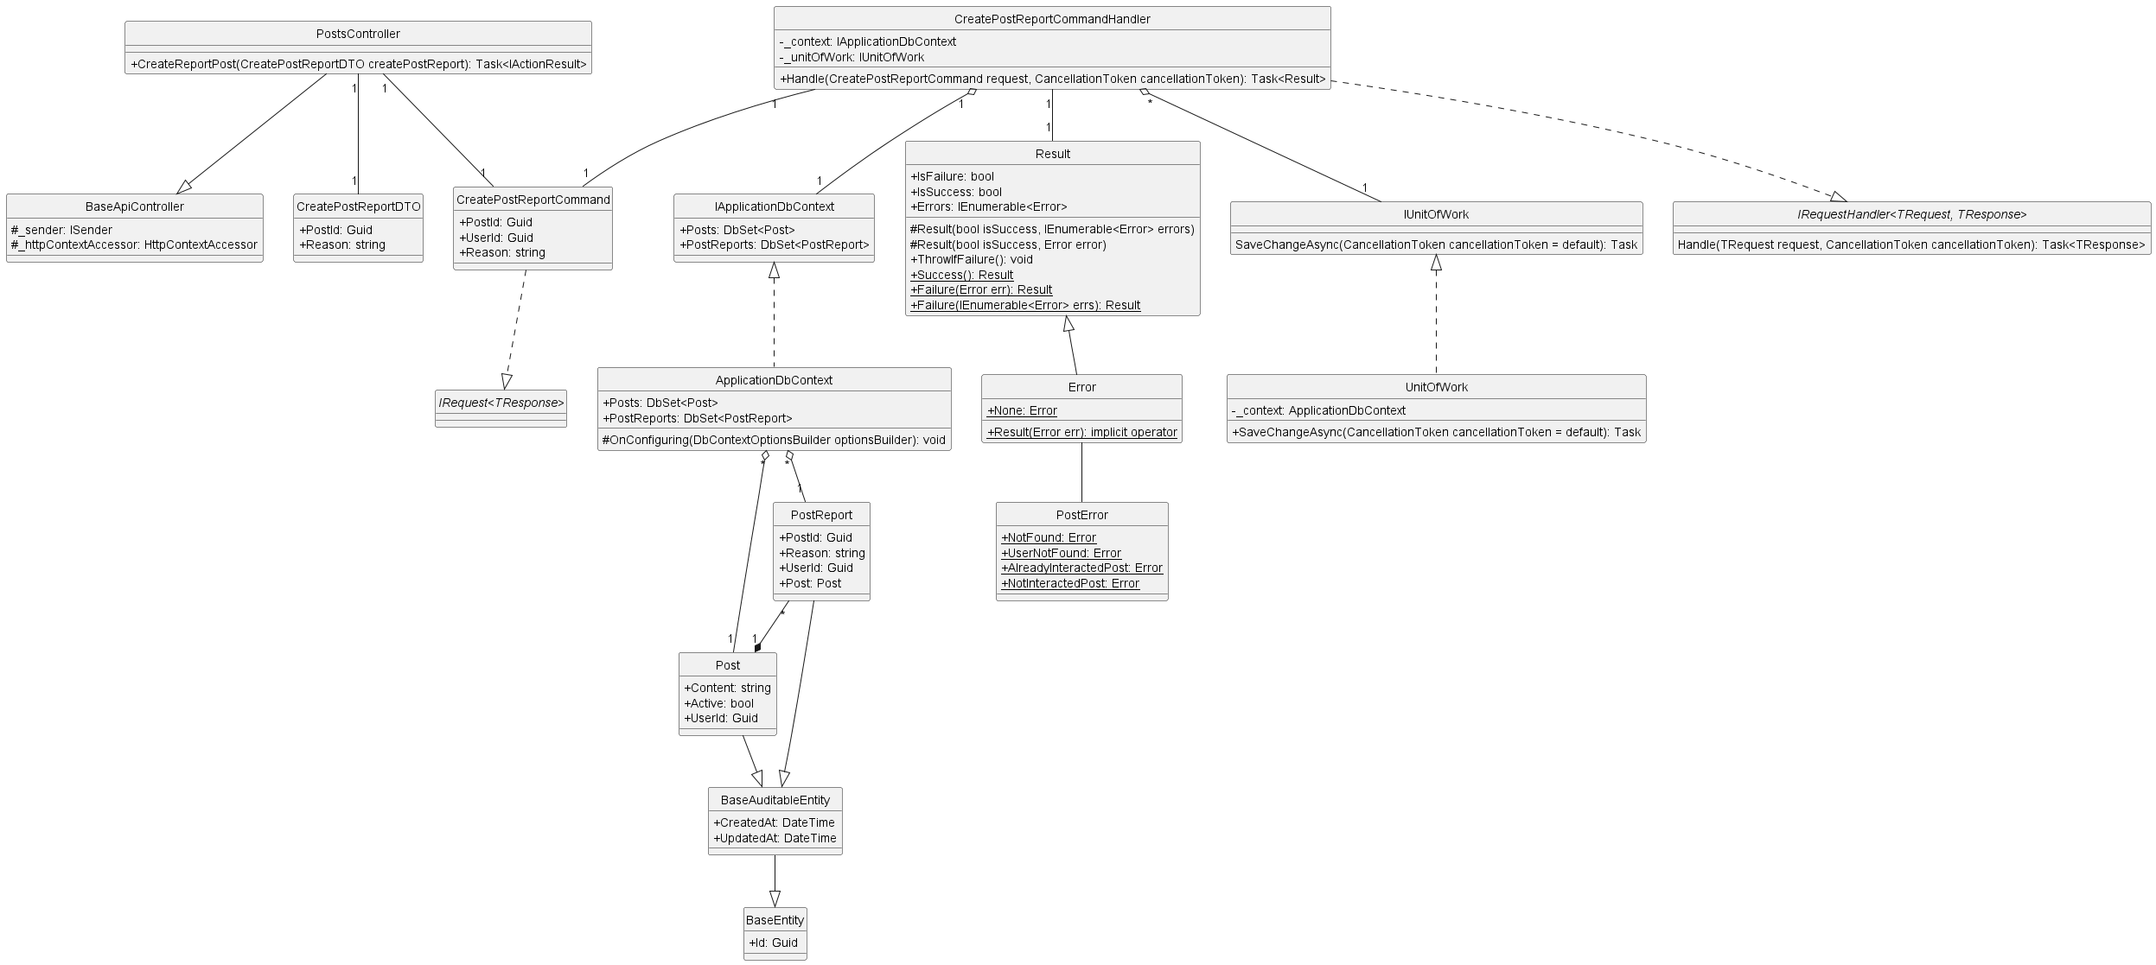

* + 1. **Get All Post**

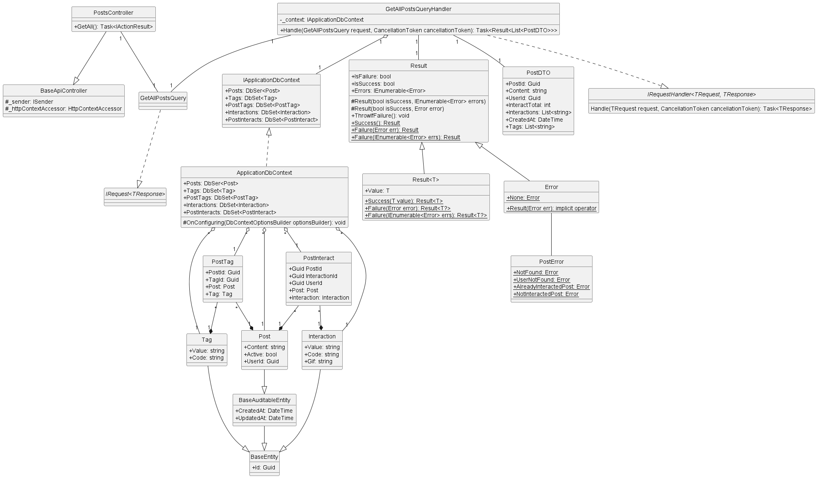

* + 1. **Get All Report Post**

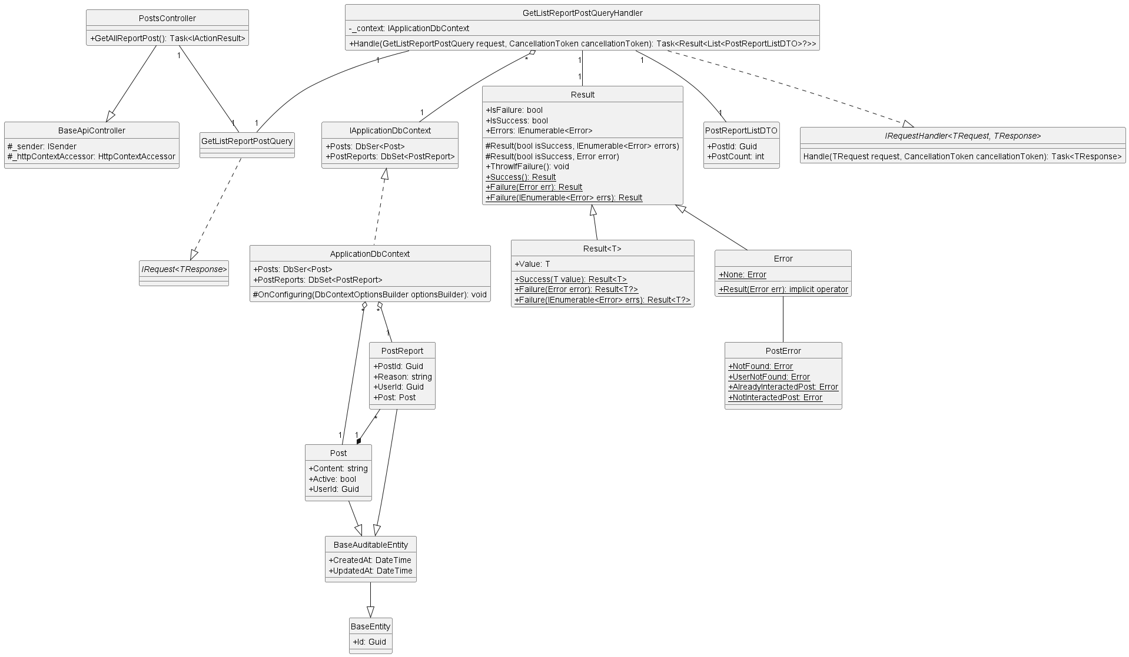

* + 1. **Get Post By Id**

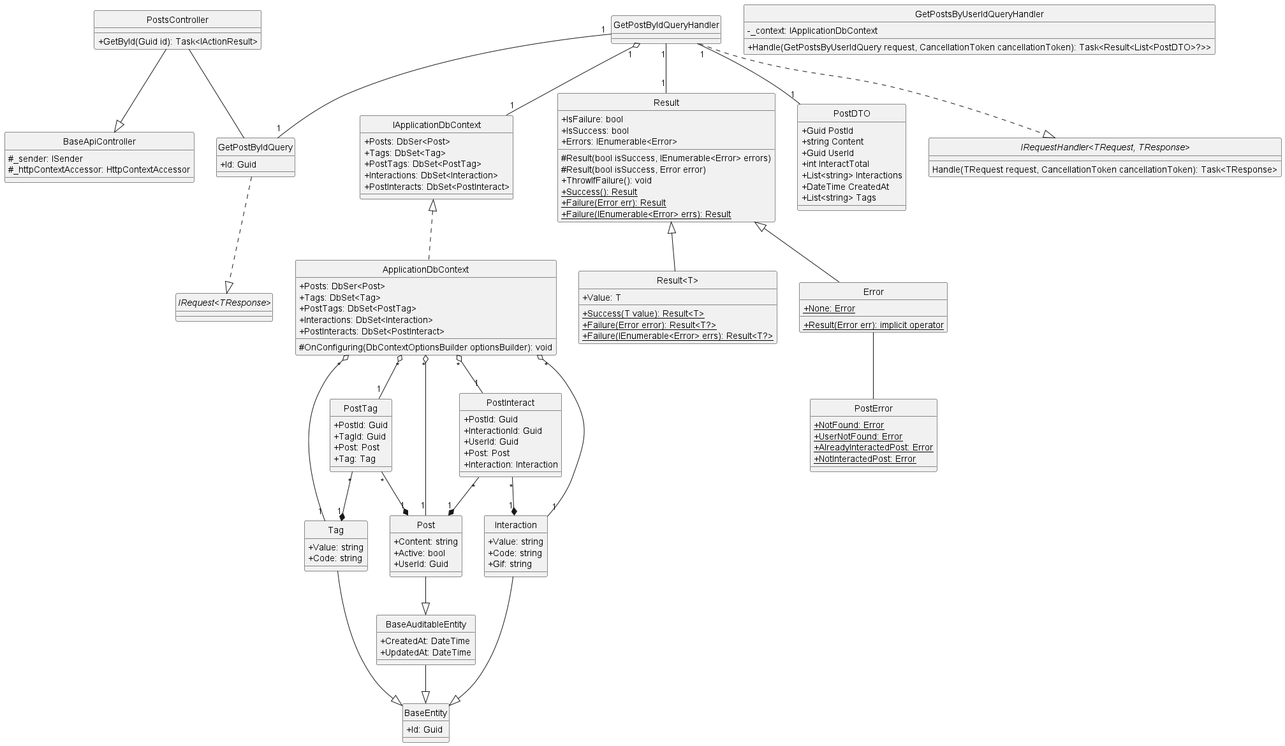

* + 1. **Get By User Id**

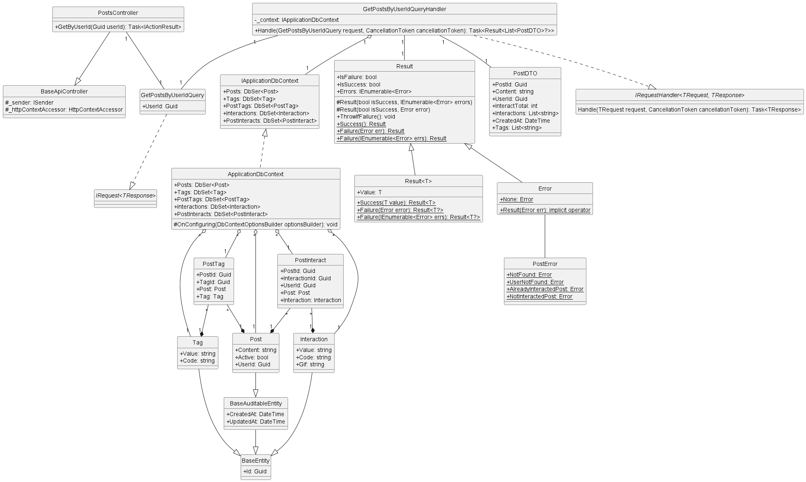

* + 1. **Get Post Interaction**

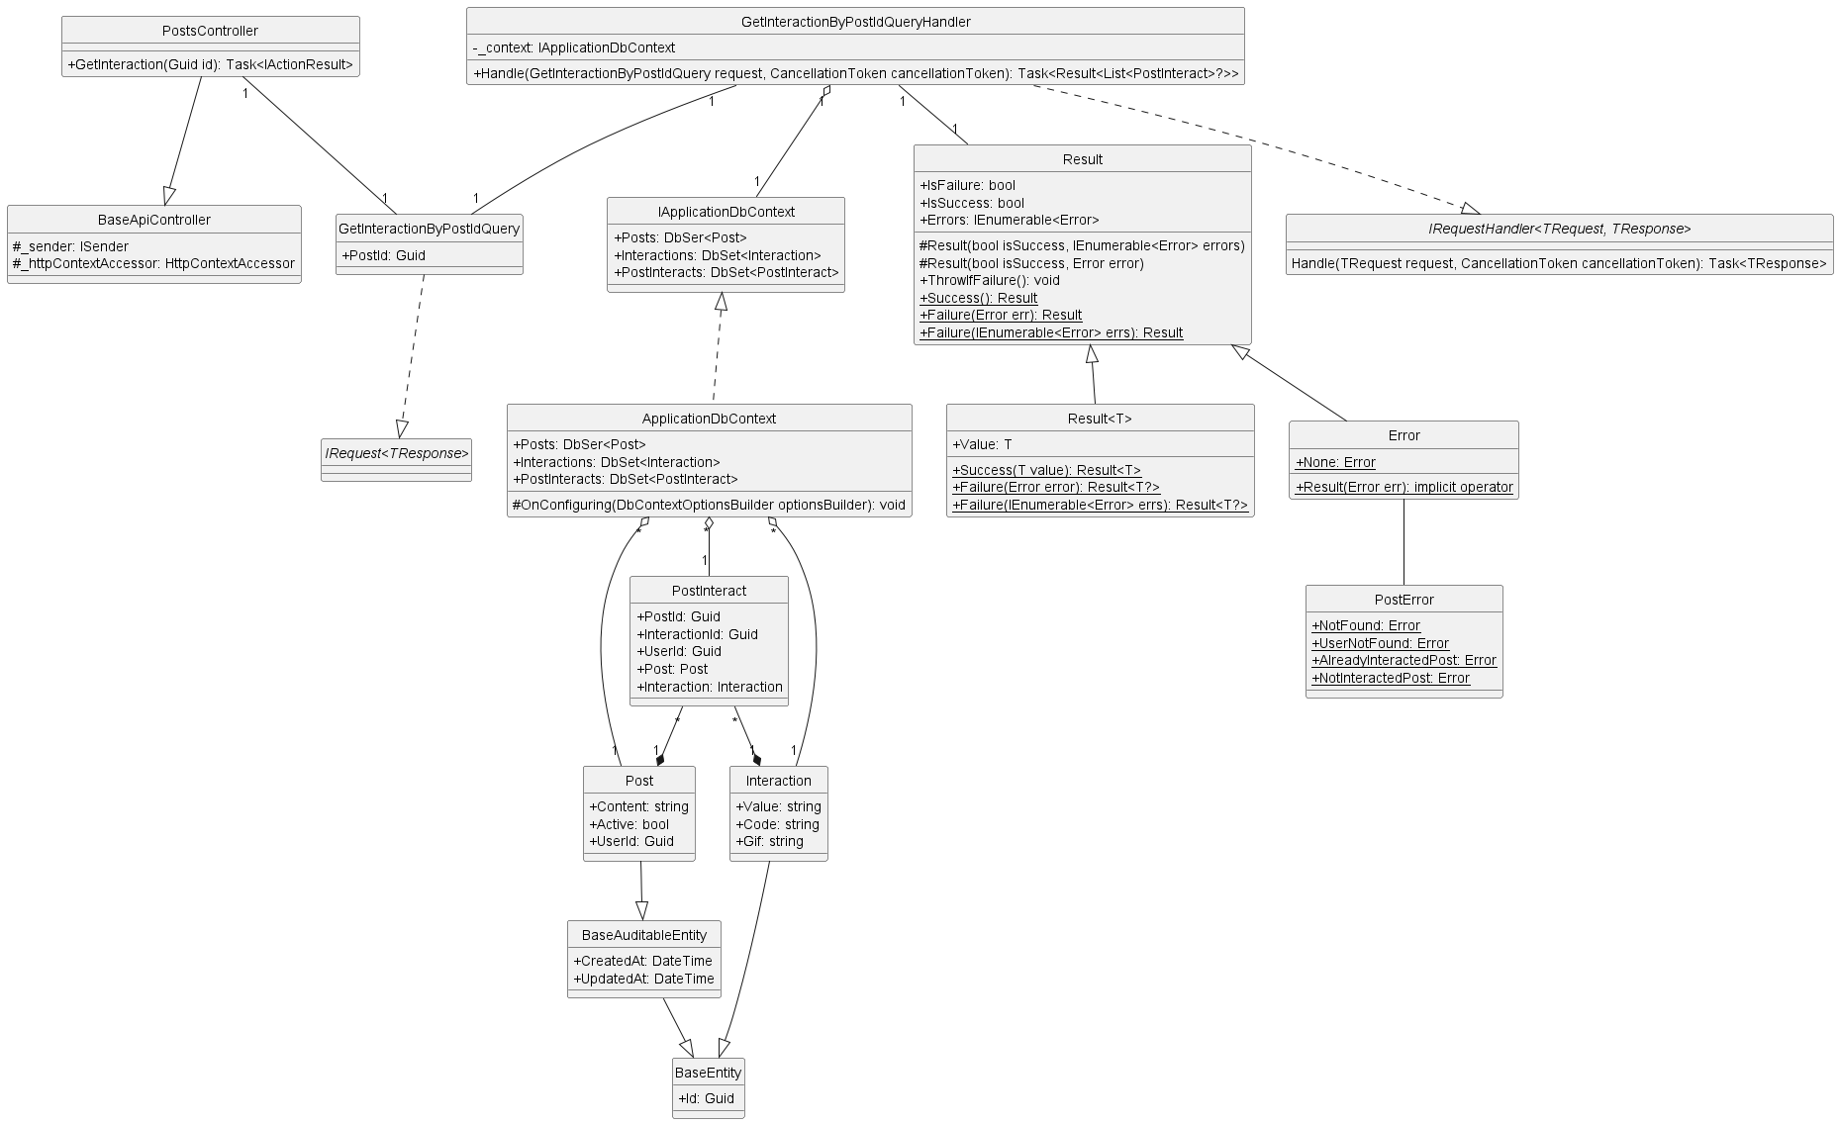

* + 1. **Get Report Post By Post Id**

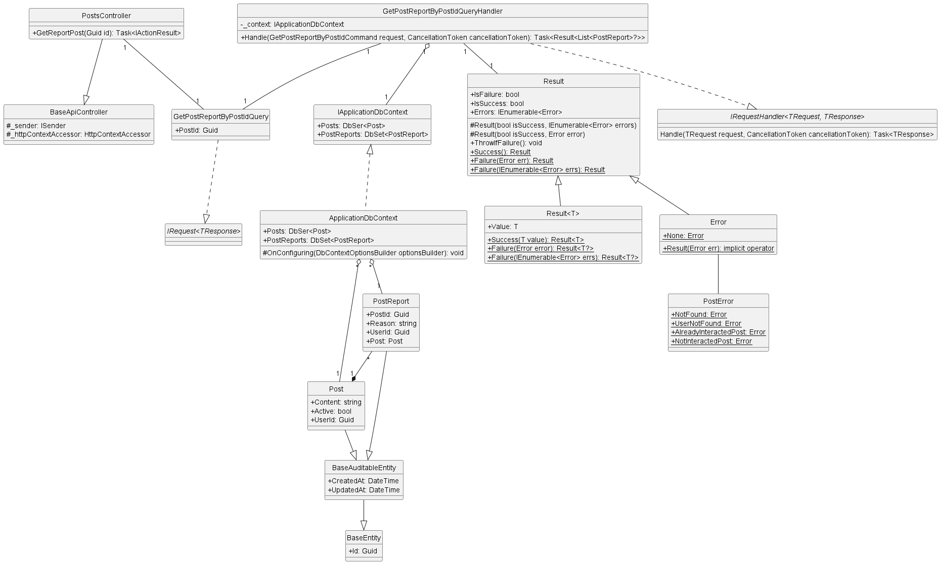

* + 1. **Uninteraction Post**

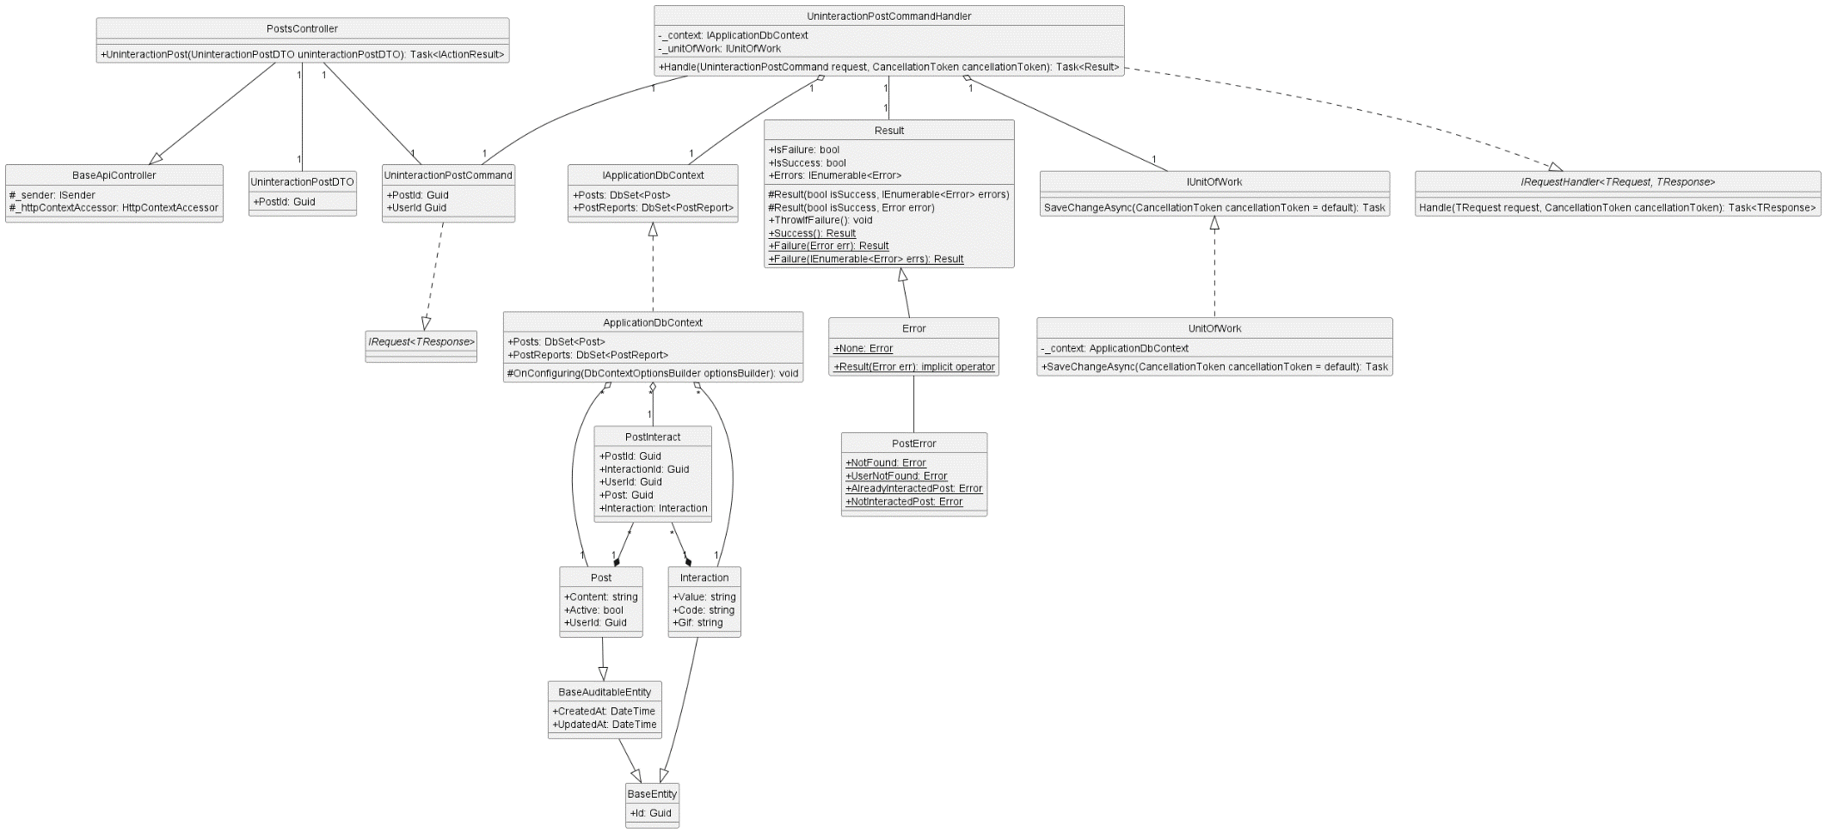

* + 1. **Update Post**

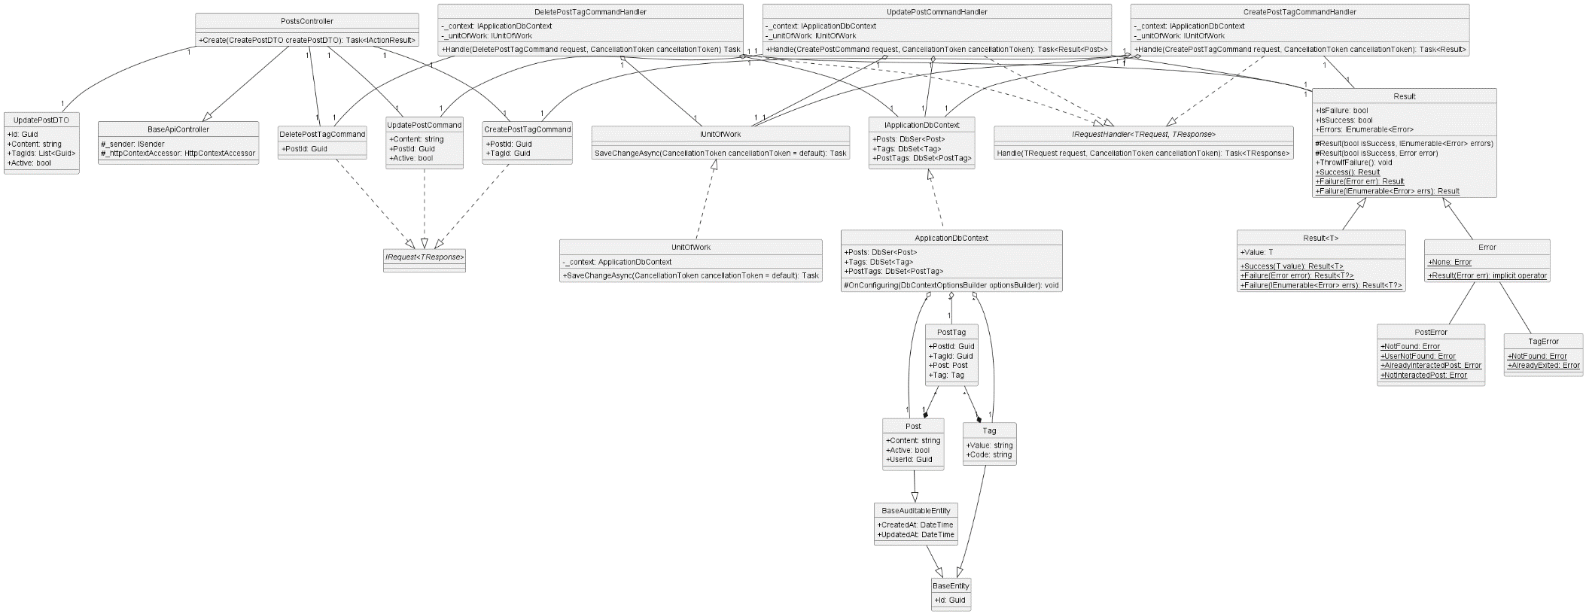

* + 1. **Create Comment**

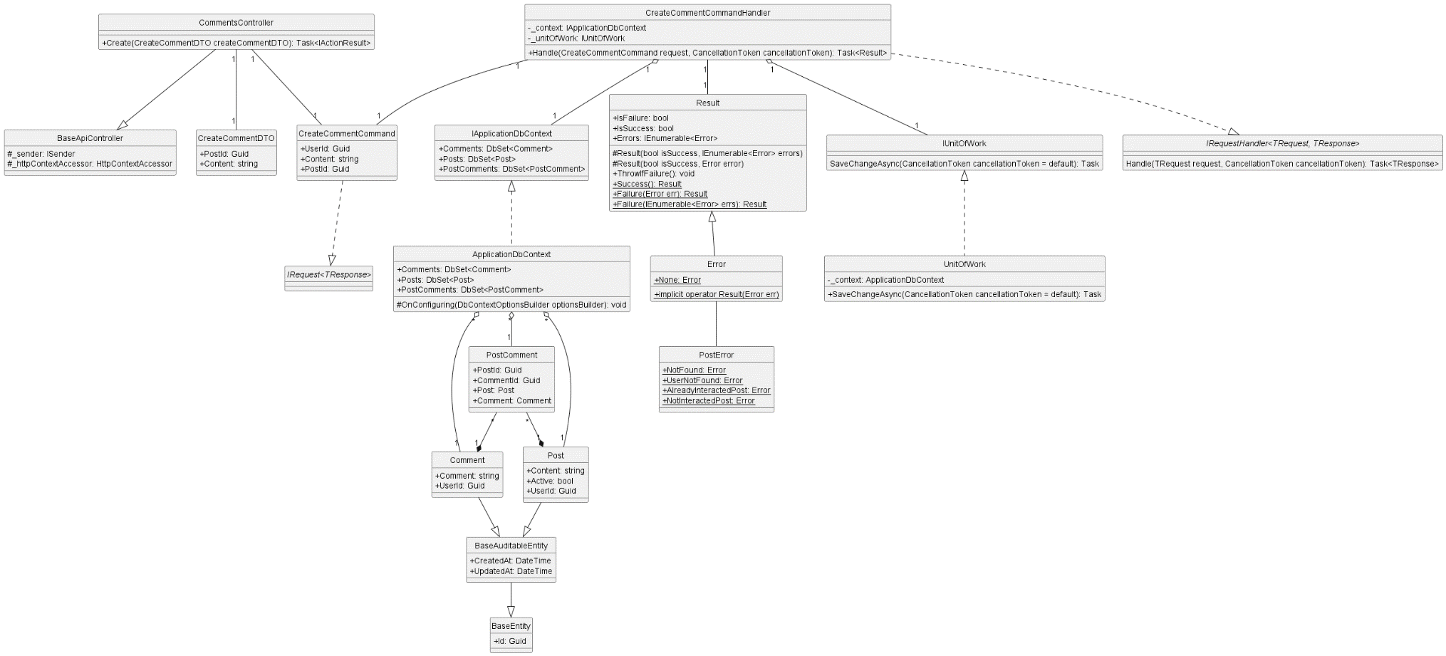

* + 1. **Get Comment By Post Id**

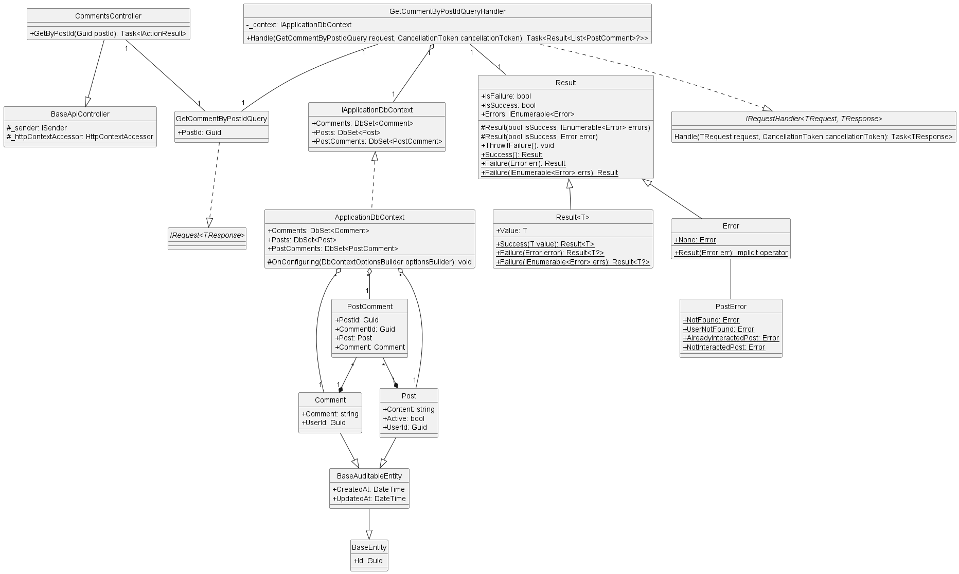

* + 1. **Update Comment**

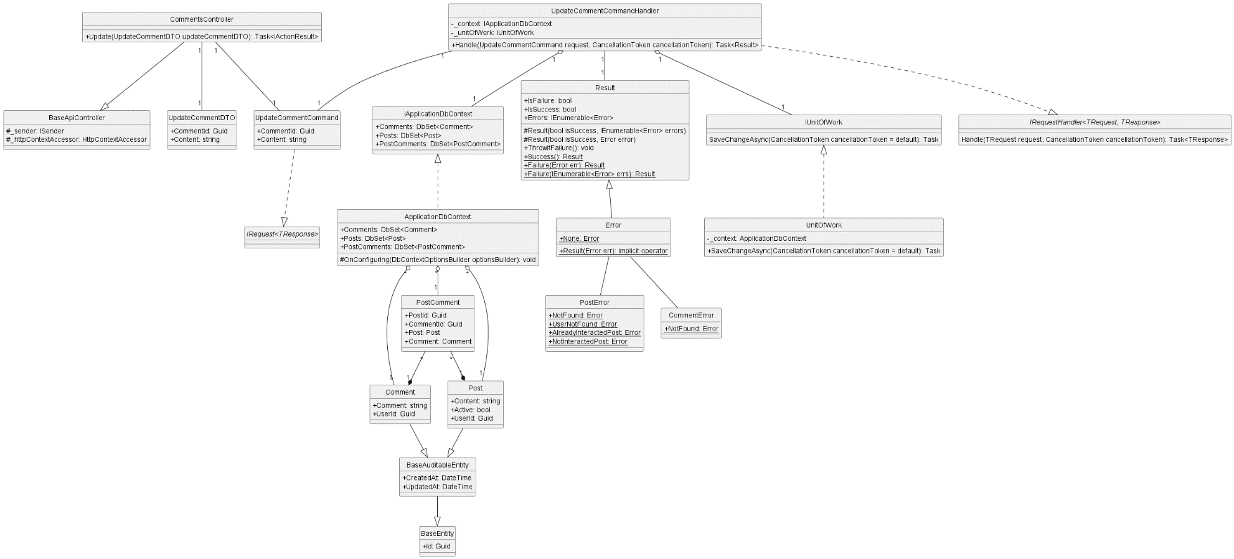

* + 1. **Create Interaction**

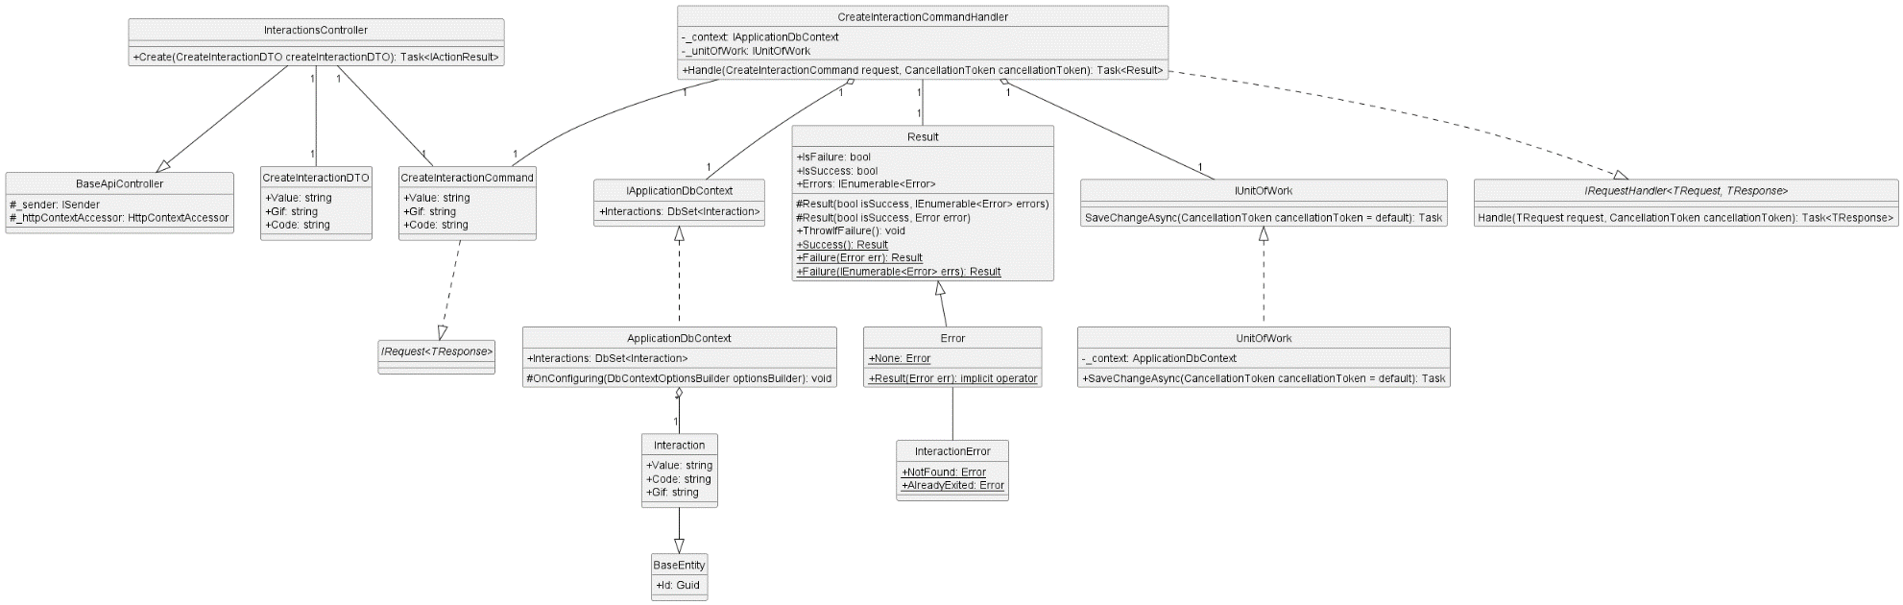

* + 1. **Delete Interaction**

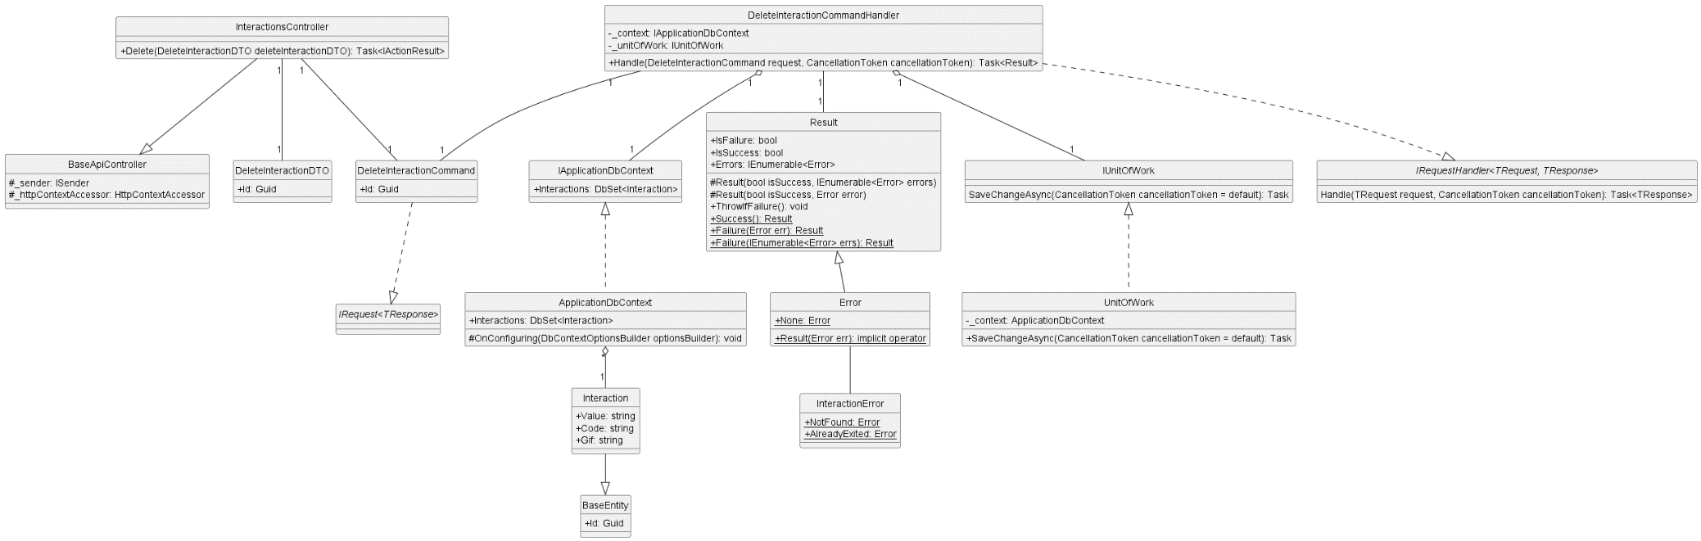

* + 1. **Get All Interaction**

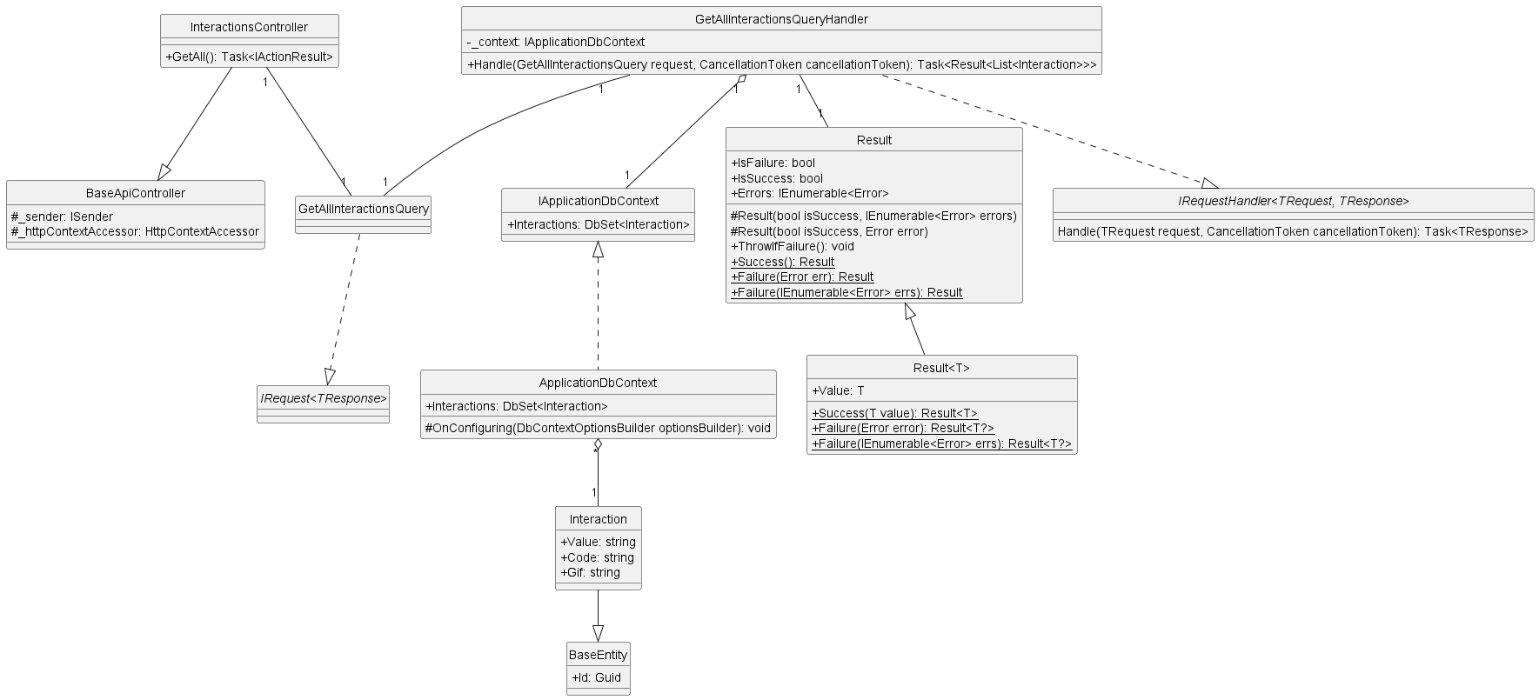

* + 1. **Update Interaction**

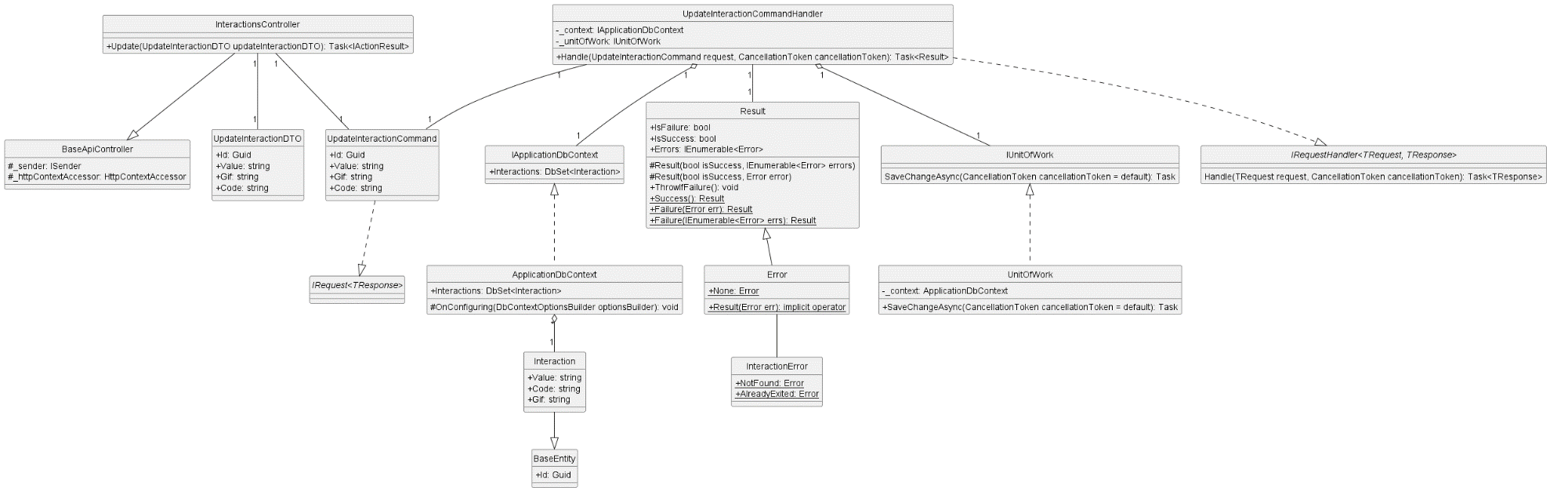

* + 1. **Create Tag**

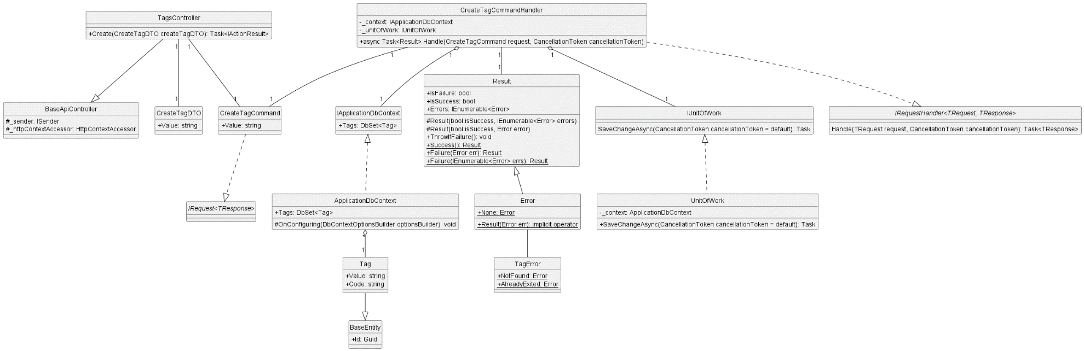

* + 1. **Delete Tag**

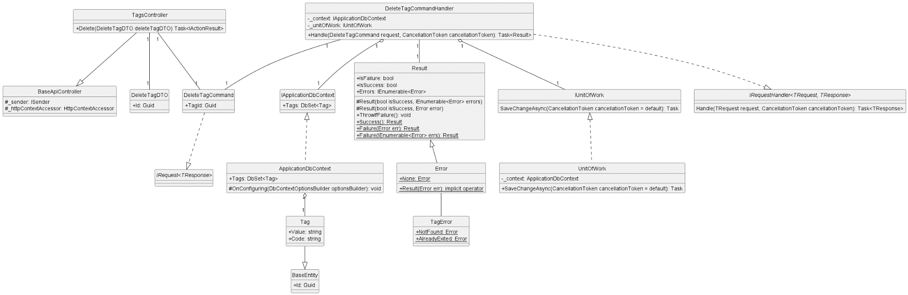

* + 1. **Get All Tag**

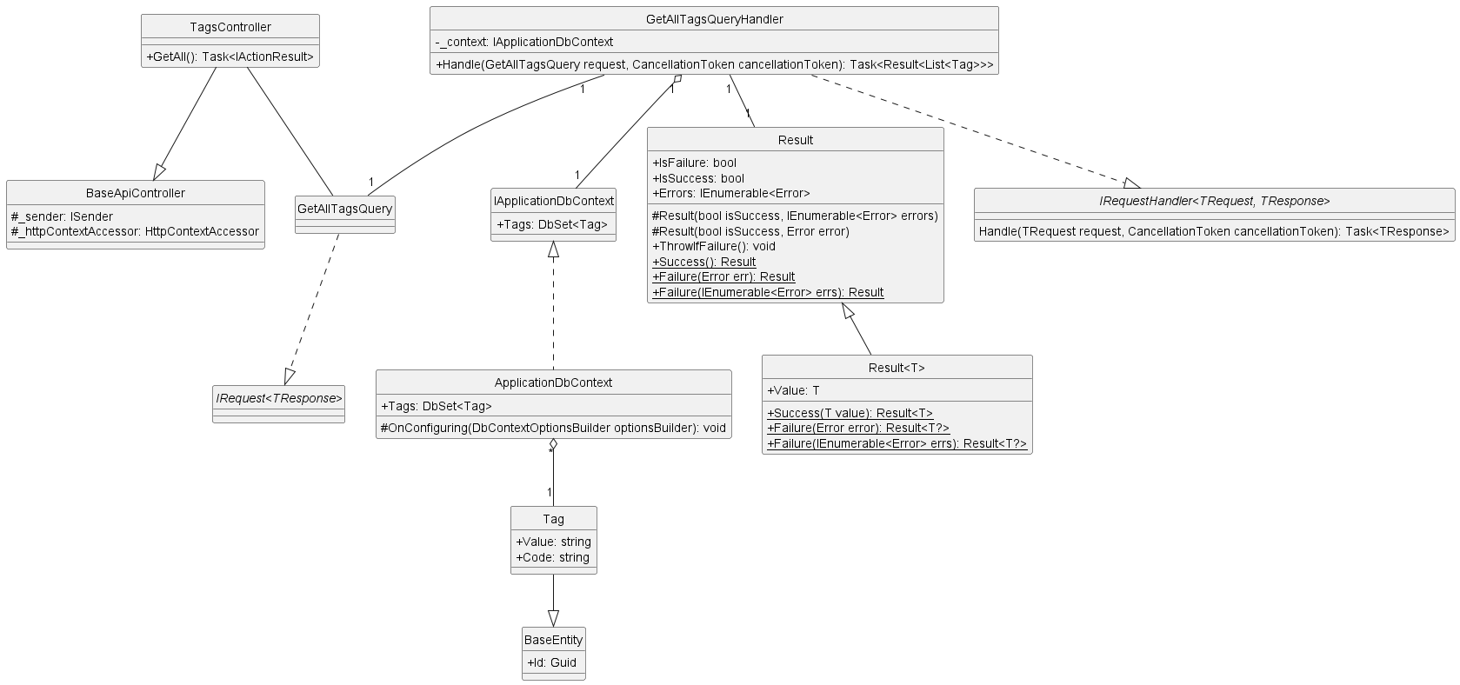

* + 1. **Update Tag**

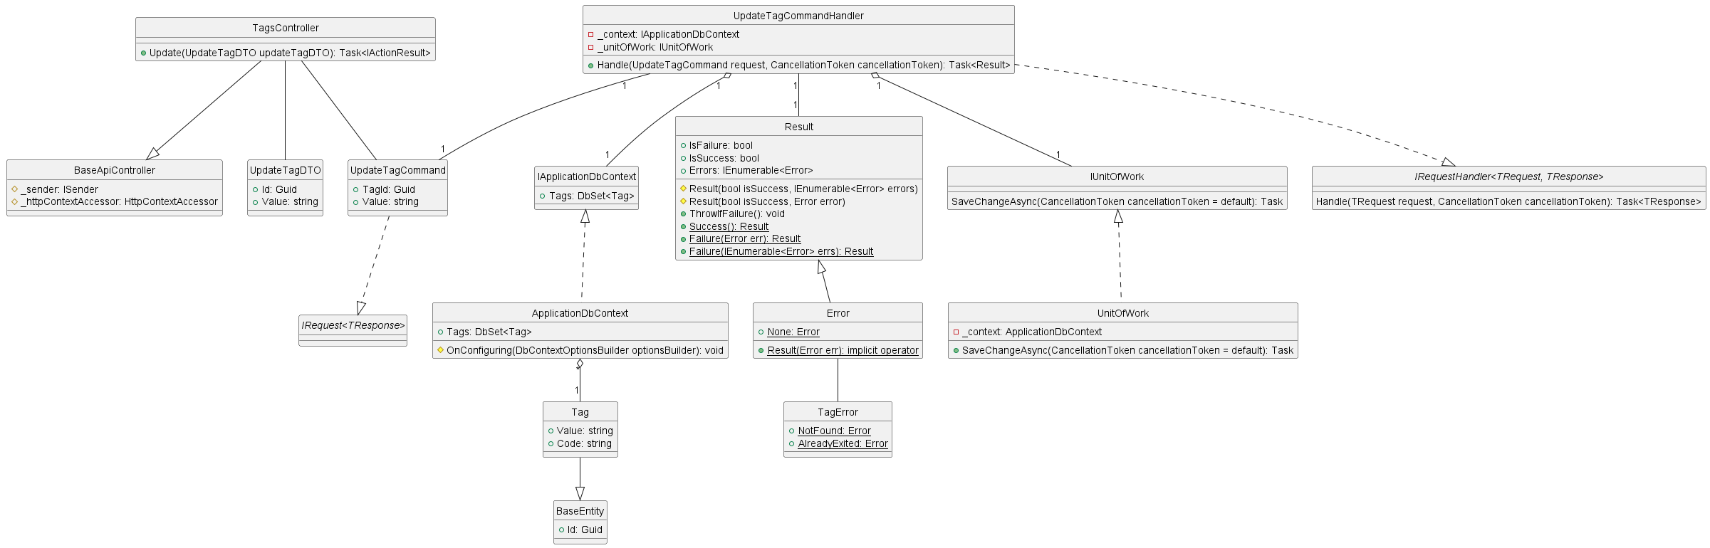

1. **Database diagram**
   1. **FileDB**

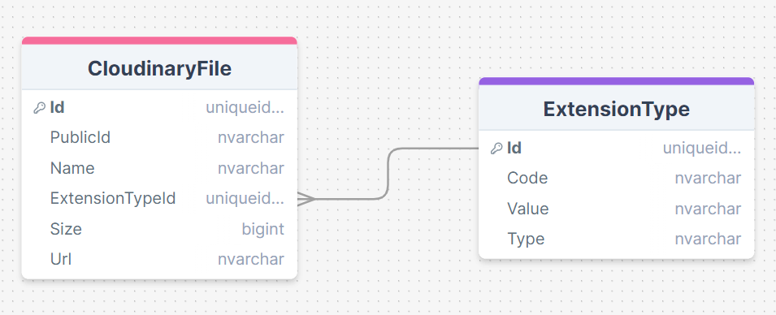

* 1. **IdentityDB**

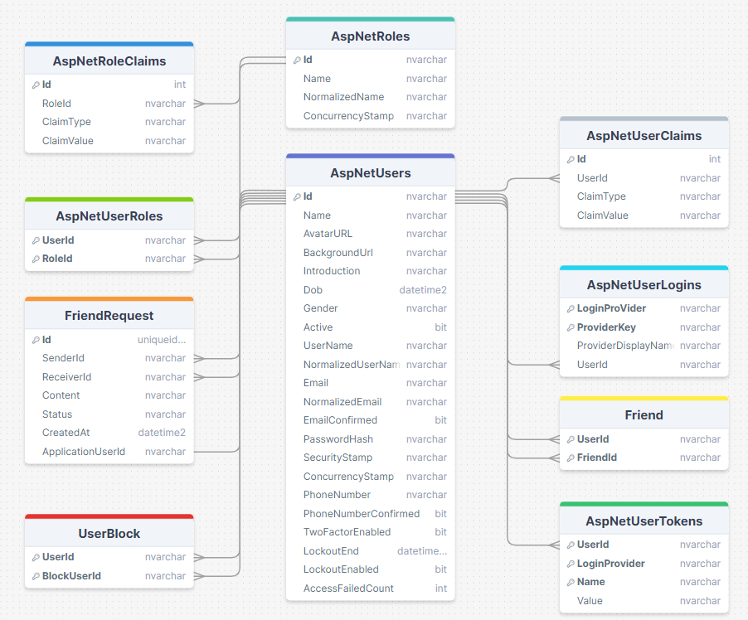

* 1. **MessageDB**

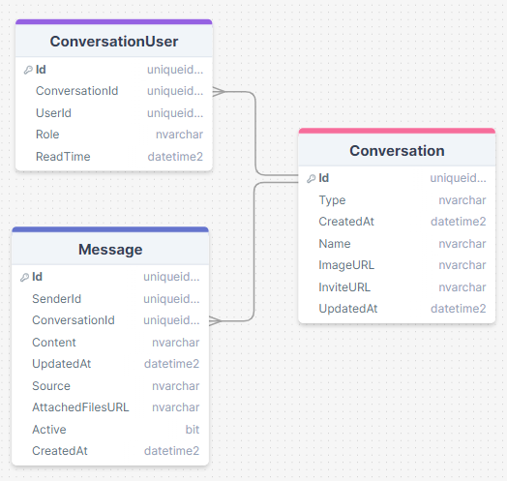

* 1. **PostDB**

